Scheme of work
Introduction

This resource provides you with a scheme of work (SOW) for the theoretical content of our GCSE Physical Education specification (8582). This is a suggested scheme of work and is not prescriptive. It can be adapted to suit the delivery of the course within different schools.
It covers the content of the specification in a logical order and suggests possible teaching and learning activities for each section of the specification, whilst the learning outcomes indicate what most students should be able to achieve after the work is completed.

Timings have been suggested but are approximate. Teachers should select activities appropriate to their students and the curriculum time available.

The resources indicate those resources commonly available to schools, and other references that may be helpful. Resources are only given in brief and risk assessments should be conducted as appropriate in your planning.

Version 2.0
January 2024

Assumed coverage
Our GCSE Physical Education qualification has been designed as a two-year course. This SOW covers the theoretical content, which is worth 60% of the qualification, and is based on approximately five hours classroom time per fortnight.

This doesn't include home-based (homework) learning time but does factor in some revision classes and time to complete a mock exam. However, schools may vary how much time they spend teaching the theoretical content and how much they spend teaching the non-exam assessment (NEA). We have produced a two-year plan to support this approach (see appendix 1).

Adapting the scheme of work

It is also worth considering how this content is used within the written NEA (Part 3 analysis and evaluation). You may wish to consider delivering specific aspects at certain times to align with when your students start their written NEA eg as the evaluation element section includes application of physical training, you may decide to teach this before the students start that aspect of their written NEA.
Some schools may opt to teach this course over a three-year period and can adapt this resource accordingly. We have produced a three-year plan to support with this approach (see appendix 2).

Contents
You can use the title links to jump directly to the different sections of this scheme of work (Use Ctrl and click to follow the link)

Section title | Page
Paper 1
Applied anatomy and physiology | 4
Movement analysis | 26
Physical training | 30
Use of data (Paper 1 and 2) | 45
Paper 2
Sports psychology | 46
Socio-cultural influences | 58
Health, fitness and well-being | 70
Appendix 1: Two-year plan | 78
Appendix 2: Three-year plan | 82
Appendix 3: Bone labels | 88
Appendix 4: Muscle names | 89
Appendix 5: Examples of how muscles, muscle groups and joint questions are assessed within the exams | 90
Appendix 6: Blood vessels | 94
Appendix 7: Heart diagram | 94
Appendix 8: Example data task | 95
Appendix 9: Example of spirometer trace | 96
Appendix 10: EPOC/Oxygen debt diagram | 97
Appendix 11: Planes and axes diagrams | 98
Appendix 12: Examples of how ‘data’ is used/assessed within the exams | 99
Appendix 13: Inverted U diagram | 103
Paper 1

Applied anatomy and physiology

Bones

Learning outcomes
- Knowledge of the bones at the following locations:
  - head/neck – cranium, vertebrae
  - shoulder – scapula and humerus
  - chest – ribs and sternum
  - elbow – humerus, radius and ulna
  - hip – pelvis and femur
  - knee – femur and tibia (students should also know that the patella sits in front of the knee joint)
  - ankle – tibia, fibula and talus.
- Teaching should focus on
  - identifying where these bones are located.
Differentiation and extension
- Name the bones.
- Correlate knowledge of the bones with the location (joint).
- Correlate to the muscles that move the bones.
- Apply the knowledge and understanding to prescribed movements/skills.

Resources
- Subject specific vocabulary.
- AQA GCSE (9-1) PE Second Edition Hodder Education ISBN 978-1-398-32652-1 (Chapter 1a, 1b and 1c).
- Command words.
- Sample assessment materials and past papers.
- Address labels with bone names to print and stick on the body (Appendix 3 and 4).

Structure of the skeleton

Learning outcomes
- How the skeletal system provides a framework for movement (in conjunction with the muscular system):
- the skeletal system allows movement at a joint
- the shape and type of the bones determine the amount of movement (short bones enable finer controlled movements, long bones enable gross movement)
- flat bones for protection of vital organs
- the different joint types allow different types of movement
- the skeleton provides a point of attachment for muscles – when muscles (contract) they pull the bone.
- Teaching should focus on applying this knowledge. For example, how flat bones protect the vital organs during specific skills and how the muscles and bones work together to perform specific movements, etc.
Differentiation and extension
- Know the main points.
- Apply these points to basic movements.
- Apply this knowledge to sports specific skills in a variety of sports.

Resources
- Subject specific vocabulary.
- AQA GCSE (9-1) PE Second Edition Hodder Education ISBN 978-1-398-32652-1 (Chapter 1a, 1b and 1c).
- Command words.
- Sample assessment materials and past papers.

Functions of the skeleton

Learning outcomes
- The main functions should be taught:
- support
- protection of vital organs by flat bones
- movement
- structural shape and points for attachment
- mineral storage
- blood cell production.
- Functions should be applied to performance in physical activity.

Differentiation and extension
- Know the functions.
- Be able to explain the functions.
- Be able to give applied examples, eg protection of the heart and lungs by the ribs when ‘chesting’ a ball.

Resources
- Subject specific vocabulary.
- AQA GCSE (9-1) PE Second Edition Hodder Education ISBN 978-1-398-32652-1 (Chapter 1a, 1b and 1c).
- Command words.
- Sample assessment materials and past papers.

Muscles of the body

Learning outcomes
- Identification of the following muscles within the body:
  - latissimus dorsi
  - deltoid
  - rotator cuffs
  - pectorals
  - biceps
  - triceps
  - abdominals
  - hip flexors
  - gluteals
  - hamstring group (not individual names)
  - quadriceps group (not individual names)
  - gastrocnemius
  - tibialis anterior.
- Students should know the role of tendons (attaching muscle to bone).
- Teaching should ensure students can identify the location of the muscles and apply that knowledge to specific movements/ skills.

Differentiation and extension
- Know the names of the muscles.
- Locate the anatomical position of each muscle.
- Apply this knowledge to basic movements.
- Apply this knowledge to sports specific skills.

Resources
- Subject specific vocabulary.
- AQA GCSE (9-1) PE Second Edition Hodder Education ISBN 978-1-398-32652-1 (Chapter 1a, 1b and 1c).
- Command words.
- Sample assessment materials and past papers.
- Muscle names (Appendix 4).
- Examples of how muscles and joints are assessed (Appendix 5).

Structure of a synovial joint

Learning outcomes
- Knowledge of the following structures of a synovial joint:
  - synovial membrane
  - synovial fluid
  - joint capsule
  - bursae
  - cartilage
  - ligaments.
- Teaching will focus on explaining how these structures fulfil their function to increase stability and prevent injury. Each should be applied to practical examples of movement at the main joints.
- Students should know the basic role of tendons.

Differentiation and extension
- Know the names.
- Explain what they do.
- Identify where they are in a joint.
- Apply their function to practical examples, eg kick a ball.

Resources
- Subject specific vocabulary.
- AQA GCSE (9-1) PE Second Edition Hodder Education ISBN 978-1-398-32652-1 (Chapter 1a, 1b and 1c).
- Command words.
- Sample assessment materials and past papers.
- Examples of how muscles and joints are assessed (Appendix 5).

Types of freely movable joints that allow different movements

Learning outcomes
- Identification of the types of joints with reference to the following:
  - elbow, knee and ankle – hinge joint
  - hip and shoulder – ball and socket.
- Teaching should focus on these joints only. Focus should be on the type of movement possible at the hinge/ball and socket with application to sporting actions.

Differentiation and extension
- Know the names of the joint types.
- Locate examples of these joints.
- Apply this knowledge to the movements during basic skills.
- Apply this knowledge to varying sporting skills.

Resources
- Subject specific vocabulary.
- AQA GCSE (9-1) PE Second Edition Hodder Education ISBN 978-1-398-32652-1 (Chapter 1a, 1b and 1c).
- Command words.
- Sample assessment materials and past papers.
- Examples of how muscles and joints are assessed (Appendix 5).

How joints differ in design to allow certain types of movement at a joint

Learning outcomes
- Understand that the following types of movement are linked to the appropriate joint type, which enables that movement to take place:
  - flexion/extension at the shoulder, elbow, hip and knee
  - abduction/adduction at the shoulder
  - rotation of the shoulder
  - plantar flexion/dorsiflexion at the ankle.
- Teaching should focus in this section on what movement is possible at the joints and their
names. Applied knowledge, ie to sporting skills, is part of movement analysis. This area and ‘movement analysis’ may be taught together.

Differentiation and extension
- Know the names of the movements.
- Understand what movements take place at specific joints.
- Apply this knowledge to sporting skills (as part of movement analysis).

Resources
- Subject specific vocabulary.
- AQA GCSE (9-1) PE Second Edition Hodder Education ISBN 978-1-398-32652-1 (Chapter 1a, 1b and 1c).
- Command words.
- Sample assessment materials and past papers.
- Examples of how muscles and joints are assessed (Appendix 5).

How the major muscles and muscle groups of the body work antagonistically on the major joints of the skeleton to affect movement in physical activity at the major movable joints

Learning outcomes
- With reference to the shoulder, elbow, hip, knee and ankle joints:
  - major muscle groups operating at these joints (see above)
  - the action of prime movers (agonists)/ antagonists
  - bones located at the joint (see above)
  - how these muscle groups work isometrically and isotonically (concentric/ eccentric).
- Teaching should focus on the difference between concentric and eccentric (isotonic) contractions. Classroom delivery should be applied, ie to sporting skills and movements.

Differentiation and extension
- Know the terms.
- Understand how these terms work in conjunction with each other eg an agonist will act as the prime mover to cause concentric contraction.
- Apply this knowledge to basic movements.
- Apply this knowledge to specific sporting skills.

Resources
- Subject specific vocabulary.
- AQA GCSE (9-1) PE Second Edition Hodder Education ISBN 978-1-398-32652-1 (Chapter 1a, 1b and 1c).
- Command words.
- Sample assessment materials and past papers.
- Examples of how muscles and joints are assessed (Appendix 5).

Pathway of air

Learning outcomes
- Identification of the pathway of air (limited to):
  - mouth/nose
  - trachea
  - bronchi
  - bronchioles
  - alveoli.
- Teaching should focus on the location of each of these although the characteristics and function of the alveoli must be covered within gaseous exchange.

Differentiation and extension
- Names of pathways.
- Order of pathways.
- Identification of pathways on diagrams.
- Characteristics and functions of the alveoli.

Resources
- Subject specific vocabulary.
- AQA GCSE (9-1) PE Second Edition Hodder Education ISBN 978-1-398-32652-1 (Chapter 1a, 1b and 1c).
- Command words.
- Sample assessment materials and past papers.

Gaseous exchange

Learning outcomes
- Gas exchange at the alveoli – features that assist in gaseous exchange:
  - large surface area of alveoli
  - moist thin walls (one cell thick)
  - short distance for diffusion (short diffusion pathway)
  - lots of capillaries
  - large blood supply
  - movement of gas from high concentration to low concentration.
- Oxygen combines with haemoglobin in the red blood cells to form oxyhaemoglobin. Students should also know that haemoglobin can carry carbon dioxide.
- Teaching should focus on the characteristics and how these characteristics assist with
gaseous exchange.

Differentiation and extension
- Identify features/characteristics.
- Identify features/characteristics on a diagram.
- Understand the role of haemoglobin in the transport of oxygen and carbon dioxide.
- Explain how the features/characteristics assist with gaseous exchange.

Resources
- Subject specific vocabulary.
- AQA GCSE (9-1) PE Second Edition Hodder Education ISBN 978-1-398-32652-1 (Chapter 1a, 1b and 1c).
- Command words.
- Sample assessment materials and past papers.

Blood vessels

Learning outcomes
- Structure of arteries, capillaries and veins:
  - size/diameter
  - wall thickness
  - valves in veins.
- Teaching should focus on differentiating between the vessel types so that students can explain the vessels and/or identify each vessel from illustrations.
- How the structure of each blood vessel relates to the function:
  - carrying oxygenated/ deoxygenated blood to/ from the heart
  - gas exchange
  - blood pressure
  - redistribution of blood during exercise (vasoconstriction and vasodilation).
- Students should know the names of the arteries and veins associated with blood entering and leaving the heart.
- Teaching should focus on the student’s ability to explain the function of each vessel and their relative importance. The vessels entering/leaving the heart should be identified from a diagram.

Differentiation and extension
- Name the vessels.
- Describe the vessels (diameter etc).
- Identify the vessels from an illustration.
- Apply the structure to the function of each vessel.
- Assess each vessel’s relative importance.
- Further apply the learning to the vessels entering/ exiting the heart.

Resources
- Subject specific vocabulary.
- AQA GCSE (9-1) PE Second Edition Hodder Education ISBN 978-1-398-32652-1 (Chapter 1a, 1b and 1c).
- Command words.
- Sample assessment materials and past papers.
- Blood vessels (Appendix 6).
- Heart diagram (Appendix 7).

Structure of the heart

Learning outcomes
- Structure of the heart:
- Atria (left and right atria)
- Ventricles (left and right ventricles)
- Teaching should focus on the positioning of the left and right atria/ventricles, linking them to the vessels above. Teaching should include illustrations of the heart.

Differentiation and extension
- Names of the chambers.
- Position within the heart.
- Basic role of each chamber.
- Correlate the chamber to the adjoining vessels.

Resources
- Subject specific vocabulary.
- AQA GCSE (9-1) PE Second Edition Hodder Education ISBN 978-1-398-32652-1 (Chapter 1a, 1b and 1c).
- Command words.
- Sample assessment materials and past papers
- Heart diagram (Appendix 7)

The cardiac cycle and the pathway of the blood

Learning outcomes
- The order of the cardiac cycle, including diastole (filling) and systole (ejection) of the chambers. This starts from a specified chamber of the heart, eg the cardiac cycle starting at the right ventricle.
- Pathway of the blood:
  - deoxygenated blood into right atrium
  - then into the right ventricle
  - the pulmonary artery then transports deoxygenated blood to the lungs
  - gas exchange occurs (blood is oxygenated)
  - pulmonary vein transports oxygenated blood back to the left atrium
  - then into the left ventricle
  - before oxygenated blood is ejected and transported to the body via the aorta.
- Valve names are not required but students should be taught that valves open due to pressure and close to prevent backflow.
- Teaching should focus on the cardiac cycle but students should be encouraged to identify the cycle from different starting points and via diagrams of the heart.

Differentiation and extension
- Re-cap of heart chambers/ vessels.
- Order of the cardiac cycle.
- Understanding of the cardiac cycle from different starting points.
- Identification of the cardiac cycle in relation to illustrated diagrams.
- Full knowledge and understanding linked to blood vessels/systole/ diastole.

Resources
- Subject specific vocabulary.
- AQA GCSE (9-1) PE Second Edition Hodder Education ISBN 978-1-398-32652-1 (Chapter 1a, 1b and 1c).
- Command words.
- Sample assessment materials and past papers.
- Blood vessels (Appendix 6).
- Heart Diagram (Appendix 7).

Cardiac output and stroke volume

Learning outcomes
- Cardiac output, stroke volume and heart rate, and the relationship between them.
- Cardiac output (Q) = stroke volume x heart rate.
- Students should be able to interpret heart rate graphs, including an ‘anticipatory rise’, and changes in intensity.
- Teaching should allow students to analyse graphs, draw their own and make use of varying data to illustrate heart rate changes.

Differentiation and extension
- Know the terms.
- Understand the relationship to calculate cardiac output.
- Be able to analyse data and spot changes in heart rate.
- Plot graphs to demonstrate heart rate data that can be explained/ analysed.

Resources
- Subject specific vocabulary.
- AQA GCSE (9-1) PE Second Edition Hodder Education ISBN 978-1-398-32652-1 (Chapter 1a, 1b and 1c).
- Command words.
- Sample assessment materials and past papers.

Mechanics of breathing – the interaction of the intercostal muscles, ribs and diaphragm in breathing

Learning outcomes
- Inhaling (at rest) with reference to the roles of the:
  - intercostals
  - rib cage
  - diaphragm.
- Exhaling (at rest) with reference to the roles of the:
  - intercostals
  - rib cage
  - diaphragm.
- Teaching should facilitate student knowledge that the lungs can expand more during exercise (inspiration) due to the use of pectorals and sternocleidomastoid. During exercise (expiration), the rib cage is pulled down quicker to force air out quicker due to use of the abdominal muscles. No other muscles are needed.
- Changes in air pressure cause the inhalation and exhalation.

Differentiation and extension
- Name the anatomical parts involved.
- Explain how these work together during inhalation.
- Explain how these work together during exhaling (including the role of other muscles).
- Evaluate their role, eg evaluate the role of the diaphragm.

Resources
- Subject specific vocabulary.
- AQA GCSE (9-1) PE Second Edition Hodder Education ISBN 978-1-398-32652-1 (Chapter 1a, 1b and 1c).
- Command words.
- Sample assessment materials and past papers.

Interpretation of a spirometry trace

Learning outcomes
- Identification of the following volumes on a spirometer trace and an understanding of how these may change from rest to exercise:
- tidal volume
- expiratory reserve volume
- inspiratory reserve volume
- residual volume.
- Teaching should enable students to interpret and explain a spirometer trace (and continue a trace on paper) to reflect the difference in a trace between rest and the onset of exercise.
- Students should be able to analyse and draw traces.

Differentiation and extension
- Names of the lung volumes.
- Explain what each volume is.
- Be able to identify each on a spirometer trace.
- Be able to interpret/analyse each on a spirometer trace.
- Be able to predict what each will do based on information/draw continuation of the trace.

Resources
- Subject specific vocabulary.
- AQA GCSE (9-1) PE Second Edition Hodder Education ISBN 978-1-398-32652-1 (Chapter 1a, 1b and 1c).
- Command words.
- Sample assessment materials and past papers.
- Example spirometer trace (see appendix 9).

Understanding the terms aerobic exercise (in the presence of oxygen) and anaerobic exercise (in the absence of enough oxygen)

Learning outcomes
- Definition of the terms:
  - aerobic exercise
  - anaerobic exercise.
- Teaching should ensure that students understand:
  - Summary of aerobic exercise (glucose + oxygen → energy + carbon dioxide + water).
  - Summary of anaerobic exercise (glucose → energy + lactic acid).
- Teaching will focus on the understanding of the formulae.

Differentiation and extension
- Understand the terms aerobic and anaerobic.
- Recite the equations.
- Link knowledge to next section.

Resources
- Subject specific vocabulary.
- AQA GCSE (9-1) PE Second Edition Hodder Education ISBN 978-1-398-32652-1 (Chapter 1a, 1b and 1c).
- Command words.
- Sample assessment materials and past papers.

The use of aerobic and anaerobic exercise in practical examples of differing intensities

Learning outcomes
- Link practical examples of sporting situations to aerobic or anaerobic exercise.
- Identification of the duration and/or intensity of a physical activity in order to identify and justify why it would be aerobic or anaerobic, eg marathon (aerobic), sprint (anaerobic).
- Several sporting examples should be used.

Differentiation and extension
- Link knowledge from above to sporting examples.
- Vary the examples.
- Provide justified answers with reasoned conclusion as to why an activity is likely to be aerobic or anaerobic.

Resources
- Subject specific vocabulary.
- AQA GCSE (9-1) PE Second Edition Hodder Education ISBN 978-1-398-32652-1 (Chapter 1a, 1b and 1c).
- Command words.
- Sample assessment materials and past papers.

Excess post- exercise oxygen consumption (EPOC)/oxygen debt as the result of muscles respiring anaerobically during vigorous exercise and producing lactic acid

Learning outcomes
- Definition of the term EPOC (oxygen debt).
- An understanding that EPOC (oxygen debt) is caused by anaerobic exercise (producing lactic acid) and requires the performer to maintain increased breathing rate after exercise to repay the debt.
- Teaching should make use of EPOC diagrams.

Differentiation and extension
- Reasons why recovery is needed.
- Understanding of the process of recovery.
- Ability to identify the process of recovery on diagrams.

Resources
- Subject specific vocabulary.
- AQA GCSE (9-1) PE Second Edition Hodder Education ISBN 978-1-398-32652-1 (Chapter 1a, 1b and 1c).
- Command words.
- Sample assessment materials and past papers.
- EPOC/Oxygen debt diagram (Appendix 10).

The recovery process from vigorous exercise

Learning outcomes
- The following methods to recover from exercise, including the reasons for their use:
  - cool down – maintain elevated breathing rate/heart rate (blood flow), stretching, removal of lactic acid
  - manipulation of diet – rehydration, carbohydrates for energy
  - ice baths/massage – prevention of delayed onset of muscle soreness (DOMS).
- Teaching should allow students to identify, explain and justify methods of recovery.

Differentiation and extension
- Know the name of each method.
- Explain how each method is carried out.
- Justify why these methods are used.

Resources
- Subject specific vocabulary.
- Command words.
- Sample assessment materials and past papers.
- AQA GCSE (9-1) PE Second Edition Hodder Education ISBN 978-1-398-32652-1.

Immediate effects of exercise (during exercise)

Learning Outcomes
Teaching should cover the effects:
- hot/sweaty/red skin
- increase in depth and frequency of breathing
- increased heart rate.

Differentiation and extension
- Name the effects.
- Explain the effects.

Resources
- Subject specific vocabulary.
- AQA GCSE (9-1) PE Second Edition Hodder Education ISBN 978-1-398-32652-1 (Chapter 1a, 1b and 1c).
- Command words.
- Sample assessment materials and past papers.

Short-term effects of exercise (24 to 36 hours after exercise)

Learning outcomes
Teaching should cover the effects:
  - tiredness/fatigue
  - light headedness
  - nausea
  - aching/delayed onset of muscle soreness
  - (DOMS)/cramp.

Differentiation and extension
- Name the effects.
- Explain the effects.

Resources
- Subject specific vocabulary.
- AQA GCSE (9-1) PE Second Edition Hodder Education ISBN 978-1-398-32652-1 (Chapter 1a, 1b and 1c).
- Command words.
- Sample assessment materials and past papers.

Long-term effects of exercise (months and years of exercising)

Learning outcomes
- Teaching should cover the effects:
  - body shape may change
  - improvements in specific components of fitness
  - build muscle strength
  - improve muscular endurance
  - improve speed
  - improve suppleness
  - build cardio-vascular endurance
  - improve stamina
  - increase in the size of the heart (hypertrophy)
  - lower resting heart rate (bradycardia).
- Students should be taught the components of fitness to understand the long-term effects of exercise.

Differentiation and extension
- Name the effects.
- Explain the effects.

Resources
- Subject specific vocabulary.
- AQA GCSE (9-1) PE Second Edition Hodder Education ISBN 978-1-3298-32652-1 (Chapter 1a, 1b and 1c).
- Command words.
- Sample assessment materials and past papers.

Movement analysis

First, second and third class lever systems within sporting examples

Learning outcomes
- Identification of first, second and third class lever systems.
- Basic drawings of the three classes of lever to illustrate the positioning of:
  - fulcrum
  - load (resistance)
  - effort
- Draw linear versions of a lever, showing the positioning of the fulcrum, load/resistance and effort.
- Students do not need to be taught to draw anatomical body parts but must be able to link the correct lever to a sporting movement or action.
- Interpretation of sporting movements or actions which involve flexion or extension of the elbow, hip and/or knee, and plantar or dorsi-flexion at the ankle.

Differentiation and extension
- Know the names of the three components of a lever.
- Identify the points on a lever diagram.
- Link the levers to anatomical body parts (joints).

Resources
- Subject specific vocabulary.
- Command words.
- Sample assessment materials and past papers.
- AQA GCSE (9-1) PE Second Edition Hodder Education ISBN 978-1-398-32652-1 (Chapter 2)

Mechanical advantage – an understanding of mechanical advantage in relation to the three lever systems

Learning outcomes
- Label the effort arm and the load/resistance arm on the three classes of lever.
- Mechanical advantage = effort arm ÷ weight (resistance) arm.
- Labelling of the effort arm and resistance arm on lever drawings, and interpretation of the mechanical advantage of that lever.

Differentiation and extension
- Label the effort and weight/ resistance arm on a lever.
- Know the equation.
- Justify why one lever has a bigger mechanical advantage than another ie, the amount of weight that can be lifted versus muscular effort required / length of effort arm compared to weight arm.

Resources
- Subject specific vocabulary.
- Command words.
- Sample assessment materials and past papers.
- AQA GCSE (9-1) PE Second Edition Hodder Education ISBN 978-1-398-32652-1 (Chapter 2).

Analysis of basic movements in sporting examples

Learning outcomes
- Types of movement:
  - flexion/extension at the shoulder, elbow, hip and knee
  - abduction/adduction at the shoulder
  - rotation of the shoulder
  - circumduction of the shoulder
  - plantar flexion/dorsiflexion at the ankle.
- This section links specific sporting actions to the types of movement. Teaching of this section should include but not be limited to the following sporting actions:
  - elbow action in push- ups/football throw in
  - knee, hip and ankle action in running, kicking, standing vertical jump, basic squats
  - shoulder action during
  - cricket bowling (overarm rotation).
- Include other sporting examples within teaching.

Differentiation and extension
- Know the names of the movements and what they mean.
- Identify these movements when in action.
- Interpret movements from one position in an image to another position in a different image.
- Interpret sporting movements at the shoulder, elbow, hip, knee and ankle.

Resources
- Subject specific vocabulary.
- Command words.
- Sample assessment materials and past papers.
- AQA GCSE (9-1) PE Second Edition Hodder Education ISBN 978-1-398-32652-1 (Chapter 2).

Identification of the relevant planes and axes of movement used whilst performing sporting actions

Learning outcomes
- Planes (frontal, transverse, sagittal) and axes (longitudinal, transverse, sagittal) should be related to sporting actions.
- Teaching of these planes/axes should include but not be limited to the following sporting actions:
  - front somersault/forward roll/running action (sagittal plane and transverse axis)
  - 360° twist (ice skating spin)/discus thrower rotating in circle effort (transverse plane and longitudinal axis)
  - cartwheel (frontal plane and sagittal axis)
- Teaching should use the specified planes/axes names. Teaching should make use of
varying sporting examples.

Differentiation and extension
- Identify the planes of the body.
- Identify the axes of the body.
- Link the relevant plane and axis together to make links to basic movements.
- Identify the relevant plane/ axes used within specified sporting movements.

Resources
- Subject specific vocabulary.
- Command words.
- Sample assessment materials and past papers.
- Lesson plan for movement analysis on our website.
- Planes and axes diagram (Appendix 11).
- AQA GCSE (9-1) PE Second Edition Hodder Education ISBN 978-1-398-32652-1 (Chapter 2).

Physical training

Health and fitness

Learning outcomes
- Definitions of health and fitness.
- Teaching should make use of the World Health Organisation (WHO).

Differentiation and extension
Simple recall of the definitions.

Resources
- Subject specific vocabulary
- AQA GCSE (9-1) PE Second Edition Hodder Education ISBN 978-1-398-32652-1 (Chapter 3)
- AQA Command words document
- Sample assessment materials and past papers

The relationship between health and fitness

Learning outcomes
- Teaching should look at the potential relationship between health and fitness and should include concepts like:
  - decreased fitness because of ill health, ie poor health can result in an inability to train which lowers fitness
  - increased fitness despite ill health, ie unhealthy but able to train, increases fitness.

Differentiation and extension
- Use of the definitions.
- Basic links of the relationship.
- How one can affect the other and vice versa.

Resources
- Subject specific vocabulary.
- Command words.
- Sample assessment materials and past papers.
- AQA GCSE (9-1) PE Second Edition Hodder Education ISBN 978-1-398-32652-1 (Chapter 3).

The components of fitness

Learning outcomes
- Definitions of the following components of fitness:
  - agility
  - balance
  - cardiovascular endurance (aerobic power)
  - coordination
  - flexibility
  - muscular endurance
  - power/explosive strength (anaerobic power)
  - reaction time
  - strength (maximal, static, dynamic and explosive)
  - speed.
- Only these components need to be taught.

Differentiation and extension
Recall the definition of each component of fitness.

Resources
- Subject specific vocabulary.
- AQA GCSE (9-1) PE Second Edition Hodder Education ISBN 978-1-398-32652-1 (Chapter 3).
- Command words.
- Sample assessment materials and past papers.
- Lesson plan on components of fitness on our website.

Linking sports and physical activity to the required components of fitness

Learning outcomes
- Understand and justify why the components of fitness (as stated above) may or may not be needed when performing certain physical activities and sports.
- Teaching should make use of a variety of sporting examples.

Differentiation and extension
- Recap the definitions above.
- Apply each to extreme examples, eg speed for sprinting.
- Apply to mixed use, eg in games.
- Evaluate and justify the importance of the components to varying sporting examples.
- Use of reasoned conclusions.

Resources
- Subject specific vocabulary.
- AQA GCSE (9-1) PE Second Edition Hodder Education ISBN 978-1-398-32652-1 (Chapter 3).
- Command words.
- Sample assessment materials and past papers.
Reasons for and limitations of fitness testing

Learning outcomes
- Teaching of the reasons for fitness testing should include:
  - to identify strengths and/or weaknesses in a performance/the success of a training programme
  - to monitor improvement
  - to show a starting level of fitness
  - to inform training requirements
  - to compare against norms of the group/national averages
  - to motivate/sets goals
  - to provide variety to a training programme.
  - Limitations of teaching of the limitations of fitness testing should include:
  - tests are often not sport specific/too general
  - they do not replicate movements of activity
  - they do not replicate competitive conditions required in sports
  - many do not use direct measuring/sub-maximal, therefore inaccurate/some need motivation/some have questionable reliability
  - they must be carried out with the correct procedures to increase validity.

Differentiation and extension
- Recall reasons for fitness testing.
- Recall limitations of fitness testing.
- Build on the repertoire of knowledge.
- Link to the section below, eg how appropriate an Illinois agility test would be for a specific sports performer.

Resources
- Subject specific vocabulary.
- AQA GCSE (9-1) PE Second Edition Hodder Education ISBN 978-1-398-32652-1 (Chapter 3).
- Command words.
- Sample assessment materials and past papers.

Measuring the components of fitness

Learning outcomes
- Students must gain knowledge of the main procedures of the tests used to measure the following components of fitness:
- agility – Illinois Agility Test
- balance – Stork Balance
- cardiovascular endurance (aerobic power) – Multi Stage Fitness Test
- coordination – Wall Toss Test
- flexibility – Sit and Reach Test
- muscular endurance – Sit- Up Bleep Test
- power/explosive strength (anaerobic power) – Vertical Jump Test
- reaction time – Ruler Drop Test
- maximal strength – One Rep Max Test
- speed – 30 metre sprint test
- strength – Handgrip Dynamometer Test.
- Testing procedures refers to ‘how each test is carried out’ and includes reference to how the test is organised (when applicable) in relation to the following:
- the facilities and the equipment needed to set it up
- the procedures that are to be followed – the tasks and the rules
- the measurements that are used to score the performance
- the way conclusions are drawn from the scores/results.
- Evaluate whether or not these tests are relevant to performers in different sporting activities.
- Teaching should only cover the stated tests. Practical experience of completing some of/all of the tests.

Differentiation and extension
- The basic protocol of each test.
- Full explanation of how to administer/carry out each test NB It is important that students know what test is applicable to each component of fitness.
- Include how data is collected – see section below.
- Evaluate the suitability of using each test for people in different sports.

Resources
- Subject specific vocabulary.
- AQA GCSE (9-1) PE Second Edition Hodder Education ISBN 978-1-398-32652-1 (Chapter 3).
- Command words.
- Sample assessment materials and past papers.

Demonstration of how data are collected for fitness testing

Learning outcomes
- Understanding of how test scores are measured/recorded (eg in seconds, levels, centimeters, numbers).
- Definitions of the terms qualitative and quantitative, in relation to the collection of fitness testing data.
- Understanding that the quantitative data collected during fitness testing can be compared to national averages.

Differentiation and extension
As above.

Resources
- Subject specific vocabulary.
- AQA GCSE (9-1) PE Second Edition Hodder Education ISBN 978-1-398-32652-1 (Chapter 3).
- Command words.
- Sample assessment materials and past papers.

The principles of training and overload

Learning outcomes
- Teaching should focus on the key principles of training.
- SPORT to include:
  - specificity
  - progressive overload
  - reversibility
  - tedium.
- Key principles of overload.
- FITT to include:
  - frequency
  - intensity
  - time
  - type.
- Students should be taught the terms and what they mean.

Differentiation and extension
- What the terms mean.
- The application to sporting activities is included below.

Resources
- Subject specific vocabulary.
- AQA GCSE (9-1) PE Second Edition Hodder Education ISBN 978-1-398-32652-1 (Chapter 3).
- Command words.
- Sample assessment materials and past papers.
Application of the principles of training

Learning outcomes
- How the principles of training can be applied to bring about improvements in fitness.
- Application of the principles to sporting examples.

Differentiation and extension
- Re-cap of the terms above.
- How the principles can be applied to a sport.
- How the principles can be applied to varying sports.
- Evaluate how certain principles hold particular importance when training for certain sports.
- Make links to the training types below.

Resources
- Subject specific vocabulary.
- AQA GCSE (9-1) PE Second Edition Hodder Education ISBN 978-1-398-32652-1 (Chapter 3).
- Command words.
- Sample assessment materials and past papers.

Types of training

Learning outcomes
- Understand the distinctions between different types of training.
- Circuit training – consider space available, equipment available, number of circuit stations, work: rest ratio, the content/demand of the circuit can be altered in order to improve different components of fitness.
- Continuous training – sustained exercise at a constant rate (steady state) without rests, involving aerobic demand for a min of 20 minutes, eg running, swimming, rowing, cycling.
- Fartlek training – varying speed, terrain and work: rest ratios.
- Interval training/high intensity interval training – periods of exercising hard, interspersed with periods of rest or low intensity exercise.
- Static stretching – a way to stretch to increase flexibility, held (isometric) for up to 30 seconds, using correct technique, advisable to avoid over stretching.
- Weight training – choice of weight/exercise depends on fitness aim, eg strength/power training or muscular endurance, the importance of safe practice/lifting technique, the need for spotters.
- Plyometrics – to increase power. Use of plyometric exercises (eg bounding, depth jumping). Basic physiological understanding – eccentric contraction followed by larger concentric contraction.
- Any training (and practice) method must take account of:
  - the training purpose(s), training thresholds/training targets/training zones (see calculating intensities below)
  - rest/recovery.

Differentiation and extension
- Name of each training type and basic understanding.
- Make links to the above.
- Evaluate as per the section below.

Resources
- Subject specific vocabulary.
- AQA GCSE (9-1) PE Second Edition Hodder Education ISBN 978-1-398-32652-1 (Chapter 3).
- Command words.
- Sample assessment materials and past papers.

Identification of the advantages and disadvantages of training types linked to specific aims

Learning outcomes
- The advantages and disadvantages (the effects on the body) of each type of training method stated above.
- Students should be taught to select and evaluate appropriate training methods for various (aerobic and anaerobic) fitness needs and make links to sporting activity, eg continuous training is fully appropriate to marathon runners.

Differentiation and extension
- Recap of the training types.
- Basic evaluation of the importance of a training type to an activity.
- Evaluation and justification (with reasoned conclusions) as to why some training types are particularly useful for specified sports.

Resources
- Subject specific vocabulary.
- AQA GCSE (9-1) PE Second Edition Hodder Education ISBN 978-1-398-32652-1 (Chapter 3).
- Command words.
- Sample assessment materials and past papers.

Calculating intensities to optimise training effectiveness

Learning outcomes
- Definition of training threshold.
- Calculate the aerobic/anaerobic training zone:
  - calculate maximum heart rate (220 minus age)
  - calculate aerobic training zone (60–80% of maximal heart rate)
  - calculate anaerobic training zone (80- 90% of maximal heart rate).
- For circuit training, altering the time/rest/content of the circuit will determine the fitness aim.
- How to calculate one repetition maximum (one rep max) as part of weight training and how to make use of one rep max, with reference to:
- strength/power training (high weight/low reps – above 70% of one rep max, approximately three sets of 4–8 reps)
- muscular endurance (low weight/high reps – below 70% of one rep max, approximately three sets of 12–15 reps).
- Students should be encouraged to calculate intensities for varying examples.

Differentiation and extension
- Basic recall of the specified intensities.
- Applications of each to specific training types.
- Linking the principles of training to sporting activities and training types, justifying the choice and the calculated intensity to be used.

Resources
- Subject specific vocabulary.
- AQA GCSE (9-1) PE Second Edition Hodder Education ISBN 978-1-398-32652-1 (Chapter 3).
- Command words.
- Sample assessment materials and past papers.

Considerations to prevent injury

Learning outcomes
- The training type/intensity should match the training purpose (eg aerobic or anaerobic).
- Where applicable, the following factors should be taken into account in order to prevent injury:
  - a warmup should be completed
  - over training should be avoided, eg appropriate weight
  - appropriate clothing and footwear should be worn
  - taping/bracing should be used as necessary
  - hydration should be maintained
  - stretches should not be overstretched or bounce
  - technique used should be correct, eg lifting technique
  - appropriate rest in between sessions to allow for recovery.
- Teaching should apply these to specified training types.

Differentiation and extension
- Basic recall of the potential ways to prevent injury.
- Evaluation of which ways are appropriate to which training types and sporting activities.

Resources
- Subject specific vocabulary.
- AQA GCSE (9-1) PE Second Edition Hodder Education ISBN 978-1-398-32652-1 (Chapter 3).
- Command words.
- Sample assessment materials and past papers.

Specific training techniques – high altitude training as a form of aerobic training

Learning outcomes
- Teaching should focus on how high-altitude training is carried out:
  - train at high altitude
  - there is less oxygen in the air and oxygen carrying capacity is reduced
  - the body compensates by making more red blood cells to carry oxygen.
- Who it benefits:
  - endurance athletes
  - athletes who work aerobically.
- Limitations:
  - can be difficult to complete training
  - fitness can be lost
  - can suffer from altitude sickness
  - benefits are lost quite quickly.
- Students do not need to be taught how to calculate intensities for altitude training.

Differentiation and extension
- What is meant by altitude training.
- Knowledge of the physiology whilst at altitude.
- Knowledge of the benefits when returning to sea level.
- Evaluation of who would use altitude training with reasoned conclusions.

Resources
- Subject specific vocabulary.
- AQA GCSE (9-1) PE Second Edition Hodder Education ISBN 978-1-398-32652-1 (Chapter 3).
- Command words.
- Sample assessment materials and past papers.

Seasonal aspects

Learning outcomes
- Names of the three training seasons:
  - pre-season/preparation
  - competition/peak/playing season
  - post-season/transition.
- An understanding of what each of the seasons entails (aims):
  - pre-season/preparation – general/aerobic fitness, specific fitness needs, being ready for competitive season
  - competition/peak/playing season – maintain fitness levels, work on specific skills
  - post-season/transition – rest and light aerobic training to maintain a level of general fitness.

Differentiation and extension
- The names of the three seasons.
- Explanation of what each season entails.
- Application to varying sporting examples.
- Evaluation of the importance of each season.

Resources
- Subject specific vocabulary.
- AQA GCSE (9-1) PE Second Edition Hodder Education ISBN 978-1-398-32652-1 (Chapter 3).
- Command words.
- Sample assessment materials and past papers.

Warming up and cooling down

Learning outcomes
- The constituent parts of warming up and cooling down.
- Warming up should include:
  - gradual pulse raising activity
  - stretching
  - skill based practices/familiarisation
  - mental preparation
  - increase amount of oxygen to the working muscles.
- Cooling down should include:
  - maintain elevated breathing and heart rate, eg walk, jog
  - gradual reduction in intensity
  - stretching.
- The benefits of warming up:
  - effect on body temperature
  - range of movement increased
  - gradual increase of effort to full pace
  - psychological preparation
  - practice of movement skills through the whole range of movement
  - injury prevention.
- The benefits of cooling down:
  - allowing the body to recover
  - the removal of lactic acid/CO2/waste products
  - prevent delayed onset of muscle soreness (DOMS)

Differentiation and extension
- What ‘parts’ a warm up and cool down should entail.
- How these ‘parts’ can be done.
- Applied examples to sporting activities.
- Evaluation of the benefits to be achieved.

Resources
- Subject specific vocabulary.
- AQA GCSE (9-1) PE Second Edition Hodder Education ISBN 978-1-398-32652-1 (Chapter 3).
- Command words.
- Sample assessment materials and past papers.

Paper 1 and 2

Use of data

Learning Outcomes
Quantitative data
- Quantitative data deals with numbers.
- Methods for collecting quantitative data. Students should know that these data can be gained via:
  - questionnaires
  - surveys

Qualitative data
- Qualitative data deals with descriptions.
- Methods for collecting qualitative data. Students should know that these data can be gained via:
  - interviews
  - observations.

Presenting data
- How to present data in tables. How to plot basic:
  - bar charts
  - line graphs
- How to label x and y axes on bar charts and line graphs.
- This should include the ability to interpret data given to students within the exams.

Differentiation and extension
- It is important to note that questionnaires and surveys are correlated to gathering quantitative data.
- It is important to note that interviews and observations are correlated to gathering qualitative data.

Resources
- Subject specific vocabulary.
- AQA GCSE (9-1) PE Second Edition Hodder Education ISBN 978-1-398-32652-1 (Chapter 7).
- Command words.
- Sample assessment materials and past papers.
- Examples of how data is being used/assessed in exams (Appendix 12).
- Lesson plan on use of data.
- Example data task (Appendix 8).

Paper 2

Sports psychology

Skill and ability

Learning Outcome
Definitions of skill and ability.

Differentiation and extension
Basic recall of the definitions of skill and ability.

Resources
- Subject specific vocabulary.
- AQA GCSE (9-1) PE Second Edition Hodder Education ISBN 978-1-398-32652-1 (Chapter 4).
- Command words.
- Sample assessment materials and past papers.

Skill classifications

Learning Outcomes
- Basic definition of the following skill classifications:
  - basic/complex
  - open/closed
  - self-paced/externally paced
  - gross/fine.
- Students should be taught to choose and justify the appropriate classifications in relation to sporting examples. The justifications must include reasoned judgements.

Differentiation and extension
- Understand how a continua line looks and functions.
- Knowledge of each continua eg open to closed.
- Classification of sporting skills using each continua.
- Full justifications for the choices of where skills fall on each continua.

Resources
- Subject specific vocabulary.
- AQA GCSE (9-1) PE Second Edition Hodder Education ISBN 978-1-398-32652-1 (Chapter 4).
- Command words.
- Sample assessment materials and past papers.

Definitions of types of goals

Learning Outcomes
- Basic definitions of the following types of goals:
  - performance goals (personal performance/no social comparison)
  - outcomes goals (winning/ result).
- Appropriate performance and/or outcomes targets for sporting examples. Teaching should include application to varying examples.

Differentiation and extension
- The names of the goal types.
- Explanation of these goal types.
- Application of the goal types to sporting examples.
- Evaluation of these goal types to various level of performers as shown below.

Resources
- Subject specific vocabulary.
- AQA GCSE (9-1) PE Second Edition Hodder Education ISBN 978-1-398-32652-1 (Chapter 4).
- Command words.
- Sample assessment materials and past papers.

The use and evaluation of setting performance and outcomes goals in sporting examples

Learning Outcomes
Teaching should cover the main points that:
  - performance and outcomes goals can be combined. However, it is generally accepted to avoid outcomes goals as they rely on factors that cannot be controlled, eg other performers.
  - beginners prefer to avoid outcomes goals because failure can demotivate/winning may be an unrealistic goal. Students should be encouraged to provide reasoned conclusions to justify their explanations.

Differentiation and extension
See above.

Resources
- Subject specific vocabulary.
- AQA GCSE (9-1) PE Second Edition Hodder Education ISBN 978-1-398-32652-1 (Chapter 4).
- Command words.
- Sample assessment materials and past papers.

The use of smart targets to improve and/or optimise performance

Learning Outcomes
Teaching should focus on SMART targets of goal setting, which are:
  - specific
  - measurable
  - accepted
  - realistic
  - time bound.

Differentiation and extension
- Know the names.
- Explain what they mean.
- Apply them to varying examples ie what could a SMART target be for?

Resources
- Subject specific vocabulary
- AQA GCSE (9-1) PE Second Edition Hodder Education ISBN 978-1-398-32652-1 (Chapter 4).
- Command words.
- Sample assessment materials and past papers.

Basic information processing model

Learning Outcomes
- The role of each stage of the model (input, decision making, output and feedback).
- Input – information from the display (senses), selective attention.
- Decision making – selection of appropriate response from memory.
- Output – information sent to muscles to carry out the response.
- Feedback – received via self (intrinsic) and/or others (extrinsic).
- Draw the basic model (in a box format) and/or explain the stages of a basic model of information processing.
- Students should be taught to apply the basic information processing model to skills from sporting examples.
- Students do need to be taught to differentiate between the use of short-term memory and long-term memory.

Differentiation and extension
- Know the names of the stages.
- Be able to identify the stages on a diagram (including memory).
- Be able to explain the stages for basic skills.
- Be able to explain the stages for a variety of skills.
- Be able to evaluate the importance of each stage.

Resources
- Subject specific vocabulary.
- AQA GCSE (9-1) PE Second Edition Hodder Education ISBN 978-1-398-32652-1 (Chapter 4).
- Command words.
- Sample assessment materials and past papers.

Identify examples of, and evaluate, the effectiveness of the use of types of guidance, with reference to beginners and elite level performers

Learning Outcomes
- Evaluation of the use of the following types of guidance with specific links to:
  - visual (seeing)
  - verbal (hearing)
  - manual (assisting movement
  - physically)
  - mechanical (use of objects/ aids).
- Students need to be taught to be able to choose and justify which types of guidance are appropriate for beginners and/or elite level performers. This should include examples of how the guidance can be given, eg visual via demonstration. Teaching should encourage students to provide reasoned conclusions for their evaluations.

Differentiation and extension
- Know the types of guidance.
- Explain the types of guidance.
- Link the types of guidance to the stages of learning, providing reasoned conclusions.

Resources
- Subject specific vocabulary.
- AQA GCSE (9-1) PE Second Edition Hodder Education ISBN 978-1-398-32652-1 (Chapter 4).
- Command words.
- Sample assessment materials and past papers.

Identify examples of, and evaluate, the effectiveness of the use of types of feedback, with reference to beginners and elite level performers

Learning Outcomes
- Evaluation of the use of the following types of feedback with specific links to beginners and to elite level performers:
  - positive and negative
  - knowledge of results and knowledge of performance
  - extrinsic and intrinsic.
- Students need to be taught what each type of feedback entails and be able to choose and justify which types of feedback are appropriate for beginners and/or elite level performers. Teaching should encourage students to provide reasoned conclusions for their evaluations.

Differentiation and extension
- Know the types of feedback.
- Explain the types of feedback.
- Link the types of guidance to the stages of learning, providing reasoned conclusions.

Resources
- Subject specific vocabulary.
- AQA GCSE (9-1) PE Second Edition Hodder Education ISBN 978-1-398-32652-1 (Chapter 4).
- Command words.
- Sample assessment materials and past papers.

Arousal

Learning Outcomes
Definition of arousal.

Differentiation and extension
Simple recall definition.

Resources
- Subject specific vocabulary.
- AQA GCSE (9-1) PE Second Edition Hodder Education ISBN 978-1-398-32652-1 (Chapter 4).
- Command words.
- Sample assessment materials and past papers.
- Lesson plan on arousal and Inverted-U theory on our website.

Inverted-U theory

Learning Outcomes
- The shape of the ‘inverted-U’ placed appropriately on a graph depicting y axis (performance level– low to high) and x axis (arousal level – low to high).
- Students should be taught to draw an inverted- U graph with both x and y axis appropriately labelled.
- Describe the inverted-U graph.
- The relationship between arousal level and performance level, eg when under aroused, performance level is low/under or over arousal causing low performance levels.

Differentiation and extension
- Draw an inverted U on graph paper including the axes labelled.
- Explain the stages of the inverted U (before optimum point, optimum point and after optimum point).

Resources
- Subject specific vocabulary.
- AQA GCSE (9-1) PE Second Edition Hodder Education ISBN 978-1-398-32652-1 (Chapter 4).
- Command words.
- Sample assessment materials and past papers.
- Inverted U diagram (Appendix 13).
- Lesson plan on arousal and Inverted-U theory on our website.

How optimal arousal levels vary according to the skill being performed in a physical activity or sport

Learning Outcomes
- Link appropriate arousal level (high/low) to gross/fine skills in sporting actions.
- Link skills (not sports) to an appropriate arousal level, eg a tackle in rugby will need a high arousal level and a golf putt will need a low level or arousal.

Differentiation and extension
- Using knowledge from above.
- Apply the inverted U to varying practical skills – does it need high, medium, low?
- Encourage students to justify their answers.

Resources
- Subject specific vocabulary.
- AQA GCSE (9-1) PE Second Edition Hodder Education ISBN 978-1-398-32652-1 (Chapter 4).
- Command words.
- Sample assessment materials and past papers.

How arousal can be controlled using stress management techniques before or during a sporting performance

Learning Outcomes
- Knowledge of the following stress management techniques:
  - deep breathing
  - mental rehearsal/visualization/imagery
  - positive self-talk.
- Students should be taught to explain how these techniques are carried out. Teaching could include experiencing these techniques.

Differentiation and extension
- Name the techniques.
- Explain the techniques.
- Apply the techniques to when/how they could be used in sporting examples.

Resources
- Subject specific vocabulary.
- AQA GCSE (9-1) PE Second Edition Hodder Education ISBN 978-1-398-32652-1 (Chapter 4).
- Command words.
- Sample assessment materials and past papers.

Understand the difference between direct and indirect aggression with application to specific sporting examples

Learning Outcomes
- Definition of direct and indirect aggression.
- Students should be taught to know the meaning of the terms direct and indirect aggression and be able to suggest examples of direct/ indirect aggression in sport.

Differentiation and extension
- Understand and explain the terms direct and indirect aggression.
- Provide sporting examples of when these occur.
- Justify the choices.

Resources
- Subject specific vocabulary.
- AQA GCSE (9-1) PE Second Edition Hodder Education ISBN 978-1-398-32652-1 (Chapter 4).
- Command words.
- Sample assessment materials and past papers.

Understand the characteristics of introvert and extrovert personality types, including examples of sports which suit these particular personality types

Learning Outcomes
- Teaching should focus on the characteristics of personality types and the link of personality type to the sporting choice they make.
- Characteristics of an introvert:
  - shy/quiet
  - thoughtful
  - enjoy being on their own/ loner.
- Tend to play individual sports when:
  - concentration/precision (fine skill) is required
  - low arousal is required.
  - Characteristics of an extrovert:
  - enjoy interaction with others/sociable/aroused by others
  - enthusiastic/talkative
  - prone to boredom when isolated/by themselves.
- Tend to play team sports when:
  - there is a fast pace
  - concentration may need to be low
  - gross skills are used.

Differentiation and extension
- Knowledge of the terms introvert and extrovert.
- Explain the characteristics of an introvert/ extrovert.
- Apply the sporting choices of a typical introvert/ extrovert.
- Justify the choices.

Resources
- Subject specific vocabulary.
- AQA GCSE (9-1) PE Second Edition Hodder Education ISBN 978-1-398-32652-1 (Chapter 4).
- Command words.
- Sample assessment materials and past papers.

Definition of intrinsic and extrinsic motivation, as used in sporting examples

Learning Outcomes
- Teaching should focus on intrinsic/extrinsic motivation.
- Intrinsic motivation is:
  - from within
  - for pride/self-satisfaction/personal achievement.
- Extrinsic motivation is:
  - from another source/person
  - tangible – certificates/ trophies, medals
  - intangible – praise/ feedback/applause.
- Students should be taught to explain appropriate examples of intrinsic and extrinsic motivation linked to sporting examples.

Differentiation and extension
- Knowledge of the terms.
- Explanation of the types of motivation.
- Evaluate the worth or significance of both types, using practical examples (see the box below).

Resources
- Subject specific vocabulary.
- AQA GCSE (9-1) PE Second Edition Hodder Education ISBN 978-1-398-32652-1 (Chapter 4).
- Command words.
- Sample assessment materials and past papers.

Evaluation of the merits of intrinsic and extrinsic motivation in sport

Learning Outcomes
Link to above:
  - intrinsic is generally deemed more effective. Overuse of extrinsic can undermine the strength of intrinsic.
  - performer can become reliant on extrinsic. Intrinsic is more likely to lead to continued effort and participation.
  - extrinsic rewards may result in feelings of pride/self-satisfaction.

Differentiation and extension
See above.

Resources
- Subject specific vocabulary.
- AQA GCSE (9-1) PE Second Edition Hodder Education ISBN 978-1-398-32652-1 (Chapter 4).
- Command words.
- Sample assessment materials and past papers.

Socio-cultural influences

Engagement patterns of different social groups and the factors affecting participation

Learning Outcomes
- Teaching should focus on how the engagement patterns in physical activity and sport can differ between different social groups.
- Understand factors that contribute to engagement patterns in the following social groups:
  - gender
  - race/religion/culture
  - age
  - family/friends/peers
  - disability.
- Students should be taught to make links between the following factors and their relevance to engagement patterns of the groups above:
- attitudes
- role models
- accessibility (to facilities/clubs/ activities)
- media coverage
- sexism/stereotyping
- culture/religion/ religious festivals
- family commitments
- available leisure time
- familiarity
- education
- socio-economic factors/ disposable income
- adaptability/inclusiveness.
- Teaching should facilitate student thinking. The list above is not always appropriate to the circumstances and students should be encouraged to analyse the barriers and make reasoned conclusions as to which barriers are appropriate.

Differentiation and extension
- Understand who the different social groups are.
- Develop a basic understanding of relevant factors.
- Develop analytical skills to ascertain what factors are relevant to differing circumstances.

Resources
- Subject specific vocabulary.
- AQA GCSE (9-1) PE Second Edition Hodder Education ISBN 978-1-398-32652-1 (Chapter 6).
- Command words.
- Sample assessment materials and past papers.

Commercialisation

Learning Outcomes
- Teaching should enable students to be able to define commercialisation.
- Links should be made to the relationship between sport, sponsorship and the media.

Differentiation and extension
- Define commercialisation
- Explain commercialisation
- Analyse/ evaluate links between sport, sponsorship and the media and their relative importance to each other.

Resources
- Subject specific vocabulary.
- AQA GCSE (9-1) PE Second Edition Hodder Education ISBN 978-1-398-32652-1 (Chapter 6).
- Command words.
- Sample assessment materials and past papers.

Types of sponsorship and the media

Learning Outcomes
- Definitions of sponsorship and the media.
- Types of sponsorship:
  - financial
  - clothing and equipment, including footwear
  - facilities.
- Types of media:
  - television
  - radio
  - the press
  - the internet
  - social media.

Differentiation and extension
- Understand the types of sponsorship/ media.
- Apply examples of types of sponsorship/ media to different scenarios, eg types of media in mainstream sport.

Resources
- Subject specific vocabulary.
- AQA GCSE (9-1) PE Second Edition Hodder Education ISBN 978-1-398-32652-1 (Chapter 6).
- Command words.
- Sample assessment materials and past papers.

Positive and negative impacts of sponsorship and the media

Learning Outcomes
- The positive impacts and the negative impacts of commercialised activity (sponsorship and the media) on the following:
  - performer
  - sport
  - official
  - audience/spectator
  - sponsor/company.
- Students should be taught to justify why the impact is positive and/or negative. They should be encouraged to provide reasoned conclusions for their justifications.

Differentiation and extension
- Provide basic advantages and disadvantages of commercialised activity to the varying groups.
- Develop a breadth of understanding, ie several advantages and disadvantages.
- Evaluate the advantages and disadvantages.

Resources
- Subject specific vocabulary.
- AQA GCSE (9-1) PE Second Edition Hodder Education ISBN 978-1-398-32652-1 (Chapter 6).
- Command words.
- Sample assessment materials and past papers.

Positive and negative impacts of technology

Learning Outcomes
- The positive and the negative impacts of technology on the following:
  - performer
  - sport
  - official
  - audience/spectator
  - sponsor/company.
- Students should be taught to justify why the impact is positive and/or negative.
- Teaching should make students aware of examples of technology used in sport (eg Hawkeye, Television Match Official).
- However, the focus should be on technology generically, not on specific types of technology (eg Hawkeye, Television Match Official). Students can use examples, but the workings/mechanics of the examples will not be assessed in the exam(s).

Differentiation and extension
- Provide basic advantages and disadvantages of technology in sport to the varying stakeholders eg the audience.
- Develop a breadth and depth of understanding, ie how technology affects the different stakeholders and what the different advantages and disadvantages are for each.
- Evaluate the advantages and disadvantages, with applied examples to varying sports.

Resources
- Subject specific vocabulary.
- AQA GCSE (9-1) PE Second Edition Hodder Education ISBN 978-1-398-32652-1 (Chapter 6).
- Command words.
- Sample assessment materials and past papers.

Conduct of performers

Learning Outcomes
- Definitions of the following terms:
  - etiquette
  - sportsmanship
  - gamesmanship
  - contract to compete.
- Students should be taught sporting examples of these terms.

Differentiation and extension
- Define the terms.
- Explain the terms.
- Applied examples of these terms in varying sporting activities.

Resources
- Subject specific vocabulary.
- AQA GCSE (9-1) PE Second Edition Hodder Education ISBN 978-1-398-32652-1 (Chapter 6).
- Command words.
- Sample assessment materials and past papers.

Prohibited substances

Learning Outcomes
Categories of prohibited substances, including the basic positive effects and the negative side effects:
  - stimulants
  - narcotic analgesics
  - anabolic agents
  - peptide hormones (EPO)
  - diuretics

Differentiation and extension
Know the names of the PEDs. Explain what each PED is.
Note: Full application comes below.

Resources
- Subject specific vocabulary.
- AQA GCSE (9-1) PE Second Edition Hodder Education ISBN 978-1-398-32652-1 (Chapter 6).
- Command words.
- Sample assessment materials and past papers.

Prohibited substances (blood doping)

Learning Outcomes
- Teaching should focus on how blood doping is carried out and the effects/side effects of doing it.
- Blood doping involves the removal of blood a few weeks prior to competition. The blood is frozen and re-injected just before competition.
- Blood doping leads to increased red blood cell count, which benefits endurance athletes.
- Side effects can be:
    - thickening of blood (viscosity)
    - potential infection
    - potential for heart attack
    - embolism (blockage of vessel).
- Teaching should focus on these side effects.

Differentiation and extension
- How blood doping is carried out.
- Side effects of blood doping.
- Evaluation of the advantages and disadvantages of blood doping, with reasoned conclusions.

Resources
- Subject specific vocabulary.
- AQA GCSE (9-1) PE Second Edition Hodder Education ISBN 978-1-398-32652-1 (Chapter 6).
- Command words.
- Sample assessment materials and past papers.

Drugs subject to certain restrictions (beta blockers)

Learning Outcomes
- Beta blockers are taken to:
  - reduce heart rate, muscle tension and blood pressure
  - reduce the effects of adrenaline
  - improve fine control/preciseness.
- Side effects can lead to:
  - nausea
  - weakness
  - heart problems.
- Beta blockers should be prescribed by a medical professional.

Differentiation and extension
- Know the term beta blockers.
- Explain what they are.
- Understand the advantages/disadvantages.
- Evaluate which type of sports person may take them.

Resources
- Subject specific vocabulary.
- AQA GCSE (9-1) PE Second Edition Hodder Education ISBN 978-1-398-32652-1 (Chapter 6).
- Command words.
- Sample assessment materials and past papers.

Which type of performers may use different types of performance enhancing drugs (PEDs) with sporting examples

Learning Outcomes
- Understanding the following uses:
  - Stimulants – for alertness.
  - Narcotic analgesics – as pain killers from over training.
  - Anabolic agents – for muscle mass.
  - Diuretics – to lose weight.
  - Peptide hormones – to boost oxygen carrying capacity.
  - Blood doping – to boost oxygen carrying capacity.
  - Beta blockers – for fine motor control
- Students should be taught to understand the types of sports performers that may decide to use PEDs, with varying examples.

Differentiation and extension
Evaluate the use of PEDs, which athletes would they benefit, with reasoned conclusions.

Resources
- Subject specific vocabulary.
- AQA GCSE (9-1) PE Second Edition Hodder Education ISBN 978-1-398-32652-1 (Chapter 6).
- Command words.
- Sample assessment materials and past papers.
- Lesson plan on performance enhancing drugs on our website.

The advantages and disadvantages of taking PEDs for the performer

Learning Outcomes
- Advantages include:
  - increased chances of success
  - fame
  - wealth
  - level playing field
- Disadvantages include:
  - cheating/immoral
  - associated health risks
  - fines
  - bans
  - reputational damage
- Teaching should focus on the performer only and deal with generic advantages/disadvantages for sports performers.

Differentiation and extension
- A basic understanding of the advantages and disadvantages of taking PEDs.
- Develop a wider repertoire of understanding.

Resources
- Subject specific vocabulary.
- AQA GCSE (9-1) PE Second Edition Hodder Education ISBN 978-1-398-32652-1 (Chapter 6).
- Command words.
- Sample assessment materials and past papers.

The disadvantages to the sport/event of performers taking peds

Learning Outcomes
- Disadvantages include:
- reputation
- credibility
- Teaching should focus solely on the disadvantages to sport generically.

Differentiation and extension
Develop understanding of the disadvantages.

Resources
- Subject specific vocabulary.
- AQA GCSE (9-1) PE Second Edition Hodder Education ISBN 978-1-398-32652-1 (Chapter 6).
- Command words.
- Sample assessment materials and past papers.

Spectator behaviour (the positive and the negative effects of spectators at events)

Learning Outcomes
- The positive influence of spectators at matches/ events:
- creation of atmosphere
- home-field advantage (for home team/individuals).
- The negative influence of spectators at matches/events:
- negative effect on performance as a result of increased pressure
- potential for crowd trouble/hooliganism
- safety costs/concerns
- negative affect on participation numbers amongst younger performers.
- Teaching should focus on the advantages and disadvantages on sport generically but should be applied to varying examples.

Differentiation and extension
- Develop an understanding of the advantages and disadvantages of spectators attending events.
- Apply to varying examples.

Resources
- Subject specific vocabulary.
- AQA GCSE (9-1) PE Second Edition Hodder Education ISBN 978-1-398-32652-1 (Chapter 6).
- Command words.
- Sample assessment materials and past papers.

Reasons why hooliganism occurs

Learning Outcomes
- Reasons for hooliganism:
  - rivalries
  - hype
  - fueled by alcohol/drugs
  - gang culture
  - frustration (eg at official's decisions)
  - display of masculinity.
- Focus should remain on these reasons although students can develop other reasons deemed justifiable.

Differentiation and extension
- Develop a basic understanding of why hooliganism occurs.
- Develop a breadth of understanding.
- Explain the reasons why hooliganism occurs.
- Evaluate the reasons why hooliganism occurs.

Resources
- Subject specific vocabulary.
- AQA GCSE (9-1) PE Second Edition Hodder Education ISBN 978-1-398-32652-1 (Chapter 5a).
- Command words.
- Sample assessment materials and past papers.

Strategies employed to combat hooliganism/spectator behaviour

Learning Outcomes
- Strategies include:
- early kick-offs
- all-seater stadia
- segregation of fans
- improved security
- alcohol restrictions
- travel restrictions/banning orders
- education/promotional activity/campaigns and high-profile endorsements.
- Students should be taught to evaluate the effectiveness of these strategies, eg high costs of security versus safety of spectators. Reasoned conclusions should be made to justify thinking.

Differentiation and extension
- Recap of knowledge from above. Develop understanding of varying strategies to combat hooliganism.
- Apply this understanding to different sporting events.
- Develop reasoned conclusions to evaluate the effectiveness of each of these strategies.

Resources
- Subject specific vocabulary.
- AQA GCSE (9-1) PE Second Edition Hodder Education ISBN 978-1-398-32652-1 (Chapter 5a).
- Command words.
- Sample assessment materials and past papers.

Health, fitness and well-being

Linking participation in physical activity, exercise and sport to health, well-being and fitness, and how exercise can suit the varying needs of different people

Learning Outcomes
- Reasons for participation in physical activity, exercise and sport, and how performance in physical activity/sport can increase health, well-being and fitness.
- Physical health and well- being:
  - improves heart function
  - improves efficiency of the body systems
  - reduces the risk of some illness
  - able to do everyday tasks
  - to avoid obesity.
- Mental health and well- being:
  - reduces stress/tension
  - release of feel good hormones (serotonin)
  - able to control emotions.
- Social health and well-being:
  - opportunities to socialise/make friends
  - cooperation
  - teamwork
  - have essential human needs (food, shelter, clothing).
- Fitness:
  - improves fitness
  - reduces the chances of injury
  - can aid in the physical ability to work, eg on your feet all day/manual labour.

Differentiation and extension
- Recap what health and fitness mean.
- Develop the ability to explain the 3 concepts (physical, mental, social).
- Link exercise to the effects on each.

Resources
- Subject specific vocabulary.
- AQA GCSE (9-1) PE Second Edition Hodder Education ISBN 978-1-398-32652-1 (Chapter 6).
- Command words.
- Sample assessment materials and past papers.
- Lesson plan on health, fitness and well-being on our website.

The consequences of a sedentary lifestyle

Learning Outcomes
- Teaching should encompass the definitions of sedentary and lifestyle.
- Students should be encouraged to explain the possible consequences of a sedentary lifestyle:
- weight gain/obesity
- heart disease
- hypertension
- diabetes
- poor sleep
- poor self-esteem
- lethargy.

Differentiation and extension
- Understand the terms.
- Explain the terms.
- Apply knowledge of the terms to consequences.

Resources
- Subject specific vocabulary.
- AQA GCSE (9-1) PE Second Edition Hodder Education ISBN 978-1-398-32652-1 (Chapter 6).
- Command words.
- Sample assessment materials and past papers.

Obesity and how it may affect performance in physical activity and sport

Learning Outcomes
- Teaching should encompass the definition of obesity.
- Knowledge should be developed to explore the following ways in which obesity may affect performance in physical activity and sport:
  - limits stamina/ cardiovascular endurance
  - limits flexibility
  - limits agility
  - limits speed/power.
- Causes ill health (physical):
  - cancer
  - heart disease/heart attacks
  - diabetes
  - high cholesterol.
- Causes ill health (mental):
  - depression
  - loss of confidence.
  - Causes ill health (social):
  - inability to socialise
  - inability to leave home.

Differentiation and extension
- Knowledge of what obesity is.
- Basic understanding of how it affects performance.
- Specific links to how obesity affects the different aspects of health and well-being.

Resources
- Subject specific vocabulary.
- AQA GCSE (9-1) PE Second Edition Hodder Education ISBN 978-1-398-32652-1 (Chapter 6).
- Command words.
- Sample assessment materials and past papers.

Somatotypes

Learning Outcomes
- Definitions of the following body types:
  - endomorph
  - mesomorph
  - ectomorph.
- Students should be taught to identify the most suitable body type for particular sports (or positions within a sport) and justify their choice with reasoned conclusions.

Differentiation and extension
- Know the different somatotype names.
- Explanation of each body type.
- Application to varying sporting examples- including evaluation of the benefits and limitations that each body type may have in different sporting examples.
- Evaluate the appropriateness of the body types to sporting examples with reasoned justifications.

Resources
- Subject specific vocabulary.
- AQA GCSE (9-1) PE Second Edition Hodder Education ISBN 978-1-398-32652-1 (Chapter 6).
- Command words.
- Sample assessment materials and past papers.

Energy use

Learning Outcomes
- Teaching should develop knowledge on energy.
- Energy is measured in calories (Kcal) and is obtained from the food we eat.
- The average adult male requires 2,500 Kcal/day and the average adult female requires 2,000 Kcal/day but this is dependent upon:
  - age
  - gender
  - height
  - energy expenditure (exercise).

Differentiation and extension
- Recall what is meant by energy.
- Recall the number of calories needed by an average male/female per day.
- Make links to what happens when too many/too little calories are consumed.

Resources
- Subject specific vocabulary.
- AQA GCSE (9-1) PE Second Edition Hodder Education ISBN 978-1-398-32652-1 (Chapter 6).
- Command words.
- Sample assessment materials and past papers.

Nutrition: reasons for having balanced diet

Learning Outcomes
- Teaching should develop the concept that there is no food that contains all the nutrients the body needs.
- A balanced diet contains lots of different types of food to provide the suitable nutrients, vitamins and minerals required.
- The reasons for a balanced diet:
  - unused energy is stored as fat, which could cause obesity (particularly saturated fat)
  - suitable energy can be available for activity
  - the body needs nutrients for energy, growth and hydration.

Differentiation and extension
- Knowledge of the term ‘balanced diet’.
- Explanation of the term ‘balanced diet’.
- Evaluation of why a balanced diet is needed.

Resources
- Subject specific vocabulary.
- AQA GCSE (9-1) PE Second Edition Hodder Education ISBN 978-1-398-32652-1 (Chapter 6).
- Command words.
- Sample assessment materials and past papers.

Nutrition: the role of carbohydrates, fat, protein and vitamins/minerals

Learning Outcomes
- A balanced diet contains 55– 60% carbohydrate, 25–30% fat, 15–20% protein.
- Carbohydrates are the main and preferred energy source for all types of exercise, of all intensities.
- Fat is also an energy source. It provides more energy than carbohydrates but only at low intensity.
- Protein is for growth and repair of muscle tissue.
- Vitamins and minerals are for maintaining the efficient working of the body systems and general health.
- Students do not need to be taught about specific vitamins and minerals.

Differentiation and extension
- Understand the constituents of a balanced diet.
- Understand the recommended percentage intake.
- Evaluate the importance of each element.

Resources
- Subject specific vocabulary.
- AQA GCSE (9-1) PE Second Edition Hodder Education ISBN 978-1-398-32652-1 (Chapter 6).
- Command words.
- Sample assessment materials and past papers.

Reasons for maintaining water balance (hydration)

Learning Outcomes
- Teaching should provide a definition of hydration, dehydration and rehydration.
- Water balance (hydration) prevents dehydration.
- Teaching should develop understanding of the consequences of dehydration:
  - blood thickening (increased viscosity), which slows blood flow
  - increases in heart rate/heart has to work harder/irregular heart rate (rhythm)
  - increase in body temperature/overheat
  - slowing of reactions/ increased reaction time/poorer decisions
  - muscle fatigue/cramps.

Differentiation and extension
- Knowledge of the term dehydration.
- Knowledge of the consequences.
- Evaluate why water intake is required, making reasoned conclusions.

Resources
- Subject specific vocabulary.
- AQA GCSE (9-1) PE Second Edition Hodder Education ISBN 978-1-398-32652-1 (Chapter 6).
- Command words.
- Sample assessment materials and past papers.

Appendix 1: Two-year plan
This is an editable document based on approximately five hours of delivery per fortnight. Remember that the NEA must include three practical activities per student and each student must also submit a written or verbal analysis and evaluation task.

Year 1
Teaching week | Summary of content to be taught
Health, fitness and well-being – Paper 2: Socio-cultural influences and well-being in physical activity and sport
1 | The meaning of health and fitness: physical, mental/emotional and social health- linking participation in physical activity to exercise, sport to health and well-being.
2 | The consequences of a sedentary lifestyle.
3 | Obesity and how it may affect performance in physical activity and sport.
4 | Somatotypes.
5 | Energy use.
6 | Reasons for having a balanced diet and the role of nutrients.
7 | The role of carbohydrates, fat, protein, vitamins and minerals.
8 | Reasons for maintaining water balance (hydration) and further applications of the topic area.
Applied anatomy and physiology – Paper 1: The human body and movement in physical activity and sport
9 | Bones and the functions of the skeleton.
10 | Structure of the skeletal system/functions of the skeleton.
11 | Muscles of the body.
12 | Structure of a synovial joint.
13 | Types of freely moveable joints that allow different movements.
14 | How joints differ in design to allow certain types of movement.
15 | How the major muscles and muscle groups of the body work antagonistically on the major joints of the skeleton to affect movement in physical activity at the major movable joints.
Movement analysis – Paper 1: The human body and movement in physical activity and sport
16 | First, second and third class levers.
17 | Mechanical advantage.
18 | Analysis of basic movements in sporting examples.
19 | Analysis of basic movements in sporting examples.
20 | Planes and axes.
Applied anatomy and physiology – Paper 1: The human body and movement in physical activity and sport
21 | The pathway of air and gaseous exchange.
22 | Blood vessels.
23 | Structure of the heart and the cardiac cycle (pathway of blood).
24 | Cardiac output and stroke volume (including the effects of exercise).
25 | Mechanics of breathing and interpretation of a spirometer trace.
26 | Aerobic and anaerobic exercise.
27 | Recovery/EPOC.
28 | The short and long term effects of exercise.
Sports psychology – Paper 2: Socio-cultural influences and well-being in physical activity and sport
29 | Skill and ability, including classification of skill.
30 | Definitions and types of goals.
31 | The use and evaluation of setting performance and outcomes goals, including the use of SMART targets to improve/optimise performance.
32 | Basic information processing.
33 | Revision of Year One content.
34 | Revision of Year One content.
35 | Mock exam
36 | Review and feedback to students.
Year 2
Teaching week | Summary of content to be taught
Physical training – Paper 1: The human body and movement in physical activity and sport
1 | Health and fitness recap, including the relationship between health and fitness.
2 | The components of fitness.
3 | Linking sports and activities to the required components of fitness.
4 | Reasons for and limitations of fitness testing.
5 | Measuring the components of fitness and demonstrating how data is collected.
6 | The principles of training and overload.
7 | Applications of the principles of training.
8 | Types of training- including an introduction to the analysis and evaluation task.
9 | Types of training (continued) with reference to the advantages and disadvantages of using these types for different sports.
10 | Calculating intensity.
11 | Considerations to prevent injury.
12 | High altitude training and seasonal aspects.
13 | Warming up and cooling down.
14 | Application of the principles to the analysis and evaluation task.
Sports psychology – Paper 2: Socio-cultural influences and well-being in physical activity and sport
15 | Examples of and evaluation of the types of feedback and guidance.
16 | Arousal and the Inverted U theory.
17 | Application of how optimal arousal has to vary in relation to the skill/stress management techniques.
18 | Aggression and personality.
19 | Intrinsic and extrinsic motivation, including evaluation of their merits.
Socio-cultural influences – Paper 2: Socio-cultural influences and well-being in physical activity and sport
20 | Engagement patterns and the factors affecting them.
21 | Commercialisation, sponsorship and the media.
22 | Positive and negative impacts of sponsorship and the media.
23 | Positive and negative impacts of technology.
24 | Conduct of performers and introduction to drugs.
25 | Sporting examples of drug taking.
26 | Advantages/disadvantages to the performer/the sport of taking PED’s.
27 | Spectator behaviour and hooliganism, including strategies to combat hooliganism.
28 | Revision and exam technique including mock exam.
29 | Revision and exam technique.
30 | Revision and exam technique.

Appendix 2: Three-year plan
This is an editable document based on approximately five hours per fortnight. Remember that the NEA must include three practical activities per student and each student must also submit a written or verbal analysis and evaluation task.

Year 1
Teaching week | Summary of content to be taught
Health, fitness and well-being – Paper 2: Socio-cultural influences and well-being in physical activity and sport
1 | The meaning of health and fitness: physical, mental/emotional and social health- linking participation in physical activity to exercise, sport to health and well-being.
2 | The consequences of a sedentary lifestyle.
3 | The consequences of a sedentary lifestyle.
4 | Obesity and how it may affect performance in physical activity and sport.
5 | Somatotypes.
6 | Somatotypes.
7 | Energy use
8 | Energy use.
9 | Reasons for having a balanced diet and the role of nutrients.
10 | The role of carbohydrates, fat, protein, vitamins and minerals.
11 | The role of carbohydrates, fat, protein, vitamins and minerals.
12 | Reasons for maintaining water balance (hydration) and further applications of the topic area.
Applied anatomy and physiology – Paper 1: The human body and movement in physical activity and sport
13 | Bones and the functions of the skeleton.
14 | Structure of the skeletal system/functions of the skeleton.
15 | Recap on bones and functions.
16 | Muscles of the body.
17 | Muscles of the body.
18 | Structure of a synovial joint.
19 | Types of freely moveable joints that allow different movements.
20 | How joints differ in design to allow certain types of movement.
21 | How joints differ in design to allow certain types of movement.
22 | How the major muscles and muscle groups of the body work antagonistically on the major joints of the skeleton to affect movement in physical activity at the major movable joints.
23 | How the major muscles and muscle groups of the body work antagonistically on the major joints of the skeleton to affect movement in physical activity at the major movable joints.
24 | Pathway of air.
25 | Gaseous exchange.
26 | Gaseous exchange.
27 | Blood vessels.
28 | Blood vessels.
29 | Effects of exercise – immediate, short and long term.
30 | Effects of exercise – immediate, short and long term.
Sports psychology – Paper 2: Socio-cultural influences and well-being in physical activity and sport
31 | Skill and ability.
32 | Classification of skill.
33 | Classification of skill.
34 | Revision of Year One content.
35 | Revision of Year One content.
36 | Mock exam.

Year 2
Teaching week | Summary of content to be taught
Physical training – Paper 1: The human body and movement in physical activity and sport
1 | Health and fitness recap, including the relationship between health and fitness.
2 | The components of fitness.
3 | The components of fitness.
4 | Linking sports and activities to the required components of fitness.
5 | Linking sports and activities to the required components of fitness.
6 | Reasons for and limitations of fitness testing.
7 | Reasons for and limitations of fitness testing.
8 | Measuring the components of fitness and demonstrating how data is collected.
9 | Measuring the components of fitness and demonstrating how data is collected.
10 | The principles of training and overload.
11 | Measuring the components of fitness and demonstrating how data is collected.
12 | Measuring the components of fitness and demonstrating how data is collected.
13 | Types of training.
14 | Types of training (continued) with reference to the advantages and disadvantages of using these types for different sports.
15 | Calculating intensity.
16 | Calculating intensity.
17 | Considerations to prevent injury.
18 | High altitude training and seasonal aspects.
19 | High altitude training and seasonal aspects.
20 | Warming up and cooling down.
21 | Warming up and cooling down.
22 | Re-cap week.
Sports psychology – Paper 2: Socio-cultural influences and well-being in physical activity and sport
23 | Arousal and the Inverted-U theory.
24 | Application of how optimal arousal has to vary in relation to the skill/ stress management techniques.
25 | Application of how optimal arousal has to vary in relation to the skill/stress management techniques.
26 | Definition of and types of goals.
27 | The use of and evaluation of setting performance and outcomes goals.
28 | The use of SMART targets to improve/optimise performance.
29 | Basic information processing model.
30 | Basic information processing model.
31 | Identify examples of, and evaluate, the effectiveness of types of guidance and feedback.
32 | Identify examples of, and evaluate, the effectiveness of types of guidance and feedback.
33 | Identify examples of, and evaluate, the effectiveness of types of guidance and feedback.
34 | Revision of Year Two content.
35 | Revision of Year Two content.
36 | Mock exam.

Year 3
Teaching week | Summary of content to be taught
Sports psychology – Paper 2: Socio-cultural influences and well-being in physical activity and sport
1 | Direct and indirect aggression.
2 | Understand the characteristics of introvert and extrovert personality types.
3 | Definition of intrinsic and extrinsic motivation, as used in sporting examples.
4 | Evaluation of the merits of intrinsic and extrinsic motivation in sport.
Socio-cultural influences – Paper 2: Socio-cultural influences and well-being in physical activity and sport
5 | Engagement patterns and the factors affecting them.
6 | Engagement patterns and the factors affecting them.
7 | Commercialisation, sponsorship and the media.
8 | Positive and negative impacts of sponsorship and the media.
9 | Positive and negative impacts of technology.
10 | Conduct of performers and introduction to drugs.
11 | Sporting examples of drug taking.
12 | Sporting examples of drug taking.
13 | Advantages/disadvantages to the performer/the sport of taking PEDs.
14 | Spectator behaviour and hooliganism, including strategies to combat hooliganism.
15 | The structure of the heart.
16 | The cardiac cycle and the pathway of blood – including revision of blood vessels.
17 | Cardiac output and stroke volume.
18 | Mechanics of breathing – including revision of gaseous exchange.
19 | Interpretation of a spirometer trace.
Movement analysis – Paper 1: The human body and movement in physical activity and sport
20 | Lever systems.
21 | Lever systems and mechanical advantage.
22 | Analysis of basic movements in sporting examples – including revision of joints/muscles/bones.
23 | Analysis of basic movements in sporting examples – including revision of joints/muscles/bones.
24 | Analysis of basic movements in sporting examples – including revision of joints/muscles/bones.
25 | Planes and axes.
26 | Planes and axes.
27 | Revision and exam technique including mock exam.
28 | Revision and exam technique.
29 | Revision and exam technique.
30 | Revision and exam technique.

Appendix 3: Bone labels

Cranium | Vertebrae | Scapula
Humerus | Ribs | Sternum
Radius | Ulna | Pelvis
Femur | Tibia and fibula | Talus

Appendix 4: Muscle names

Latissimus dorsi | Deltoid | Pectorals
Abdominals | Triceps | Biceps
Tibialis anterior | Hip flexors | Hamstrings
Gluteals | Gastrocnemius | Quadriceps

Appendix 5: Examples of how muscles, muscle groups and joint questions are assessed within the exams

Questions from 8582/1 June 2019 paper

Question 05.3
In order to improve the strengths in his legs, Alex preforms some squats as shown in Figure 1.

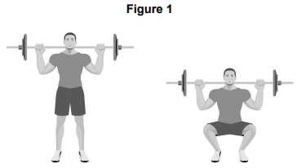

Identify the joint action at the knee as Alex performs the downward phase of the squat.
[1 mark]
Mark scheme
Marks for this question: AO2 = 1

Award one mark for each of the following points up to a maximum of one mark.
- Flexion (1)
Maximum 1 mark

Question 05.4
Identify the main agonist at the knee as Alex performs the downward phase of the squat.
[1 mark]
Mark scheme
Marks for this question: AO2 = 1

Award one mark for each of the following points up to a maximum of one mark.
- Quadriceps (1)
Maximum 1 mark

Question 05.5
Identify the muscular contraction at the knee as Alex performs the downward phase of the squat.
[1 mark]
Mark scheme
Marks for this question: AO2 = 1

Award one mark for each of the following points up to a maximum of one mark.
- Eccentric (1)
Maximum 1 mark

Questions from 8582/1 November 2020 paper

Question 07
Figure 2 shows an individual performing a push-up.

Question 07.1
Using Figure 2, identify what type of muscle contraction is taking place in the arms during the downward phase (A to B) of the push-up.
[1 mark]

Mark scheme
Marks for this question: AO2:1

Award one mark for identifying the type of muscle contraction taking place in the arms during the downwards phase of the push-up.
- Eccentric (1)
Maximum 1 mark

Question 07.2
Using Figure 2, identify the main agonist in the arm during the downward phase (A to B) of the push-up.
[1 mark]

Mark scheme
Marks for this question: AO2:1

Award one mark for identifying the main agonist in the arm during the downwards phase of the push-up.
- Triceps (1)
Maximum 1 mark

Questions from 8582/1 November 2021 paper

Question 09
Figure 1 shows an athlete in two different positions (A and B) as he performs a biceps curl.

Use Figure 1 to help you answer Questions 09.1 to 09.3.

Figure 1

Question 09.1
Identify the joint action taking place at the elbow as the arm moves from A to B.
[1 mark]

Mark scheme
Marks for this question: AO2:1

Award one mark for identifying the joint action taking place at the elbow as the arm moves from A to B.
- Flexion (1)
Maximum 1 mark

Question 09.2
Identify the main antagonist at the elbow as the arm moves from A to B.
[1 mark]

Mark scheme
Marks for this question: AO2:1

Award one mark for identifying the main antagonist at the elbow as the arm moves from A to B.
- Triceps (1)
Maximum 1 mark

Question 09.3
Identify the type of muscle contraction that is taking place at the elbow as the arm moves from A to B.

Mark scheme
Marks for this question: AO2:1

Award one mark for identifying the type of muscle contraction that is taking place at the elbow as the arm moves from A to B.
- Concentric (1)
- Isotonic concentric (1)

NB Do not accept isotonic on its own.
Maximum 1 mark

Appendix 6: Blood vessels

Blood vessel | Pressure | Wall size | Lumen diameter
Artery | High | Thick, muscular | Small
Vein | Low | Thin | Large
Capillary | Low | Very thin | Very small

Appendix 7: Heart diagram

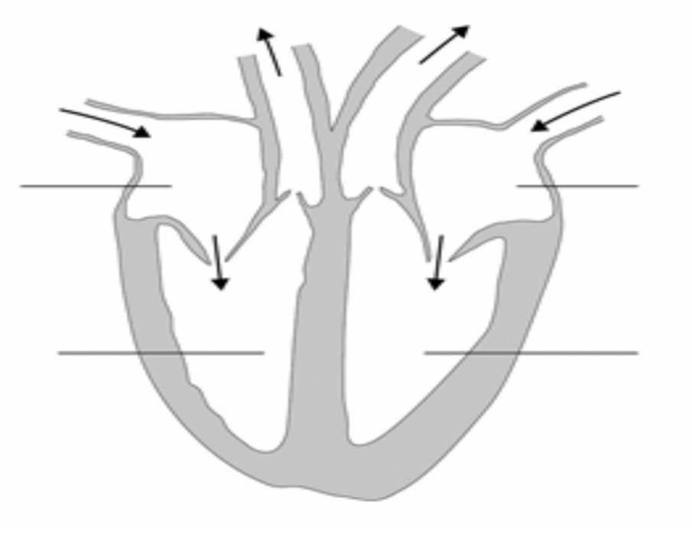
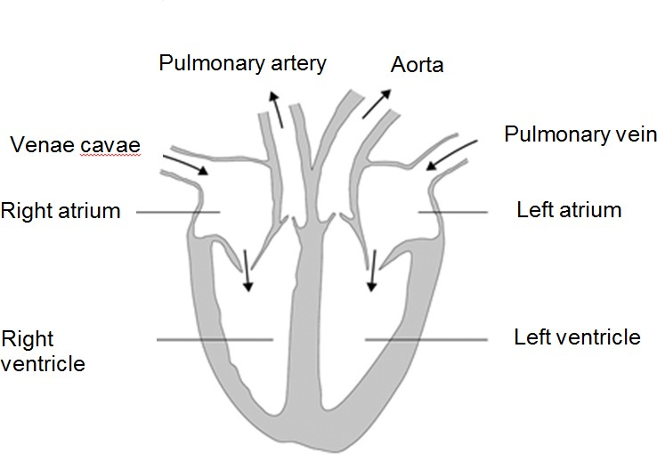

Appendix 8: Example data task

Period of time | Heart rate
At the | 76 bpm
1 minute into exercise | 80 bpm
2 minutes into exercise | 88 bpm
3 minutes into exercise | 105 bpm
4 minutes into exercise | 116 bpm
5 minutes into exercise | 120 bpm
6 minutes into exercise | 120 bpm

Try turning the data in the above table into a line graph using the graph paper below. Work out what the axes labels should be first and then plot the points and connect them together.

Appendix 9: Example of spirometer trace

AQA Preparing to teach, Booklet 4 (2016)

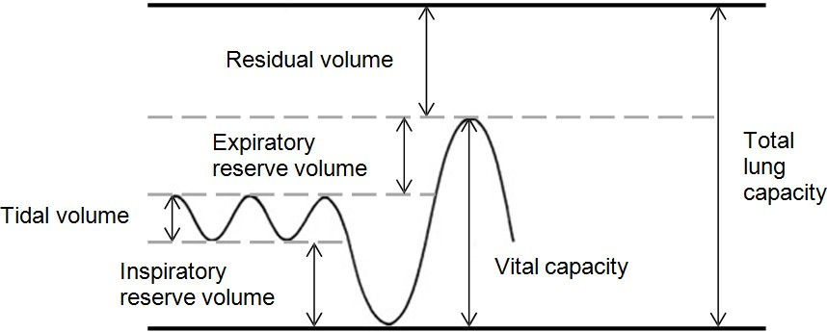

Appendix 10: EPOC/oxygen debt diagram

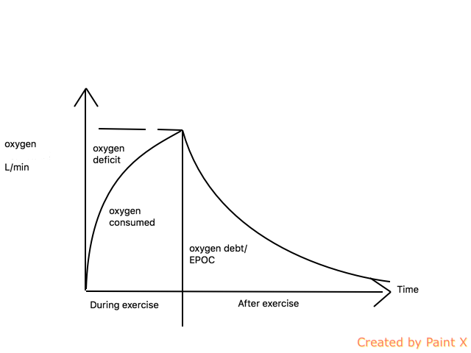

Appendix 11: Planes and axes diagrams
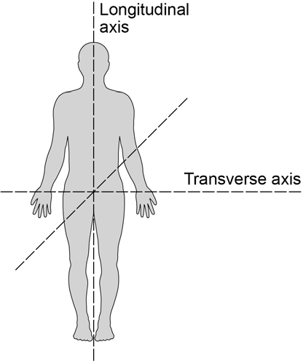
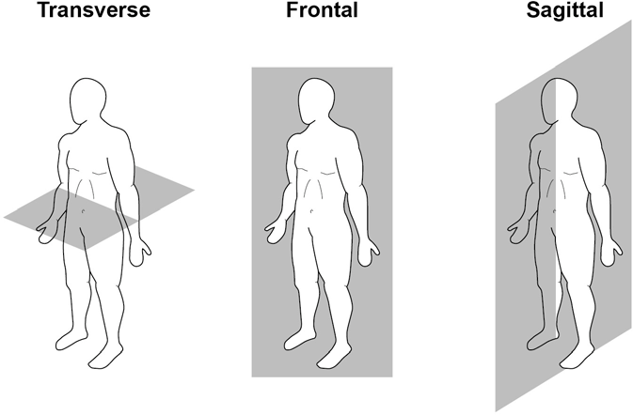
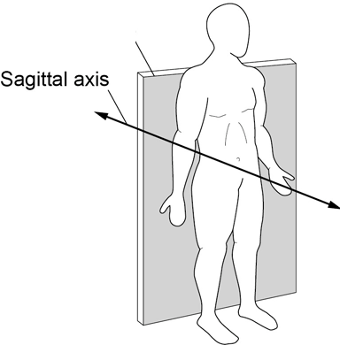
Frontal plane
Appendix 12: Examples of how ‘data’ is used/assessed within the exams

Questions from 8582/2 Sample paper 2018

Question 10
A group of five friends have recently calculated their body mass indexes (BMI) and have researched how to follow a balanced diet. Their current BMI scores are shown in Table 1.

Table 1 – BMI scores of a group of five friends

Friend | Friend 1 | Friend 2 | Friend 3 | Friend 4 | Friend 5
BMI score | 38 | 21 | 29 | 31 | 30

Question 10.1
Analyse the information shown in Table 1 and identify which of the friends are classified as obese. Justify your answer.
[2 marks]

Question 11.3
During one of his training sessions, Amar decided to record his heart rate every two minutes. Some of figures he recorded are shown in Table 2.

Table 2

Time into (minutes) | 12 | 14 | 16 | 18 | 20
Heart rate (BPM) | 128 | 130 | 130 | 132 | 134

If Amar is 20 years old, do the recorded figures suggest that he was working in his aerobic training zone? Justify your answer.
[3 marks]

Question 08.2
Complete Figure 1 by sketching a graph to show the shape of the inverted-U theory in relation to arousal (low to high) and performance (low to high).
[1 mark]

Figure 1 – Inverted-U theory graph
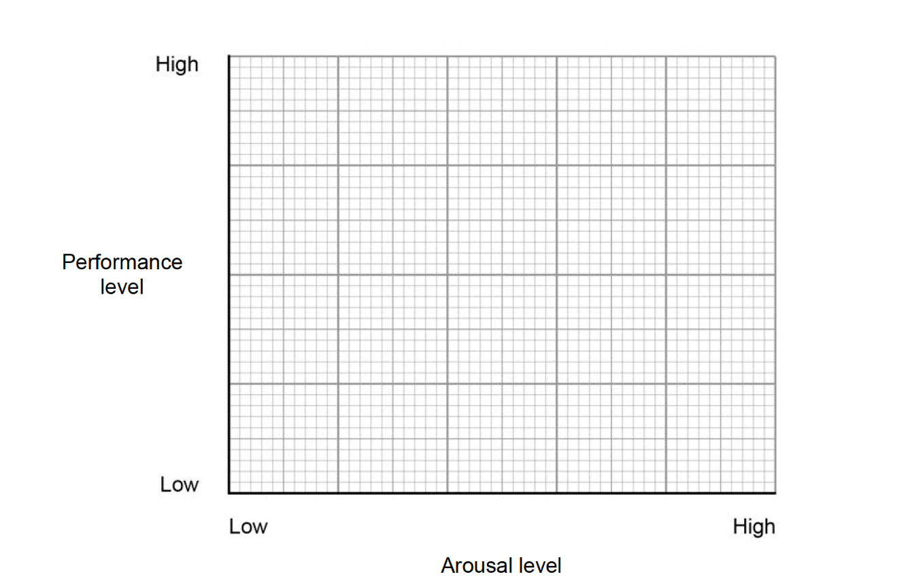

Table 1 shows the redistribution of blood flow during rest and maximal exercise.

Table 1

Destination | Rest | Maximal exercise
Skeletal | 20% | 88%
Brain | 15% | 3%
Heart | 5% | 4%
Skin | 10% | 3%
Liver and intestines | 30% | 1%
Kidneys | 20% | 1%

Question 06.2
At rest the blood flow to the skeletal muscle is 20%. At rest the blood flow to the other organs 80%.

Using the data in Table 1, calculate the blood flow to the other organs at maximal exercise.
[1 mark]

Question 12
Figure 1 shows the participation levels in physical activity of different age groups in England.

Figure 1
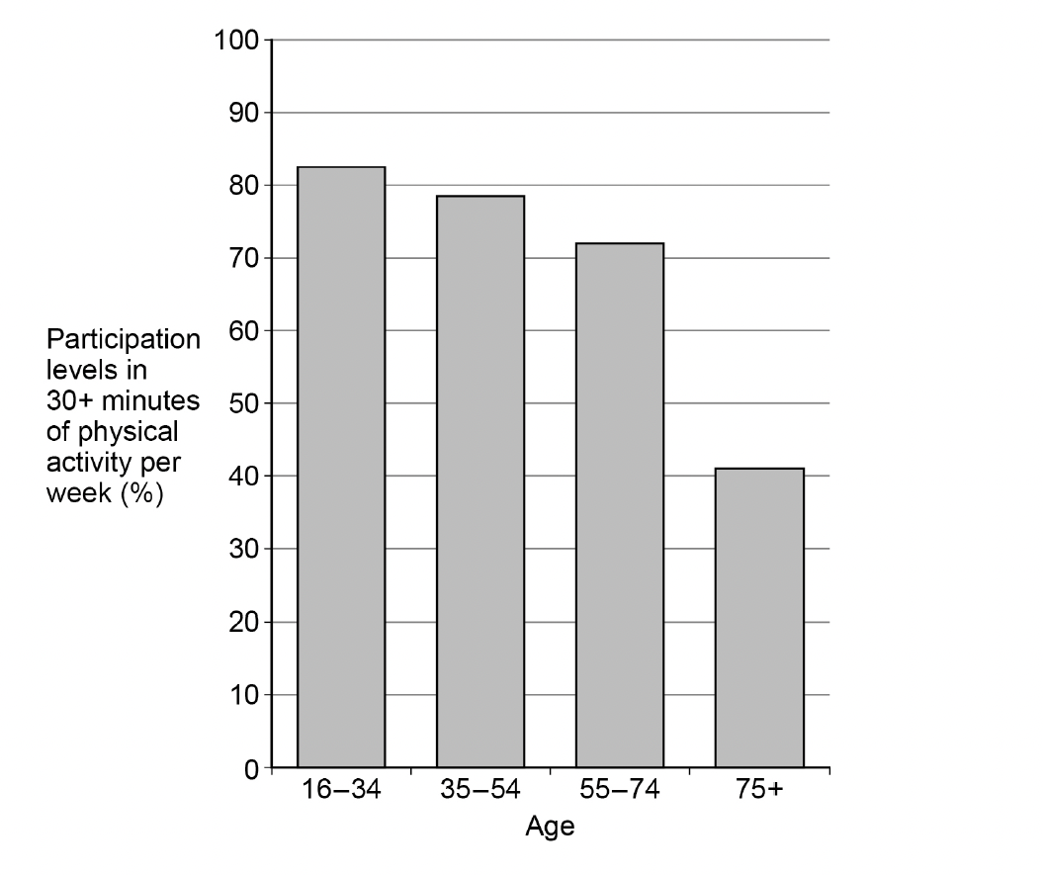
Using Figure 1, analyse the reasons for the participation levels amongst the different age groups.
[9 mark]
Appendix 13: Inverted U diagram
