Applied General Assignment Brief
Unit 6a: Microbiology (PO3 and PO4)
Qualification title | Level 3 certificate and extended certificate in applied science
Unit code | J/507/6502
Unit title | Microbiology

Learner name
Tutor/Assessor name
Assignment Title | Assignment 2 Growth and use of microorganisms
Date assignment issued |  | Submission Date

Performance Criteria
 | Pass | Merit | Distinction
Performance Outcome3 | P6 | M5 | D3
 | P7 | M6 | D4
 | P8 | M7
Performance Outcome4 | P9 | M8 | D5
 | P10 | M9 | D6

Tasks | Performance criteria covered
Task1 | P6(2 hours)
Task2 | P7,P8, M5, M6, M7, D3, D4 (18 hours)
Task3a | P9, M8 (4 hours)
Task3b | P10, M9, D5 (6 hours)
Task3c | D6 (2 hours)
NB P8 and M7 may be incorporated into any one of the Task 2 tasks or carried out independently

Submission Checklist (please insert the items the learner should hand in) | Confirm submission
Task 1
To achieve P1 provide evidence that describes a range of factors (minimum of three) that affect the growth of microorganisms.
Task 2a,2b,2c
For P7 use one suitable technique to count measure microorganisms e.g. use of a haemocytometer (or other suitable technique)and a light microscope to perform a total count of a microorganism such as yeast. This should include a signed observation statement completed by the assessor and possibly visual evidence.
To obtain M6 the technique used must be explained and appropriate calculations performed e.g. correct methodology of establishing total counts of yeast cells using a haemocytometer.
For P8 a serial dilution should be carried out for one practical activity. (This may be carried out independently or as part of one of the three practical activities.) This should include a signed observation statement completed by the assessor and possibly visual evidence.
To obtain M7 use calculations to establish the number of microorganisms in the original sample prior to serial dilution. (This may be carried out independently or as part of one of the three practical activities.) This should include a signed observation statement completed by the assessor and possibly visual evidence.
D3 should provide evidence that conclusions have been drawn about how the three factors have affected the growth of the microorganisms.
By carrying out three practical activities to investigate three factors affecting the growth of microorganisms the M5 will be achieved. This should include signed observation statement(s) completed by the assessor and possibly visual evidence.
For D4 the effectiveness of the measuring /counting techniques used are evaluated and suggestions for improvements made e.g. issues associated with a total count of yeast cells using a haemocytometer.
Task 3a,3b,3c
To achieve P9 describe batch and continuous processing in biotechnological industry.
M8 will be achieved with an explanation of the benefits of an industrial fermenter.
For P10 Describe the use of named microorganisms and the relevant industrial processes or techniques used in two different biotechnological processes.
For M9 explain the benefits to society of the use of microorganisms in the biotechnological industries described
Make a comparison D5 of the relevant industrial processes or techniques used for the two named microorganisms in specific biotechnological industries.
Evaluate the use of genetic engineering of microorganisms in one biotechnological industry for the D6 evidence.
Learner - please confirm that you have proofread your submission

Learner Authentication
I confirm that the work and/or the evidence I have submitted for this assignment is my own. I have referenced any sources in my evidence (such as websites, text books). I understand that if I don’t do this, it will be considered as a deliberate deception and action will be taken.
Learner Signature Date
Tutor declaration
I confirm the learner’s work was conducted independently and under the conditions laid out by the specification. I have authenticated the learner’s work and am satisfied that the work produced is solely that of the learner.
Tutor/Assessor Signature* Date
*Please record any assistance given to the learner beyond the group as a whole even if within the parameters of the specification

For marking purposes only

Marking grid

Performance Criteria (PC) Achieved |  |  |  |  |  |  |  |  | 1stsub* | Resub*
Pass | 1st sub*  / X** | Resub*  / X** | Merit*** | 1st sub*  / X** | Resub*  / X** | Distinction*** | 1st sub*  / X** | Resub*  / X** | Number of PCs achieved | Number  of PCs achieved
P6 |  |  | M5 |  |  | D3
P7 |  |  | M6 |  |  | D4
P8 |  |  | M7
P9 |  |  | M8 |  |  | D5
P10 |  |  | M9 |  |  | D6
Total PCs achieved:

* Sub= submission and Re-sub=Re-submission (Re-submission column to be completed only if the learner has re-submitted the assignment.
** Achieved ( ) Not achieved (X). Please tick or cross for each performance criteria (PC)
*** Distinction and Merit criteria can be achieved only where the associated Merit and Pass criteria have been achieved first.

Tutor summative feedback for learner
(Note to tutors: this section should focus on what the learner has done well. Where a learner has not achieved a specific performance criterion or is likely to want to improve on a response to a performance criterion, then you may identify the issues related to the criterion, but should not provide explicit instructions on how the learner can improve their work to achieve the outstanding criteria.)*
Feedback

Tutor name(print) and date

Resubmission Feedback

Tutor name(print) and date
* All tutor notes should be deleted before the template is used.

Scenario:

You are working as a member of a product development team in the biotechnology laboratories of a global company (Biofutures) in the United Kingdom. You have been tasked with investigating the influence of various factors on the growth of microorganisms and to produce research material in order to promote the use of microorganisms in biotechnology industries.

When carrying out laboratory investigations or producing descriptions/explanations, standard procedures should be followed and written reports produced; which may take various forms (Word documents, posters, leaflets, magazine articles, PowerPoint). Laboratory work requires completed risk assessments and confirmation of the correct use of techniques undertaken (witness confirmation form, together with video/photographic evidence if appropriate).

Activities

TASK 1: PO3: Use practical techniques to investigate factors that affect the growth of microorganisms.
Investigate and describe (P6) a range (minimum three) of factors that affect the growth of microorganisms:
The range could be taken from the following list
- temperature
- pH
- various nutrients
- aerobic/anaerobic
- sterilisation
- irradiation
- osmotic potential
- commercial antimicrobials e.g. in toothpaste, mouthwash
- natural antimicrobials e.g. garlic, honey

Present the evidence in a suitable way in your portfolio (P6).
©iStock.com/curtoicurto

TASK 2a, 2b, 2c: PO3: Use practical techniques to investigate factors that affect the growth of microorganisms.
Following research, tutor demonstration and learner practise counting and measuring microorganisms to include the use of a haemocytometer and the technique of serial dilution. Ensure the evidence presented confirms you have used these techniques correctly when performing the practical work (P7/P8).For the haemocytometer count, the use of the technique must be explained and appropriate calculations performed.(M6) Learners could use a haemocytometer to count yeast cells under the light microscope; a total count should include numbers of both viable and non-viable microorganisms.

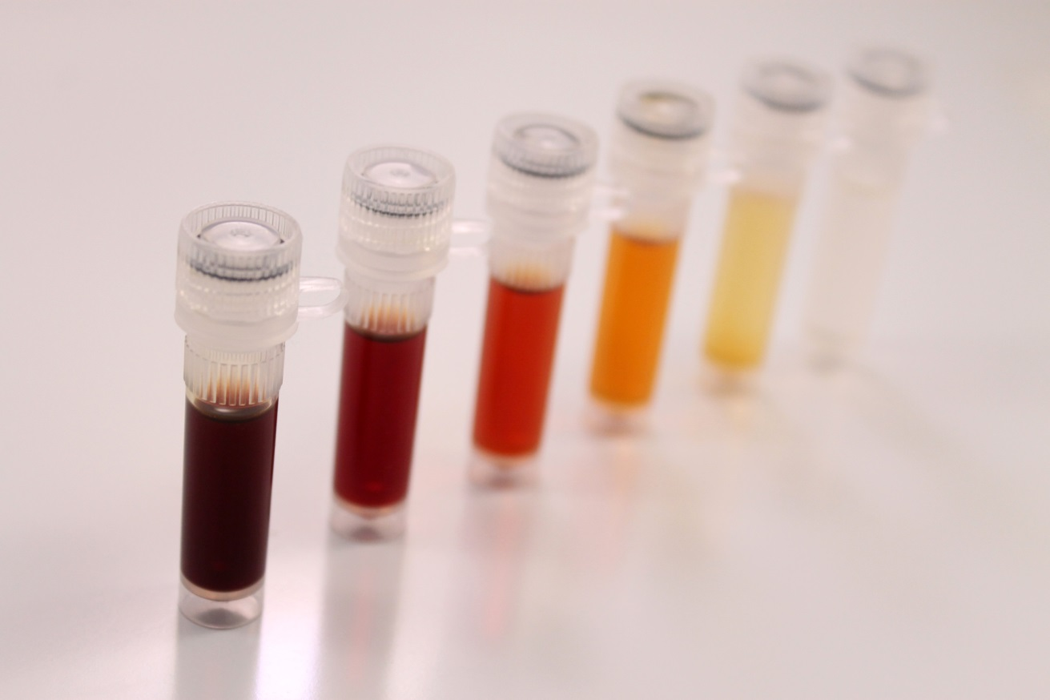
©iStock.com/ValerieVS
For the serial dilution, calculations should be performed to establish the number of microorganisms in the original sample (M7). The effectiveness of the measuring/counting techniques are evaluated, together with proposing justified suggestions for improvement (D4).
NB serial dilution may be part of the three activities or performed as an additional activity.
To achieve the merit grades, perform practical activities to investigate three factors affecting growth (M5) .The distinction grade involves drawing conclusions about how the factors affect growth (D3).
Suggested examples of practical activities include:
- learners prepare lawn plates of bacteria using nutrient agar and place antibiotic discs on the plates the clear zones around the antibiotic discs can be measured after incubation for 48 hours
NB discs can be made from filter paper and a hole puncher and impregnated with any chosen growth factor
  - learners use yeast and pour plates with malt agar to investigate the effect of temperature on growth by placing plates in areas such as the incubator, room temperature, the fridge, a cool place; viable counts (of visible colonies) can be made from the plates after 48 hours.

  - learners use serial dilutions and lawn plates to investigate
number of microorganisms in a set of original cultures of bacteria that have been prepared at different pH values.

Present the evidence in a suitable way in your portfolio.
©iStock.com/10174593_258

TASKS 3a, 3b, 3c: PO4: Identify the use of microorganisms in biotechnological industries
3a: Investigate and describe the main features of:
- batch processing
- continuous processing in biotechnological industry (P9)

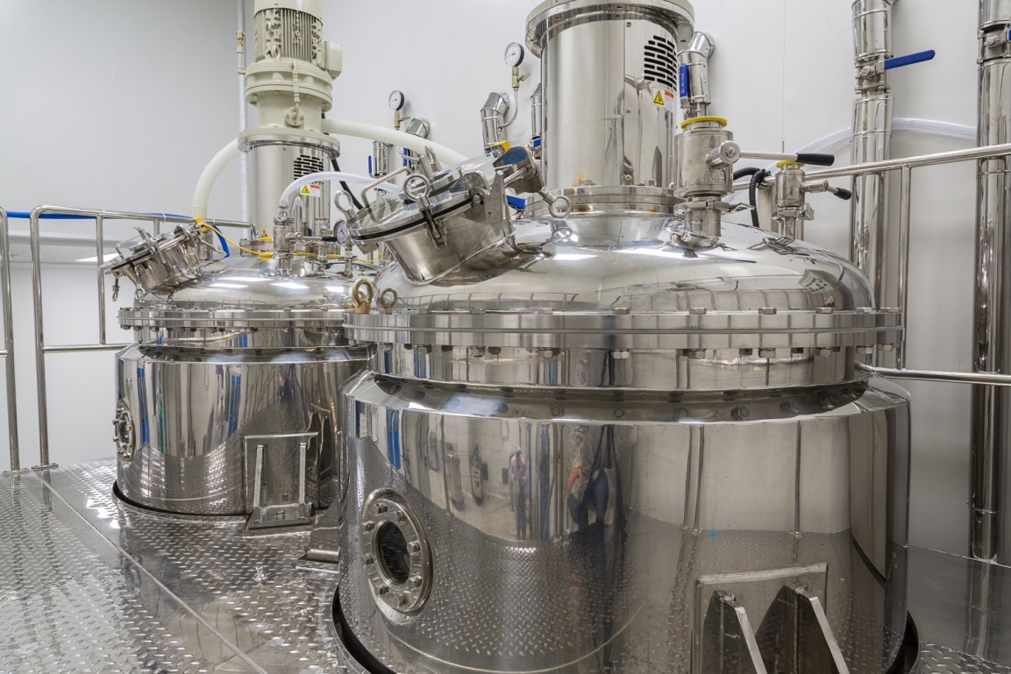
©iStock.com/Traimak_Ivan
Explain the benefits of an industrial fermenter. (M8)
3b: Select two microorganisms that are used in two different biotechnological industries to make two different biotechnology products/processes.
Suggested examples include:
- food technology – cheese, yogurt, beer, wine, bread, vinegar, soy sauce, vitamins, amino acids.
- enzyme production.
- energy resources – gasohol, biogas.
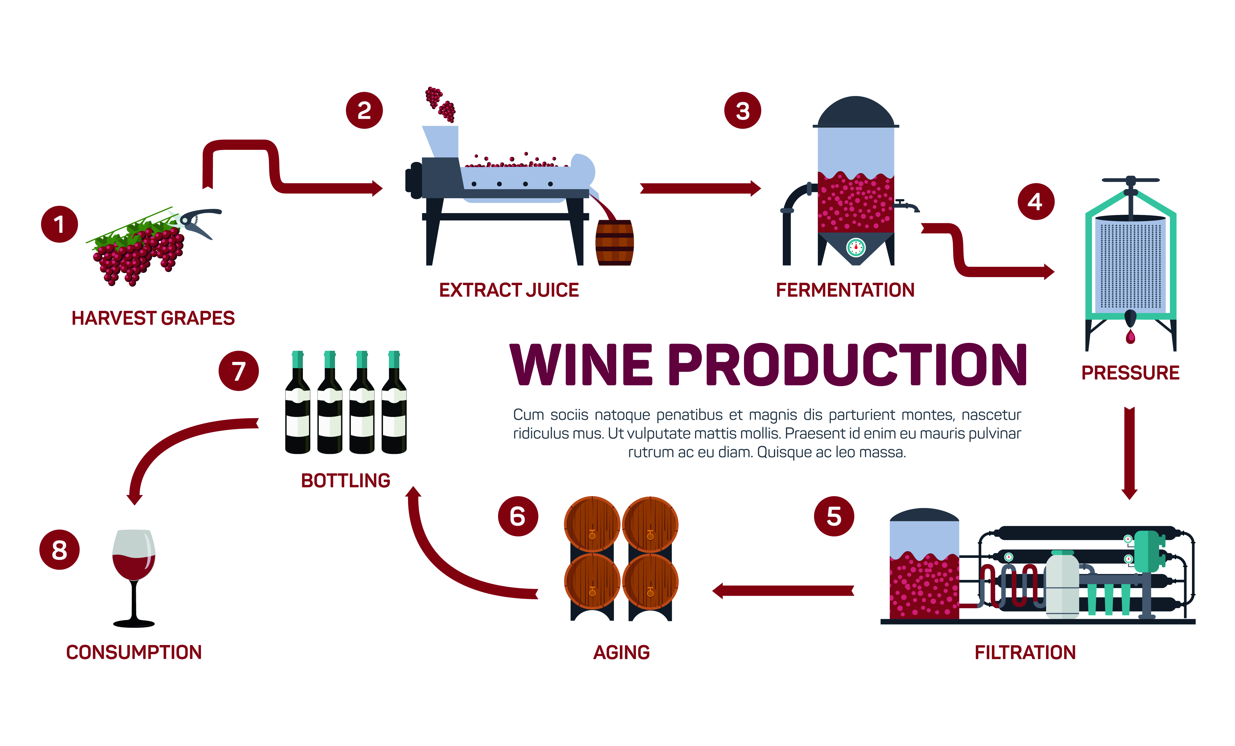
- sewage treatment.
- Bioremediation

©iStock.com/reportman1985

Following selection, describe how your chosen organisms are used (P10). For the merit explain the benefits to society of the uses of these microorganisms (M9). Make a comparison of the two processes or techniques for the distinction (D5).
3c: Select a further biotechnological industry that involves genetic engineering of a microorganism and evaluate its use (D6).
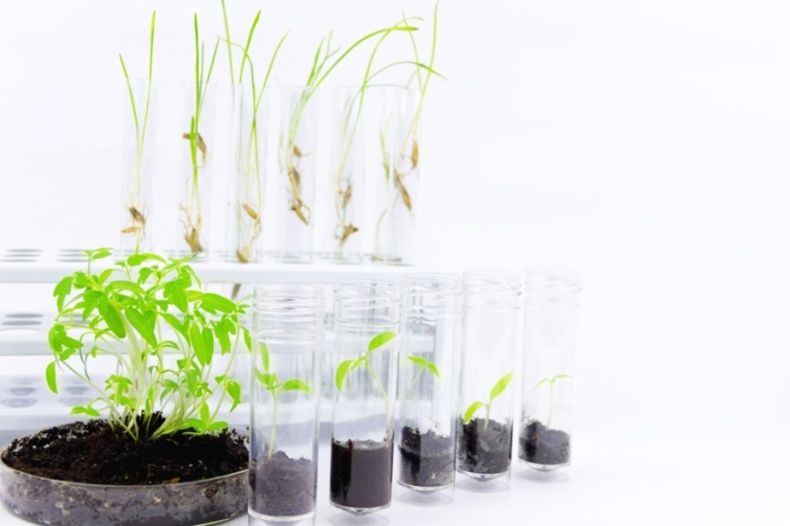

©iStock.com/monstAaa
Present the evidence in a suitable way in your portfolio.

Useful Links
www.microbiologyonline.org.uk/
HomeTeachersResources. Download Basic Practical Microbiology: A Manual

Science Buddies Interpreting Plates

Describe the conditions favourable to the growth of bacteria in food
Microbial Growth: cell number Chapter 6: Microbial Growth
www.lamission.edu/lifesciences/lecturenote/mic20/Chap06Growth.pdf
Serial Dilution in Biology: Calculation, Method & Technique

The Haemocytometer (counting chamber) MicrobeHunter Microscopy

gene technology notes - mrothery.co.uk

Curriculum Resources: Amtech Biotech Experience

BBSRC Post 16 Resources Key Stage 5

Technical Notes
Microbiology Online
Download Basic Practical Microbiology: A Manual. A practical resource book covering health and safety techniques, aseptic techniques, microscopy, Gram staining, pour, streak and spread (lawn) plate methods

Manchester Metropolitan University MMU in the Loop Microbiology Services
An Introduction to Practical Biology: a downloadable PDF which also covers the above basic techniques together with those for cultivating fungi can be found together with accompanying video presentations

