Sample assignment brief

Level 3 Certificate/Extended Certificate in Applied Science

UNIT 6B Medical Physics

Tutor/Assessor name
Assignment title | Assignment 1 Radio-isotopes, Optical fibres and Lasers
Date assignment issued |  | Submission date

Example of grading criteria
 | Pass | Merit | Distinction
Performance  outcome | P7,P8,P9 and P10 | M7,M8 and M9 | D5 and D6

Assessment criteria to be evidence in the tasks provided | Criteria
Task 1 | P7 M7 D5 (6 hours)
Task 2 | P8 M8 (4 hours)
Task 3 | P9 (4 hours)
Task 4 | P10 M9 D6 ((6 hours)

Learner authentication
I confirm that the work and/or the evidence I have submitted for this assignment is my own. I have referenced any sources in my evidence (such as websites, text books). I understand that if I don’t do this, it will be considered as a deliberate deception and action will be taken.

Learner signature Date

Tutor/Assessor signature Date

Scenario:

You are working for a company that deals with the health service throughout the British Isles. This company specialises in equipment and materials that are used for diagnosis and therapy; two of the areas within the company specialise in using radioisotopes and optical fibres.

- Optical fibres have been used in medical devices since the 1960s, when bundled fibres were successfully pioneered for both illumination and imaging.
- Radiotherapy can be used to treat some medical conditions, especially cancer, using radiation to weaken or destroy particular targeted cells.

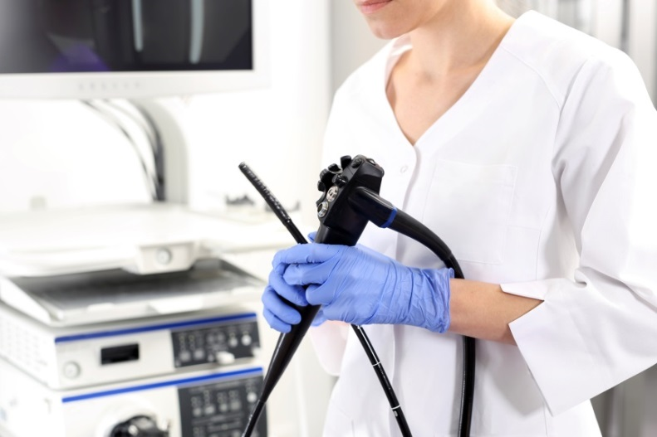

©iStock.com/fotofermer ©iStock.com/akesak

As a new graduate to the company you have been given two research and two practical tasks in order for you to build a foundation of knowledge before you are able to carry out your own research projects.

Activities:

PO3: Demonstrate the ability to work with radioisotopes in the laboratory

Task 1: (P7, M7, D5)
Your project is to work out the half-life of an unknown radioactive source to see if it is suitable for use in medical therapy.

Procedure
Before starting this standard procedure it is important to complete a risk assessment and to adhere to the safety requirements.

- Support the Geiger-Muller (GM) tube holder in a clamp, so that the tube is facing downwards towards the neck of the bottle.

b) Allow the bottle to stand for at least ten minutes. Take the background count by running the counter for at least 30 seconds. This is done with the bottle in position, because some of the count will come from the lower layer. You can do this before the experiment or sometime after it has finished.

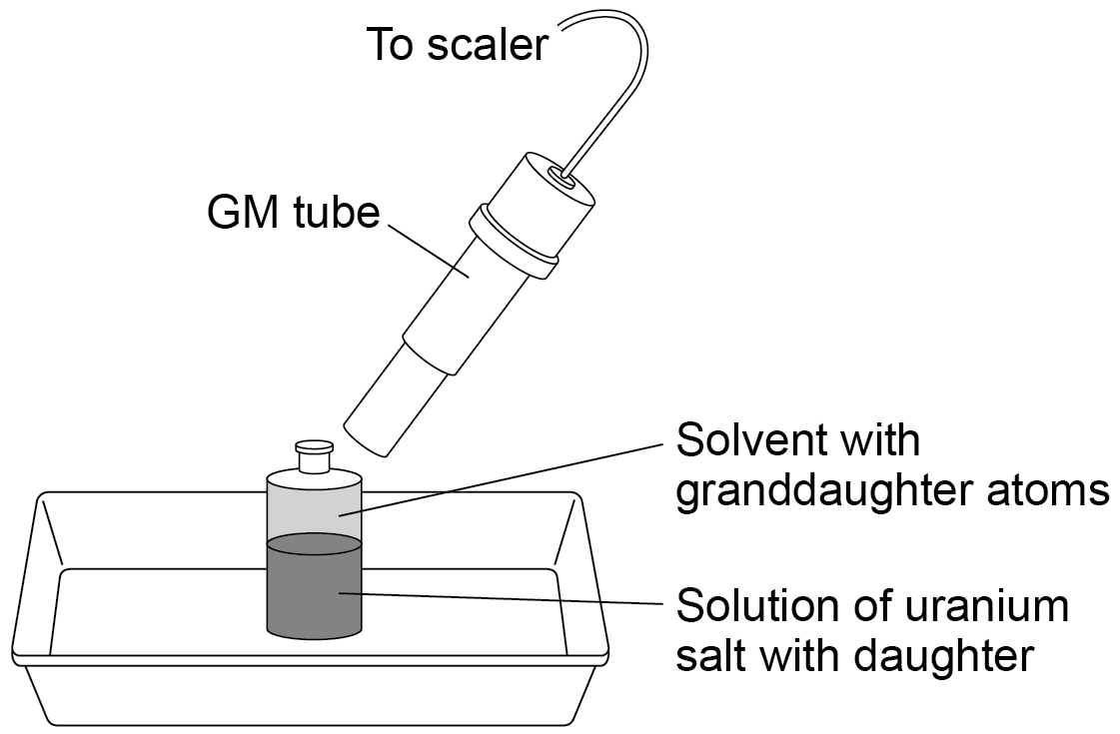

Alternatively, the GM tube can be clamped horizontally with the window close to the upper layer.
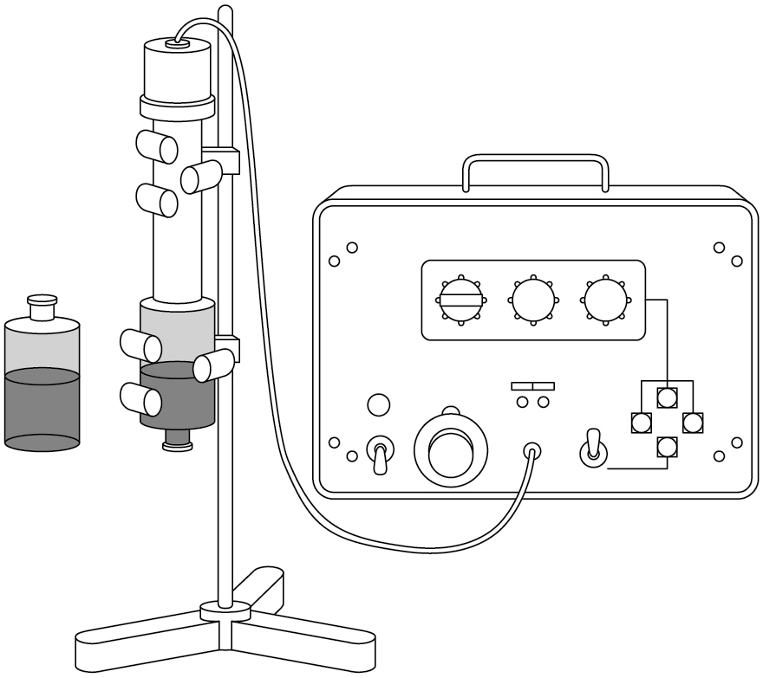

c) Shake the bottle vigorously for about 15 seconds to thoroughly mix the layers.

d) Place the bottle into the tray.

e) As soon as the two layers have separated, start the count and start the stop-clock.

f) Record the time from the beginning of the experiment - i.e. the 'time of day' for the sample.

g) Record the count every 10 seconds. Or record it for 10 seconds every 30 seconds.

h) Run the experiment for about five minutes, ample time to reveal the meaning of the term half-life and to illustrate the decay process.

i) Provided you leave a few minutes between each attempt, you can repeat the experiment. In 5 minutes the activity of the protactinium in the aqueous layer grows to 15/16 of its equilibrium value.

j) It is possible to record the growth to equilibrium. Do this by moving the GM tube so that the aqueous layer at the bottom of the bottle is immediately above the end window of the GM tube. (P7)

Using the results that you have obtained, could this radioisotope be used in medical treatment and why. How and why are other radioisotopes used in medical treatment? (M7)

All radioisotopes emit either alpha (α), beta (β) or gamma (γ) rays or sometimes a mixture; what are the advantages and disadvantages of these different types of emissions in medical treatments. (D5)

For P7, M7 and D5, produce a written report supported by a witness observation.

PO4: Understand the medical uses of optical fibres and lasers

Task 2 (P8, M8)

Part of the research for the company is the structure and function of optical fibres and how they can be applied to medical procedures. Your task is to produce a report, this will have to show correct scientific names and have an index so all the information can be found quickly.

What is the structure of optical fibres and how do they transmit light? What materials are used to make the different layers? Also consider the different types of modes and refraction / reflection. (P8).

Using the information from P8 explain how optical fibres are used for medical treatments (M8).

Task 3 (P9)

This task is to work out the refractive index of different materials; this is an important property that can determine the medical use(s) of these materials.

Before starting this standard procedure it is important to complete a risk assessment and to adhere to the safety requirements.
Apparatus
- rectangular glass or perspex block
- ray box or optics lamp 1 cylindrical lens 1 single slit
- power supply
- leads
- protractor
- A4 plain white paper
- shaded or darkened conditions

Preparation
You will be using Snell’s law to determine values for the refractive index of transparent materials:

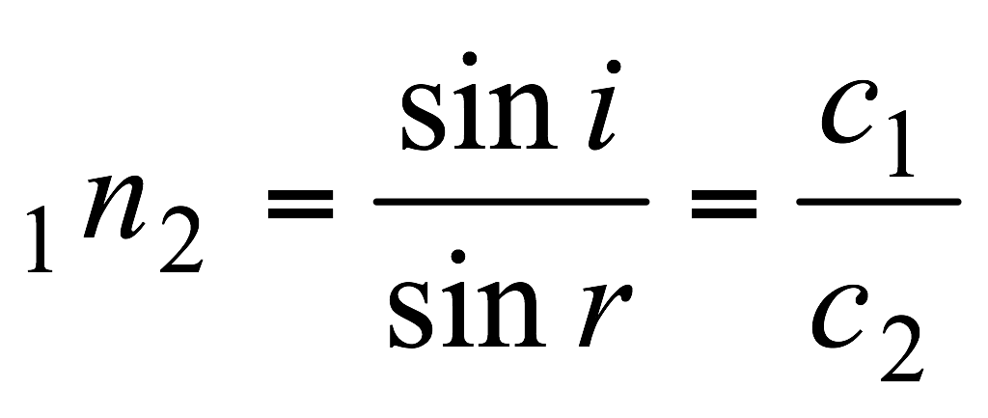

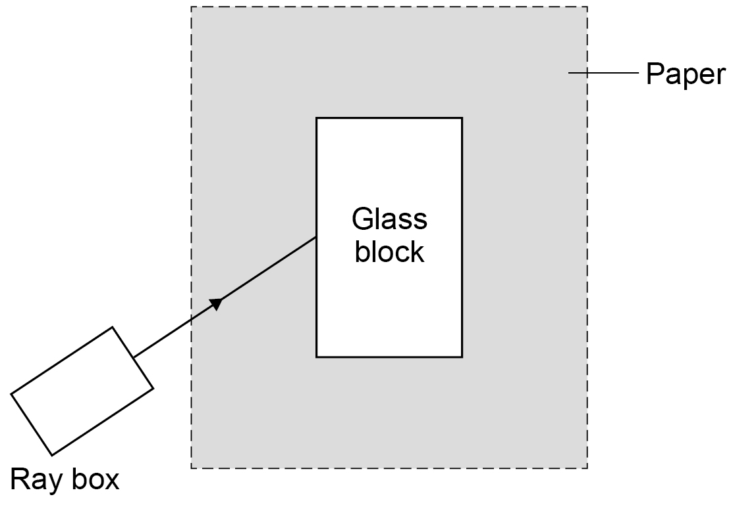
Have a look through the instructions below, and decide how best to record information in a systematic way from the start of this activity.
Safety
Ray boxes become very hot over 30minutes.
Measurements and calculations
Using the apparatus shown above, direct a ray of light to enter the block near the middle of the longest side and to leave by the opposite side crossing directly from one side to the other. As you change the angle of the block to the light, notice the alterations in the direction of the emerging ray.
- Draw round the edges of the block for one arrangement.
- Mark the paths of the light outside the block with a few pencil dots.
- Remove the block and draw in (with a ruler) the path of the ray through the block as a straight line. Use arrows to show which way the light travelled.
- Construct a normal where the ray enters the block and measure i and r.
- Estimate the experimental uncertainty on your measurements of i and r.
Repeat for at least five different angles of incidence. Calculate the refractive index for the material of your block.
Return to your ray diagrams. Measure the angles of incidence and refraction for the ray as it leaves the block. Calculate the refractive index at the exit.

Task 4 (P10, M9, D6)

Laser therapies are medical treatments that use focused light. Laser light is a very special kind of light. Unlike most light sources, it is tuned to very specific wavelengths. This allows it to be focused into powerful beams. Your task is to research two medical conditions where laser light is used as a treatment. Look at two different types of conditions and why laser light is used for them. (P10)

Using the information from P10, explain the scientific principles behind the use of lasers. Explain how it is done, making reference to the scientific principles and type of equipment is used. (M9)

What are the risks and benefits (advantages and disadvantages) of laser and non-laser treatments? Pick one specific medical condition to illustrate this. (D6)

Technical Notes

Measuring the half-life of protactinium

Preparation of the protactinium generator
It is now possible to purchase the chemicals already made up in a sealed bottle. One supplier is TAAB Laboratories Equipment Ltd, 3 Minerva House, Calleva Park, Aldermaston, RG7 8NA. Tel: 0118 9817775. However, you can make your own if you prefer.

These quantities make a total volume of 20 cm³. You can scale them up if you have a larger bottle. (A '30 ml' bottle has a capacity of about 35 ml, so there is still room to shake the solution when the total volume is 30 ml.)

1) Dissolve 1 g of uranyl nitrate in 3 cm³ of water. Wash it into a small separating funnel or beaker with 7 cm³ of concentrated hydrochloric acid.

2) To this solution, add 10 cm³ of iso-butyl methyl ketone or amyl acetate.

3) Shake the mixture together for about five minutes. Then run the liquid into the polypropylene bottle and firmly screw down the cap.

(It can help to shield the lower half of the bottle with some lead)

4) Place the bottle in a tray lined with absorbent paper.

Once you have made the protactinium generator, you can store it with other radioactive materials, taking care to follow your school code of practice and local rules - see the Managing radioactive materials in schools guidance note.

A polypropylene bottle is preferable to polythene because it is somewhat more resistant to attack by the acid and ketone. Nevertheless, polythene bottles can be used, provided no attempt is made to store the liquid in them for more than a few weeks.

The organic layer which separates out contains the protactinium-234. This decays with a half-life of about 70 seconds.

An alternative to protactinium: A new, effective and extremely low hazard system for measuring half-life is available from Cooknell Electronics Ltd, Weymouth, DT4 9TJ. This uses fabric gas mantles designed for camping lights. Each mantle contains a small quantity of radioactive thorium. More details are available on the Cooknell Electronics website.

Teaching notes

1) The chemistry of the experiment.

2) Get the students to make a table of count rate against time, and correct it for background count. The first 10-second reading should be allocated to a time of zero.

3) Get the students to plot a graph of count rate against time. They should draw a smooth curve through the points.

First point out the general pattern - that the count rate decreases with time. Then look for an exponential trend - that the best fit curve always takes the same amount of time to halve.

Get students to measure the half-life from the curve.

Point out the random nature of the points: although the decay follows a pattern, there is an element of randomness and it is not perfectly predictable.

4) How Science Works extension: This experiment provides an opportunity to assess the accuracy of the measured half-life value and how the random nature of decay affects the answer.

The accepted value for the half-life of protactinium is about 70 seconds.

Explore different ways in which a half-life value can be obtained from this apparatus:
- Amend the procedure described above so that, instead of a scaler (counter), a ratemeter is used. One learner just records the time it takes for the count-rate to halve. This will provide a very approximate value.
- Repeat the experiment with several members of the class timing how long it takes for the count-rate to halve. There is likely to be considerable spread in results across the group and the mean result may differ from the accepted value for half-life. In each case, ask learners to identify errors and uncertainties in their measurement(s) and to suggest ways in which these could be reduced.

For example, ask: how does the random nature of the decay affect the measured count-rate when the count is low, or high, compared the background count?

Either you or your learners may suggest a graphical method as an improvement. The procedure described in the main experiment above could then be carried out, and then the accuracy of the half life value assessed and evaluated.

Radioactive materials raise significant safety issues, providing an opportunity to discuss the value and use of secondary data sources.

Measuring refractive index
By tracing rays of light through a rectangular block of transparent material and measuring the angles at the interfaces, use Snell’s law to calculate the refractive index for that material.
Extension
You will have to add a lens to the ray box to make suitable beams of light for this part of the activity.
Go back to your apparatus and find out how a broad beam of light emerges from the block if it enters as:
(a) a parallel beam
(b) a converging beam.
Describe your observations.
Practical advice
Snell’s law of refraction
This is a standard practical method to determine refractive index for glass or perspex.
Students should appreciate that the angles are related to changes in the wave speed.
The calculations give an opportunity for the revision of sine functions and the use of calculators.
Encourage the mathematically timid to write out their calculations line by line.
Some students might find the use of suffixes off-putting so encourage them to treat them as useful labels.
Insist on clear drawings. If this is the students’ first experience of ray diagrams, ground rules need to be made about using rulers and sharp pencils. Check that students can use protractors with precision.
Agree with students beforehand what you require in the way of a written account of this work and its format. We suggest asking them to produce summary notes and diagrams for their own later use.

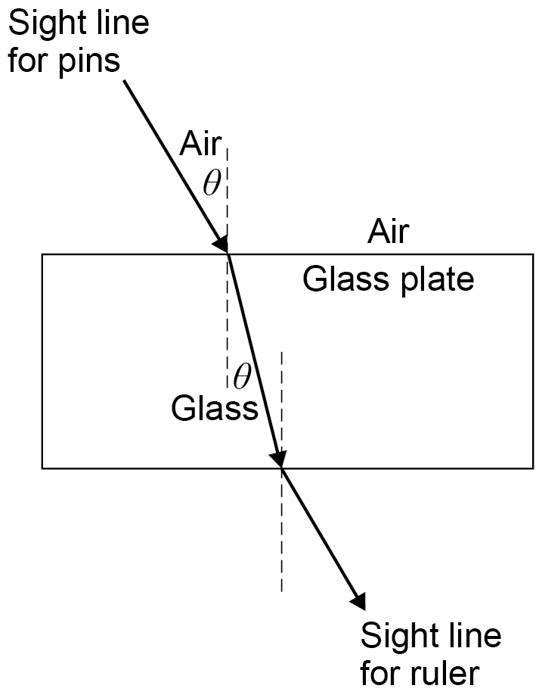

External reference:
This activity is taken from Salters Horners Advanced Physics, section TSOM, activity 22

Submission checklist (please insert the items the learner should hand in) | Confirm submission
Learner - please confirm that you have proofread your submission

