Applied General Assignment Brief
Unit 6c: Organic Chemistry (PO3)

Qualification title | Level 3 certificate and extended certificate in applied science
Unit code | R/507/6504
Unit title | Organic Chemistry

Learner name
Tutor/Assessor name
Assignment Title | Assignment 2 Preparing organic compounds
Date assignment issued |  | Submission Date

Performance Criteria
 | Pass | Merit | Distinction
Performance Outcome 3 | P7 | M6
 | P8 | M7 | D4
 | P9 | M8 | D5
 | P10 | M9 | D6

Tasks | Performance criteria covered
Task1 | P7 M6 (4 hours)
Task2 | P8 P9 M7 M8 D4 D5 (20 hours)
Task3 | P10 M9 D6 (6 hours)

Submission Checklist (please insert the items the learner should hand in) | Confirm submission
Task 1
Produce evidence to show the (four) main techniques that are used in organic chemistry to prepare and purify compounds. Include a diagram of the relevant apparatus, a short description and one example (compound) for each of the four techniques listed in the Specification. (P7)
Give evidence to describe how melting points and boiling points are measured; for example the apparatus used and a brief explanation of how the data are obtained. Give a full description of the effects of impurities on melting point and boiling point and the use of the data as criteria for purity. (M6)
Task 2
Produce evidence for P8 of learner completion of experiments and following SPs to prepare* and purify two different types of organic compounds; complete learner observation and data records and full, complete risk assessments.
(* or, for one compound, extract)
Produce calculations for P9 for percentage yields for each compound made. Tabulated melting point and boiling point data.
NB a specific boiling point determination is expected – a distillation temperature/range is not acceptable
Give evidence that would justify your choice of method. Include references to yield, rate and purity. (M7) Note: This links to the data discussed in M8
Produce evidence that compares your results for the boiling point and yield with researched literature values. (M8)
Produce evidence to compare the method used with those methods used in industry for the two compounds preparared/extracted. (D4)
For one of the compounds prepared choose a suitable spectroscopic technique to identify this compound. Give evidence of a detailed explanation of how this technique is used to assess purity and characterise the compound. (D5)
Task 3
Using the notes from the practical preparations, learners should produce their evidence in two reports (P10), one for each of the preparations, describing the methodology, equipment and outcome from each preparation.
Evidence for (M9) conclusions should be linked to the yields obtained and levels of purity achieved for each compound prepared.
Evidence for (D6) should suggest improvements for increasing the yield and purity of the compounds prepared.
The report will include risk assessments (P8),witness statements confirming that the learner has followed the two SPs successfully and safely, and possibly photographic evidence of the two preparations.
The reports could cover P7, P8, P9, M6, M7, M8, M9, D4 and D5
Learner - please confirm that you have proofread your submission

Learner Authentication
I confirm that the work and/or the evidence I have submitted for this assignment is my own. I have referenced any sources in my evidence (such as websites, text books). I understand that if I don’t do this, it will be considered as a deliberate deception and action will be taken.
Learner Signature Date
Tutor declaration
I confirm the learner’s work was conducted independently and under the conditions laid out by the specification. I have authenticated the learner’s work and am satisfied that the work produced is solely that of the learner.
Tutor/Assessor Signature* Date
*Please record any assistance given to the learner beyond the group as a whole even if within the parameters of the specification

For marking purposes only

Marking grid

Performance Criteria (PC) Achieved |  |  |  |  |  |  |  |  | 1stsub* | Resub*
Pass | 1st sub*  ✓ / X** | Resub*  ✓ / X** | Merit*** | 1st sub*  ✓ / X** | Resub*  ✓ / X** | Distinction*** | 1st sub*  ✓ / X** | Resub*  ✓ / X** | Number of PCs achieved | Number  of PCs achieved
P7 |  |  | M6
P8 |  |  | M7 |  |  | D4
P9 |  |  | M8 |  |  | D5
P10 |  |  | M9 |  |  | D6
Total PCs achieved:

* Sub= submission and Re-sub=Re-submission (Re-submission column to be completed only if the learner has re-submitted the assignment.
** Achieved (✓) Not achieved (X). Please tick or cross for each performance criteria (PC)
*** Distinction and Merit criteria can be achieved only where the associated Merit and Pass criteria have been achieved first.

Tutor summative feedback for learner
(Note to tutors: this section should focus on what the learner has done well. Where a learner has not achieved a specific performance criterion or is likely to want to improve on a response to a performance criterion, then you may identify the issues related to the criterion, but should not provide explicit instructions on how the learner can improve their work to achieve the outstanding criteria.)*
Feedback

Tutor name(print) and date
Resubmission Feedback

Tutor name(print) and date

*All tutor notes should be deleted before the template is used

Scenario:

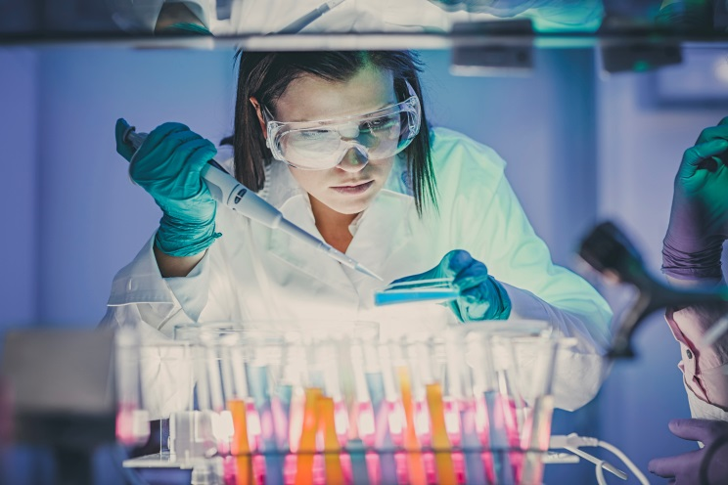
You are working for J & M Pharmaceuticals who as well as developing and manufacturing a variety of pharmaceuticals, work with the forensic services to help identify different kinds of chemicals. Part of the identification process is to prepare, purify and assess the purity of many types of organic compounds. These are used as standards by which unknown chemicals are compared and could be used by the Crown Prosecution Service (CPS).

©iStock.com/poba

As a new member of staff you need to get to know the processes by which new chemicals are prepared and developed.

Health and safety is an important issue and a risk assessment must be prepared for every stage of the preparations. Other aspects that need to be considered are:

- equipment
- chemicals used
- preparative method
- yield of compound
- purity of compound
- comparison to known values

You have been given two different types of organic chemicals to prepare; this includes assessing the purity, calculating percentage yield and writing accurate reports on each of the preparations.

When carrying out laboratory investigations, standard procedures should be followed and laboratory workbooks used to record your findings. The Witness Confirmation form should indicate that you have carried out both chemical investigations. Records should include a full account of the results obtained as well as calculations for the yield and purity.

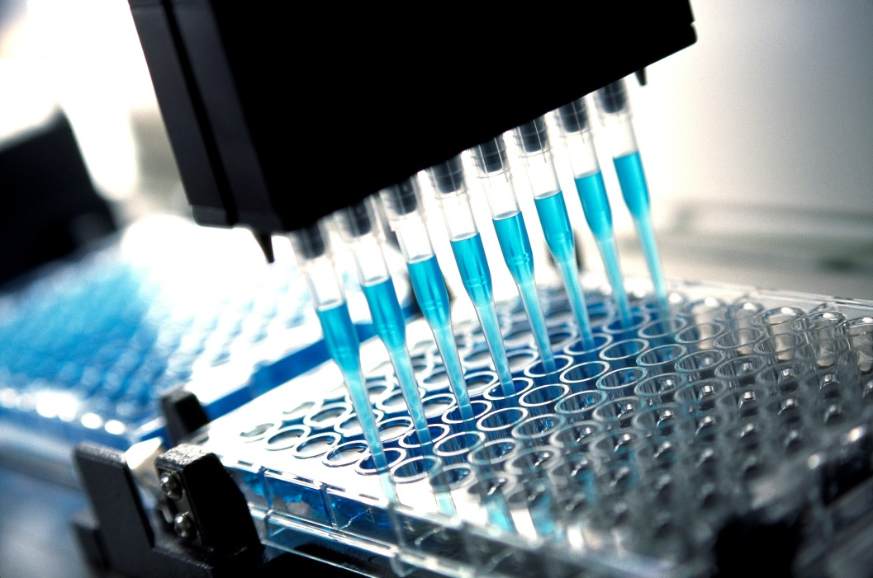
©iStock.com/DavidBGray

Activities

For each task carried out learners are encouraged to keep notes for completing any final report.

PO3: Prepare organic compounds
Task 1
P7, M6

What standard techniques are used in organic chemistry to prepare and purify compounds? Use an organic compound as an example to describe each type of technique that would be used. (P7)

Melting points and boiling points are used to assess the purity of compounds. Describe how melting points and boiling points are measured; for example the apparatus used and how accurate the results are. Give a full description of the effects of impurities on melting point and boiling point (M6)

Task 2
P8, P9, M7, M8, D4, D5

To prepare a sample of aspirin

Equipment and apparatus
Part 1
- salicylic acid
- 100 cm³ conical flask
- 10 cm³ measuring cylinder
- ethanoic anhydride
- concentrated sulfuric acid in a dropping bottle
- 400 cm³ beaker
- Tripod, gauze and Bunsen burner
- Thermometer (-10 ºC to 110 ºC)
- 250 cm³ beaker
- Reduced pressure filtration apparatus
- Filter paper
- Glass stirring rod
- Deionised or distilled water in a wash bottle
- Spatula

Part 2

- 25 cm3 measuring cylinder
- Boiling tube
- ethanol
- Thermometer (-10 oC to 110 oC)
- Deionised or distilled water in a wash bottle
- 250 cm3 beaker
- 100 cm3 conical flask
- Glass stirring rod
- A kettle

The aim of this experiment is to prepare a sample of aspirin

Introduction

Aspirin is prepared by the acylation of salicylic acid (2-hydroxybenzenecarboxylic acid) using ethanoic anhydride as the acylating agent.

The reaction can be represented as follows.

HOOCC₆H₄OH + (CH₃CO)₂O ==> HOOCC₆H₄OCOCH₃ + CH₃COOH
salicylic acid + ethanoic anhydride ==> aspirin + ethanoic acid

Aspirin (2-ethanoylhydroxybenzenecarboxylic acid) is an antipyretic drug (reduces fever by lowering body temperature) and an analgesic (relieves pain).
Aspirin does not react in the acidic conditions in the stomach, but is hydrolysed in the alkaline conditions found in the intestines to produce ethanoate ions and salicylate

(2-hydroxybenzencarboxylate) ions. Salicylates lower the body temperature of feverish patients and have a mild analgesic effect relieving headaches and other pain. The toxic dose is relatively high, but symptoms of poisoning can occur with quite small quantities.

Experiment

It is the responsibility of the learner to carry out and be responsible for their own safety risk assessment (and agreed as appropriate by the Centre) before carrying out this experiment. Wear safety glasses at all times. Assume that all of the reagents and liquids are toxic, corrosive and flammable. (P8)

Part 1
The preparation

a) Weigh out approximately 6.00 g of salicylic acid directly into a 100 cm³ round bottomed flask.

b) Record the mass of salicylic acid used.

c) Using a 10 cm³ measuring cylinder, add 10 cm³ of ethanoic anhydride to the flask and swirl the contents.

d) Add 5 drops of concentrated sulfuric acid to the flask and swirl the mixture in the flask for a few minutes to ensure thorough mixing.

e) Put a reflux condenser on the flask and warm gently using a hot water bath for 20 minutes at approximately 60 ºC The temperature in the flask should not be allowed to rise above 65 ºC. Alternatively, a thermostatically controlled mantle may be used.

f) Allow the flask to cool and pour its contents into 75 cm³ of water in a beaker, stirring well to precipitate the solid.

g) Filter off the aspirin under reduced pressure using a Buchner funnel and flask, avoiding skin contact. Wash the product with a little cold water.

h) Collect the crude aspirin on a double thickness of filter paper and allow it to dry. Record the mass of the crude product.

Purification

i) Using a 25 cm³ measuring cylinder, measure out 15 cm³ of ethanol into a 100 ml conical flask..

j) Prepare a beaker half-filled with hot water at a temperature of approximately 75 ºC (or use a hot water bath at the same temperature). The safest way to do this is to use a kettle of boiling water and add water from the kettle to cold water in the beaker until the temperature is at approximately 75 ºC.
N.B. The boiling point of ethanol is 78 ºC and the temperature of the water in the beaker or bath should not be allowed to go above this.

k) Use a spatula to add the crude aspirin to the conical flask and place the tube in the beaker of hot water or on the water bath.

l) Swirl the contents of the flask until all of the aspirin dissolves into the ethanol.
[Note: If necessary (ie if solid, undissolved materials is present) the solution should be filtered hot, but this stage is not expected in this preparation)

m) Pour the hot solution containing dissolved aspirin into approximately 40 cm³ of water in a 100 cm³ conical flask. If a solid separates at this stage, gently warm the contents of the flask in the water bath

until solution is complete. You should avoid prolonged heating, since this will decompose the aspirin. Allow the conical flask to cool slowly and white needles of aspirin should separate.
If no crystals have formed after the solution has cooled to room temperature, you may need to use an ice bath and to scratch the insides of the flask with a glass stirring rod to obtain crystals.

n) Filter off the purified solid under reduced pressure and allow it to dry completely on filter paper.
Record the mass of the dry, purified solid. (P8)

Justify your choice of method. Include references to yield, rate and purity. (M7)

Calculate the percentage yield of aspirin from your experiment and carry out a melting point determination to assess purity. (P9)

Compare your results for the melting point and yield obtained with researched literature values. (M8)

Consider the reasons why the alternative preparative method which uses ethanoyl chloride rather than ethanoic anhydride, is not favoured by industry even though this alternative method has a higher yield (D4)

To prepare an ester

www.sciencemadness.org/talk/files.php?pid=399042&aid=38599

Equipment and apparatus
- goggles
- gloves
- ethanol
- glacial ethanoic acid
- concentrated sulphuric acid
- 10ml measuring cylinders
- two Quickfit round bottomed flasks, reflux condenser, stillhead, receiver adapter
- bosses and clamps; retort stands
- anti-bumping granules
- separating funnel
- heating mantle (or oil bath)
- 0-100ºC thermometer
- small conical flask, funnel and fluted filter paper
- anhydrous granular calcium chloride
- sodium carbonate solution

Theory:

Ethyl ethanoate (ethyl acetate) is an ester. The general method of ester preparation can be summarised as the reversible reaction: ‘acid + alcohol → ester + water’. Concentrated sulphuric acid is used to catalyse the reaction and to remove water from the right hand side of the equilibrium, increasing the yield of ester.

CH₃COOH + C₂H₅OH → CH₃COOC₂H₅ + H₂O

Calcium chloride removes water by forming a series of hydrates; it also reacts with alcohols to form similar compounds, and can thus remove unchanged ethanol in the crude ethyl ethanoate. The calcium chloride solution added first in step 6 reacts with excess ethanol, when the solid is added in step 7 it removes water.

Safety:
- Wear goggles and a lab coat. Use gloves for handling organic reagents.
- Perform experiment in a fume cupboard if available.
- When concentrated sulphuric acid is mixed with ethanol considerable heat is evolved - add it slowly and carefully.
- Glacial ethanoic acid is an irritant and can cause burns.
- prepare risk assessment before starting any experiments. (P8)
- It is the responsibility of the learner to carry out and be responsible for their own safety risk assessment (and checked and agreed as appropriate by the Centre) before carrying out this experiment. Wear safety glasses at all times. Assume that all of the reagents and liquids are toxic, corrosive and flammable

Method:

- Pour 10cm³ of ethanol and 10cm³ glacial ethanoic acid into a 100cm³ round bottomed flask. Carefully add 5cm³ concentrated sulphuric acid slowly and with swirling . Add some anti-bumping granules.

- Set up the apparatus for reflux and heat gently using a heating mantle for about 10 minutes. (Alternatively, use an oil bath as the heating method)

- Set up the apparatus for distillation with a 0-100ºC thermometer and distil off about two thirds of the mixture into a small conical flask to receive the ester.

Purification of ethyl ethanoate

- Pour the distillate into a separating funnel and wash with 20cm³ saturated aqueous sodium carbonate solution. CARE – invert the funnel at intervals and open the tap to release pressure due to the carbon dioxide released at this stage
Discard the lower aqueous layer.
- Shake the impure ester in the funnel with a solution made by dissolving 10g hydrated calcium chloride in 10cm³ water. Separate and discard the lower layer.

- Run the ethyl ethanoate into a small conical flask and stand the ester over a few lumps of anhydrous calcium chloride until the liquid clears – 20 minutes. The liquid may then be filtered or decanted, and distilled in clean dry Quickfit. Collect the fraction boiling over in the range 74-79 C.

- Perform a boiling point test on the distillate and record your boiling point. (P8)

Record your boiling point and melting point in an appropriate way. Record your yield for each preparation and calculate percentage yields. (P9)

- Justify your choice of method. Include references to yield, rate and purity. (M7)
- Compare your results for the boiling point and yield with researched literature values. (M8)
- Compare the method used with the methods used in industry for the preparation of these two compounds. (D4)
- For one of the compounds prepared choose a suitable spectroscopic technique to identify this compound. Give a detailed explanation of how it is used to assess purity and to identify/characterise the compound. (D5)

Task 3

P10, M9, D6

Using the notes from the practical preparations, learners should produce two reports (P10) on each of the preparations describing the methodology, equipment and outcome from each preparation. For (M9) conclusions should be linked to the yields obtained and levels of purity achieved for each compound prepared. For (D6) suggested improvements for increasing the yield and purity of the compounds prepared should be made.

The report could include risk assessments (P8), any witness statements and photographic evidence.

The reports could cover P7, P8, P9, M6, M7, M8, M9, D4 and D5

