GCSE Combined science: Required practical handbook

Version 3.8

The methods provided in this Required practical handbook are suggested examples, designed to help your students fulfil the Apparatus and Techniques requirements outlined in the specifications. Written papers will include questions requiring knowledge gained from carrying out the specified practicals.
Please note: it is the Apparatus and Techniques requirements which are compulsory and must be fulfilled. Teachers are encouraged to adapt or develop activities, resources and contexts to suit their equipment and provide the appropriate level of engagement and challenge for their own students.

Contents
Introduction | 2 | Electrolysis | 70
The practical science statement | 3 | Temperature changes | 76
Apparatus and techniques | 4 | Rates of reaction | 81
Suggested practical apparatus list | 6 | Chromatography | 89
Risk assessment | 9 | Water purification | 95
Required practicals summary | 9 | Specific heat capacity | 101
Microscopy | 18 | Resistance | 108
Osmosis | 25 | I-V characteristics | 116
Enzymes | 30 | Density | 123
Food tests | 36 | Force and extension | 131
Photosynthesis | 47 | Acceleration | 136
Reaction time | 52 | Waves | 143
Field investigations | 56 | Radiation and absorption | 151
Making salts | 64

Introduction

Students need to undertake the required practical activities listed in the GCSE Combined science specifications (8464 and 8465) so that they have the opportunity to experience all of the apparatus and techniques required by Ofqual.

In this guide we suggest methods and activities for carrying out the required practical activities to help you plan the best experience for your students.

All of the activities we describe have been written and trialled by practising teachers and use apparatus and materials that are commonly available in most schools.

Why do practical work?

Practical work is at the heart of science – that’s why we have placed it at the heart of each of our GCSE science specifications.

There are three separate, but interconnected, reasons for doing practical work in schools.

- To support and consolidate scientific concepts. Doing practical work enables students to make sense of new information and observations, and provides them with insights into the development of scientific thinking.

- To develop investigative skills. These transferable skills include:
- devising and investigating testable questions
- identifying and controlling variables
- analysing, interpreting and evaluating data.

- To build and master practical skills such as:
- using specialist equipment to take measurements
- handling and manipulating equipment with confidence and fluency
- recognising hazards and planning how to minimise risk.

This guide signposts opportunities for developing these working scientifically skills (WS). Working scientifically is explained in more detail in the GCSE Biology specification on page 9. There are blank spaces in the student sheets for students to write down the learning outcomes for each required practical activity.

Helping you to plan

This guide includes:
- teachers’ notes providing information and tips on setting up and running practicals
- technical information providing guidance for technicians preparing for the practicals
- student sheets providing a possible method for students to carry out the practical.

The student sheets contain a blank space for students to add the learning outcomes. It is your choice as to what outcomes you choose as the focus for your practical lesson. By focusing on the reasons for carrying out a particular practical, you will help your students to:
- understand the subject better
- develop the skills of a scientist
- master the manipulative skills required for further study or jobs in STEM subjects.

At least 15% of the marks in the written exams will draw on the knowledge and understanding students have gained by carrying out the required practical activities. It is therefore essential that you plan your practical activities with reference to the specification and make students aware of the key content that they need to learn.

You can find examples of the type of practical questions students can expect in our guide, Practicals in exams.

We have designed the methods in this guide specifically to help your students fulfil the apparatus and techniques requirements outlined in the specification. We encourage you to adapt or develop these activities, resources and contexts to suit your circumstances and to tailor the level of engagement and challenge to your students. To help you do this, we’ve provided the guide in Word.

The practical science statement

Unlike the A-levels, there will be no practical endorsement. Instead, we will provide the head of each school or college a Practical science statement to sign confirming that reasonable steps have been taken to secure that each student has:
- completed the required practical activities detailed in the specification
- made a contemporaneous record of such work done during the activities and the knowledge, skills and understanding derived from those activities.

The head of centre will need to return the signed statement to us by the date we will publish on our website, on our practicals page. We will also contact schools and colleges directly with the deadline date and send timely reminders if we don’t receive the form. Failure to send this form counts as malpractice/maladministration, and may result in formal action or warning for the school or college.

Not having done some of the practicals, despite the school’s best efforts, will not stop a student from entering for the GCSE. However, it may affect their grade, because there may be questions in the exams that they won’t be able to answer.

Apparatus and techniques

The following table lists the combined science Apparatus and techniques (AT). Students must be given the opportunity to experience all of these during their GCSE Combined science course, regardless of the awarding body whose specification they study. The list includes opportunities for choice and use of appropriate laboratory apparatus for a variety of experimental problem-solving and/or enquiry-based activities.

Use and production of appropriate scientific diagrams to set up and record apparatus and procedures used in practical work is common to all science subjects and should be included wherever appropriate.

Where possible, we have added links to the Apparatus and techniques in our A-level science courses, to show how the skills progress from GCSE to A-level.

 | Apparatus and techniques (Biology)
AT 1 | Use of appropriate apparatus to make and record a range of measurements accurately, including length, area, mass, time, temperature, volume of liquids and gases, and pH (links to A-level AT a).
AT 2 | Safe use of appropriate heating devices and techniques including use of a Bunsen burner and a water bath or electric heater (links to A-level AT a).
AT 3 | Use of appropriate apparatus and techniques for the observation and measurement of biological changes and/or processes.
AT 4 | Safe and ethical use of living organisms (plants or animals) to measure physiological functions and responses to the environment (links to A-level AT h).
AT 5 | Measurement of rates of reaction by a variety of methods including production of gas, uptake of water and colour change of indicator.
AT 6 | Application of appropriate sampling techniques to investigate the distribution and abundance of organisms in an ecosystem via direct use in the field (links to A-level  AT k).
AT 7 | Use of appropriate apparatus, techniques and magnification, including microscopes, to make observations of biological specimens and produce labelled scientific drawings (links to A-level AT d and e).
 | Apparatus and techniques (Chemistry)
AT 1 | Use of appropriate apparatus to make and record a range of measurements accurately, including mass, time, temperature, and volume of liquids and gases (links to A-level AT a).
AT 2 | Safe use of appropriate heating devices and techniques including use of a Bunsen burner and a water bath or electric heater (links to A-level AT b).
AT 3 | Use of appropriate apparatus and techniques for conducting and monitoring chemical reactions, including appropriate reagents and/or techniques for the measurement of pH indifferent situations (links to A-level AT a and d).
AT 4 | Safe use of a range of equipment to purify and/or separate chemical mixtures including evaporation, filtration, crystallisation, chromatography and distillation (links to A-level AT d and g).
AT 5 | Making and recording of appropriate observations during chemical reactions including changes in temperature and the measurement of rates of reaction by a variety of methods such as production of gas and colour change (links to A-level AT a and l).
AT 6 | Safe use and careful handling of gases, liquids and solids, including careful mixing of reagents under controlled conditions, using appropriate apparatus to explore chemical changes and/or products (links to A-level AT a and k).
AT 7 | Use of appropriate apparatus and techniques to draw, set up and use electrochemical cells for separation and production of elements and compounds (links to A-level AT d and j).
 | Apparatus and techniques (Physics)
AT 1 | Use of appropriate apparatus to make and record a range of measurements accurately, including length, area, mass, time, volume and temperature. Use of such measurements to determine densities of solid and liquid objects (links to A-level AT a and b).
AT 2 | Use of appropriate apparatus to measure and observe the effects of forces including the extension of springs (links to A-level AT a).
AT 3 | Use of appropriate apparatus and techniques for measuring motion, including determination of speed and rate of change of speed (acceleration/deceleration) (links to A-level AT a, b and d).
AT 4 | Making observations of waves in fluids and solids to identify the suitability of apparatus to measure speed/frequency/wavelength. Making observations of the effects of the interaction of electromagnetic waves with matter (links to A-level AT i and j).
AT 5 | Safe use of appropriate apparatus in a range of contexts to measure energy changes/ transfers and associated values such as work done (links to A-level AT a, b).
AT 6 | Use of appropriate apparatus to measure current, potential difference (voltage) and  resistance, and to explore the characteristics of a variety of circuit elements (links to  A-level AT f).
AT 7 | Use of circuit diagrams to construct and check series and parallel circuits including a variety of common circuit elements (links to A-level AT g).

Suggested practical apparatus list

Through their study of the new GCSE Sciences students must be given the opportunity to experience a wide range of apparatus. Hands-on experience will help them acquire the practical skills defined by the DfE in their apparatus and techniques criteria.

We have designed all the activities to use standard equipment and materials that can be found in most school laboratories. The lists are not exhaustive, and we encourage teachers to modify the activities to suit their students’ needs and learning objectives, and the resources available in their school/college.

Lab equipment

- 100 cm³ beakers
- 100 cm³ conical flasks
- 100 cm³ measuring cylinders
- 10 cm³ measuring cylinders
- 10 cm³ plastic syringes
- 12 V, 24 W lamps (eg ray box lamps)
- 1kg copper, iron and aluminium metal blocks (each with two holes – one for heating rod and one for thermometer)
- 0.5 m² quadrats
- 250 cm³ beakers
- 250 cm³ conical flasks
- 30 W, 12 V heaters
- 30 cm rulers
- 30 m tape measures
- 4 mm leads
- 50 cm³ measuring cylinders
- 5 cm³ measuring cylinders/syringes
- ammeters (or multimeters)
- bench pulleys
- blue litmus paper
- boiling tubes
- Bunsen burners
- carbon rod electrodes with support bungs
- chromatography paper
- circuit component holders
- clamp stands
- clamps and bosses
- component holders
- connecting leads
- cork borer
- crocodile/4mm plug leads
- crocodile clips
- crystallising dishes
- delivery tubes with bungs
- digital balances (capable of measuring 1 kg+; accurate to 0.01g)
- diode and protective resistor (eg 10 Ω)
- displacement cans
- dropping bottles
- evaporating basins
- expanded polystyrene cups and lids
- filter funnels and filter paper
- forceps
- g clamps
- gauze mats
- glass capillary tubes
- glass spreaders
- glass stirring rods
- heatproof mats
- infrared detector
- Leslie cube
- light gates, interface and computer software
- light sources (LED or standard. Not energy saving)
- linear air track and gliders
- materials kits (ie various regular shaped objects made of iron, copper, aluminium)
- metre rulers
- microscope slide coverslips
- microscope slides
- microscopes
- milliammeters (or multimeters)
- multimeters
- power supplies (variable)
- nichrome wires mounted in handles
- pestles and mortars
- petri dish lids (to fit 100 cm³ beaker)
- Perspex rulers
- pulleys on clamps
- resistance wire (eg constantan of different diameters)
- resistors, for example 100 Ω, 1 W
- rheostats (eg 10 Ω, 5 A)
- ripple tank plus accessories
- sets of 10 g masses and hangers
- small weight stacks (eg 1 N in steps of 0.2 N)
- large weight stacks (eg 10 N in steps of 1 N)
- spatulas
- spotting tiles
- springs of suitable stiffness (eg capable of extending more than 1 cm under a load of 1 N) with loops at each end
- stopwatches
- teat pipettes
- test tube racks
- test tubes
- thermometers (stirring)
- tripods
- tweezers
- vibration generators
- voltmeters (or multimeters)
- water baths (electrical or Bunsen burners and beakers)
- white tiles
- wooden ‘bridges’ (for Waves practical)

Specialist supplies
- amylase solution
- Benedict’s solution
- biuret solution
- copper (II) chloride solution (0.5 M)
- copper (II) oxide powder
- copper (II) sulfate solution (0.5 M)
- distilled water
- hydrochloric acid (2.0 M)
- iodine solution
- nitric acid (0.4 M)
- silver nitrate solution (0.05 M)
- sodium carbonate solution (0.05 M)
- sodium chloride solution (0.5 M)
- sodium hydrogen carbonate solution (0.2%)
- sodium hydroxide solution (2.0 M)
- sodium sulfate solution (0.5 M)
- sodium thiosulfate solution (0.2 M)
- starch solution
- Sudan III stain solution
- sulfuric acid (1.0 M)
Risk assessment

Safety is an overriding requirement for all practical work. Although all of the suggested practical activities have been suggested by teachers who have successfully carried them out in the lab, schools and colleges are responsible for ensuring that appropriate safety procedures are followed whenever their students undertake practical work, and should undertake full risk assessments.

Required practicals summary
The practicals that have been selected will be familiar, using apparatus and materials that are readily available in most schools. This table summarises the 21 practicals required for Combined Science – the same practicals are required for both Trilogy and Synergy.
A student who has undertaken all of the practicals will have had the opportunity to experience all of the apparatus and techniques required for the specification. Opportunities for developing mathematical skills and working scientifically skills have also been signposted.

Microscopy | Spec ref. | Skills
Use a light microscope to observe, draw and label a selection of plant and animal cells. A magnification scale must be included. | Biology 4.1.1.5  Trilogy 4.1.1.5  Synergy 4.1.3.2 | AT 1 – use appropriate apparatus to record length and area.  AT 7 – use a microscope to make observations of biological specimens and produce labelled scientific drawings.  MS 1d, 3a
Osmosis | Spec ref. | Skills
Investigate the effect of a range of concentrations of salt or sugar solutions on the mass of plant tissue. | Biology 4.1.3.2  Trilogy 4.1.3.2  Synergy 4.1.3.3 | AT 1 - use appropriate apparatus to record mass and time.  AT 3 - use appropriate apparatus and techniques to observe and measure the process of osmosis.  AT 5 - measure the rate of osmosis by water uptake.  MS 1a, MS 1c, MS 2b, MS 4a, MS 4b, MS 4c, MS 4d  WS 2.1, WS 2.2, WS 2.4, WS 2.6, WS 2.7  WS 3.1, WS 3.2
Enzymes | Spec ref. | Skills
Investigate the effect of pH on the rate of reaction of amylase enzyme.  Students should use a continuous sampling technique to determine the time taken to completely digest a starch solution at a range of pH values. Iodine reagent is to be used to test for starch every 30 seconds.  Temperature must be controlled by use of a water bath or electric heater. | Biology 4.2.2.1  Trilogy 4.2.2.1  Synergy 4.2.1.5 | AT 1 – use appropriate apparatus to record the volumes of liquids, time and pH.  AT 2 – safe use of a water bath or electric heater.  AT 5 – measure the rate of reaction by the colour change of iodine indicator.  AT 8 – use of qualitative iodine reagent to identify starch by continuous sampling. (Biology only)  MS 1a, MS 1c  WS 2.1, WS 2.4, WS 2.5, WS 2.6  WS 3.1, WS 3.2
Food Tests | Spec ref. | Skills
Use qualitative reagents to test for a range of carbohydrates, lipids and proteins. To include: Benedict’s test for sugars; iodine test for starch; and Biuret reagent for protein. | Biology 4.2.2.1  Trilogy 4.2.2.1  Synergy 4.2.1.5 | AT 2 – safe use of a Bunsen burner and a boiling water bath.  AT 8 – use of qualitative reagents to identify biological molecules. (Biology only)  WS 2.4
Photosynthesis | Spec ref. | Skills
Investigate the effect of light intensity on the rate of photosynthesis using an aquatic organism such as pondweed. | Biology 4.4.1.2  Trilogy 4.4.1.2  Synergy 4.2.2.6 | AT 1 - use appropriate apparatus to record the rate of production of oxygen gas produced; and to measure and control the temperature of the water in the 'heat shield' beaker.  AT 2 – safe use of a thermometer to measure and control temperature of water bath.  AT 3 - use appropriate apparatus and techniques to observe and measure the process of oxygen gas production.  AT 4 – safe and ethical use and disposal of living pondweed to measure physiological functions and responses to light.  AT5 – measuring rate of reaction by oxygen gas production.  MS 1a, MS 1c, MS 4a, MS 4c, MS 3a, MS 3d (HT)  WS 2.1, WS 2.2, WS 2.5, WS 2.6  WS 3.1, WS 3.2
Food Tests | Spec ref. | Skills
Use qualitative reagents to test for a range of carbohydrates, lipids and proteins. To include: Benedict’s test for sugars; iodine test for starch; and Biuret reagent for protein. | Biology 4.2.2.1  Trilogy 4.2.2.1  Synergy 4.2.1.5 | AT 2 – safe use of a Bunsen burner and a boiling water bath.  AT 8 – use of qualitative reagents to identify biological molecules. (Biology only)  WS 2.4
Photosynthesis | Spec ref. | Skills
Investigate the effect of light intensity on the rate of photosynthesis using an aquatic organism such as pondweed. | Biology 4.4.1.2  Trilogy 4.4.1.2  Synergy 4.2.2.6 | AT 1 - use appropriate apparatus to record the rate of production of oxygen gas produced; and to measure and control the temperature of the water in the 'heat shield' beaker.  AT 2 – safe use of a thermometer to measure and control temperature of water bath.  AT 3 - use appropriate apparatus and techniques to observe and measure the process of oxygen gas production.  AT 4 – safe and ethical use and disposal of living pondweed to measure physiological functions and responses to light.  AT5 – measuring rate of reaction by oxygen gas production.  MS 1a, MS 1c, MS 4a, MS 4c, MS 3a, MS 3d (HT)  WS 2.1, WS 2.2, WS 2.5, WS 2.6  WS 3.1, WS 3.2
Electrolysis | Spec ref. | Skills
Investigate what happens when aqueous solutions are electrolysed using inert electrodes.  This should be an investigation involving developing a hypothesis. | Chemistry  4.4.3.4  Trilogy 5.4.3.4  Synergy 4.7.5.3 | AT 3 - Use of appropriate apparatus and techniques for conducting and monitoring chemical reactions.  AT 7 – Use of appropriate apparatus and techniques to draw, set up and use electrochemical cells for separation and production of elements and compounds.  AT 8 - Use of appropriate qualitative reagents and techniques to analyse and identify unknown samples or products including gas tests for hydrogen, oxygen and chlorine (Chemistry only).  WS 2.1, WS 2.2, WS 2.3, WS 2.4,WS 2.6
Temperature changes | Spec ref. | Skills
Investigate the variables that affect temperature changes in reacting solutions, eg acid plus metals, acid plus carbonates, neutralisations, displacement of metals. | Chemistry  4.5.1.1  Trilogy 5.5.1.1  Synergy  4.7.3.3 | AT 1 – Use of appropriate apparatus to make and record a range of measurements accurately, including mass, temperature, and volume of liquids.  AT 3 - Use of appropriate apparatus and techniques for conducting and monitoring chemical reactions.  AT 5 - Making and recording of appropriate observations during chemical reactions including changes in temperature.  AT 6 - Safe use and careful handling of gases, liquids and solids, including careful mixing of reagents under controlled conditions, using appropriate apparatus to explore chemical changes.  MS 1a, MS 2a, MS 2b, MS 4a, MS 4c  WS 2.1, WS 2.2, WS 2.3, WS 2.4, WS 2.6, WS 2.7
Rates of reaction | Spec ref. | Skills
Investigate how changes in concentration affect the rates of reactions by a method involving measuring the volume of a gas produced and a method involving a change in colour or turbidity.  This should be an investigation involving developing a hypothesis. | Chemistry  4.6.1.2  Trilogy 5.6.1.2  Synergy 4.7.4.3 | AT 1 – Use of appropriate apparatus to make and record a range of measurements accurately, including mass, temperature, and volume of liquids.  AT 3 - Use of appropriate apparatus and techniques for conducting and monitoring chemical reactions.  AT 5 - Making and recording of appropriate observations during chemical reactions including changes in temperature.  AT 6 - Safe use and careful handling of gases, liquids and solids, including careful mixing of reagents under controlled conditions, using appropriate apparatus to explore chemical changes.  MS 1a, MS 1c, MS 1d, MS 2a, MS 2b, MS 4a, MS 4b, MS 4c, MS 4d, MS 4e  WS 2.1, WS 2.2, WS 2.3, WS 2.4, WS 2.6, WS2.7
Electrolysis | Spec ref. | Skills
Investigate what happens when aqueous solutions are electrolysed using inert electrodes.  This should be an investigation involving developing a hypothesis. | Chemistry  4.4.3.4  Trilogy 5.4.3.4  Synergy 4.7.5.3 | AT 3 - Use of appropriate apparatus and techniques for conducting and monitoring chemical reactions.  AT 7 – Use of appropriate apparatus and techniques to draw, set up and use electrochemical cells for separation and production of elements and compounds.  AT 8 - Use of appropriate qualitative reagents and techniques to analyse and identify unknown samples or products including gas tests for hydrogen, oxygen and chlorine (Chemistry only).  WS 2.1, WS 2.2, WS 2.3, WS 2.4,WS 2.6
Temperature changes | Spec ref. | Skills
Investigate the variables that affect temperature changes in reacting solutions, eg acid plus metals, acid plus carbonates, neutralisations, displacement of metals. | Chemistry  4.5.1.1  Trilogy 5.5.1.1  Synergy  4.7.3.3 | AT 1 – Use of appropriate apparatus to make and record a range of measurements accurately, including mass, temperature, and volume of liquids.  AT 3 - Use of appropriate apparatus and techniques for conducting and monitoring chemical reactions.  AT 5 - Making and recording of appropriate observations during chemical reactions including changes in temperature.  AT 6 - Safe use and careful handling of gases, liquids and solids, including careful mixing of reagents under controlled conditions, using appropriate apparatus to explore chemical changes.  MS 1a, MS 2a, MS 2b, MS 4a, MS 4c  WS 2.1, WS 2.2, WS 2.3, WS 2.4, WS 2.6, WS 2.7
Rates of reaction | Spec ref. | Skills
Investigate how changes in concentration affect the rates of reactions by a method involving measuring the volume of a gas produced and a method involving a change in colour or turbidity.  This should be an investigation involving developing a hypothesis. | Chemistry  4.6.1.2  Trilogy 5.6.1.2  Synergy 4.7.4.3 | AT 1 – Use of appropriate apparatus to make and record a range of measurements accurately, including mass, temperature, and volume of liquids.  AT 3 - Use of appropriate apparatus and techniques for conducting and monitoring chemical reactions.  AT 5 - Making and recording of appropriate observations during chemical reactions including changes in temperature.  AT 6 - Safe use and careful handling of gases, liquids and solids, including careful mixing of reagents under controlled conditions, using appropriate apparatus to explore chemical changes.  MS 1a, MS 1c, MS 1d, MS 2a, MS 2b, MS 4a, MS 4b, MS 4c, MS 4d, MS 4e  WS 2.1, WS 2.2, WS 2.3, WS 2.4, WS 2.6, WS2.7
Resistance | Spec ref. | Skills
Use circuit diagrams to set up and check appropriate circuits to investigate the factors affecting the resistance of an electrical circuit.  This should include: the length of a wire (at constant temperature); combinations of resistors in series and parallel. | Physics 4.2.1.3  Trilogy 6.2.1.3  Synergy 4.7.2.2 | AT 1 - use appropriate apparatus to measure and record length accurately.  AT 6 - use appropriate apparatus to measure current, potential difference and resistance.  AT 7 - use circuit diagrams to construct and check series and parallel circuits.  MS 2a, MS 2b, MS 4b, MS 4c, MS 4d  WS 2.1, WS 2.2, WS 2.3, WS 2.4, WS 2.5, WS 2.6, WS 2.7  WS 3.1, WS 3.2, WS 3.3, WS 3.4, WS 3.5, WS 3.6,  WS 3.7, WS 3.8  WS 4.2, WS 4.3, WS 4.6
I-V characteristics | Spec ref. | Skills
Use circuit diagrams to construct appropriate circuits to investigate the I-V characteristics of a variety of circuit elements including a filament lamp, a diode and a resistor at constant temperature. | Physics 4.2.1.4  Trilogy 6.2.1.4  Synergy 4.7.2.2 | AT 6 - use appropriate apparatus to measure current and potential difference and to explore the characteristics of a variety of circuit elements.  AT 7 - use circuit diagrams to construct and check series and parallel circuits including a variety of common circuit elements.  MS 2a, MS 2g, MS 4b, MS 4c  WS 2.1, WS 2.2, WS 2.3, WS 2.4, WS 2.5, WS 2.6, WS 2.7  WS 3.1, WS 3.4, WS 3.5, WS 3.6, WS 3.8  WS 4.2, WS 4.3 , WS 4.6
Density | Spec ref. | Skills
Use appropriate apparatus to make and record the measurements needed to determine the densities of regular and irregular solid objects and liquids.  Volume should be determined from the dimensions of regularly shaped objects and by a displacement technique for irregularly shaped objects.  Dimensions to be measured using appropriate apparatus such as a ruler, micrometre or Vernier callipers. | Physics 4.3.1.1  Trilogy 6.3.1.1  Synergy 4.1.1.2 | AT 1 - use appropriate apparatus to make and record measurements of length, area, mass and volume accurately. Use such measurements to determine the density of solid objects and liquids.  MS 2a, MS 2b, MS 5c  WS 1.2 , WS 2.1, WS 2.2, WS 2.3, WS 2.4, WS 2.6, WS 2.7  WS 3.1, WS 3.5, WS 3.8  WS 4.2, WS 4.3, WS 4.6
Force and Extension | Spec ref. | Skills
Investigate the relationship between force and extension for a spring. | Physics 4.5.3  Trilogy  6.5.3  Synergy 4.6.1.6 | AT 1 - use appropriate apparatus to make and record length accurately.  AT 2 - use appropriate apparatus to measure and observe the effect of force on the extension of springs and collect the data required to plot a force-extension graph.  MS 2a, MS 2b, MS 4a, MS 4b, MS 4c  WS 2.1, WS 2.2, WS 2.3, WS 2.4, WS 2.6  WS 3.1, WS 3.2, WS 3.3, WS 3.5, WS 3.8  WS 4.6
Acceleration | Spec ref. | Skills
Investigate the effect of varying the force on the acceleration of an object of constant mass and the effect of varying the mass of an object on the acceleration produced by a constant force. | Physics 4.5.6.2.2  Trilogy 6.5.4.2.2  Synergy 4.7.1.6 | AT 1 - use appropriate apparatus to make and record measurements of length, mass and time accurately.  AT 2 - use appropriate apparatus to measure and observe the effect of force.  AT 3 - use appropriate apparatus and techniques for measuring motion, including determination of speed and rate of change of speed (acceleration/deceleration).  MS 2a, MS 2b, MS 2g, MS 4a, MS 4b, MS 4c  WS 2.1, WS 2.2, WS 2.3, WS 2.4, WS 2.6, WS 2.7  WS 3.1, WS 3.2, WS 3.3, WS 3.4, WS 3.5, WS 3.6, WS 3.7  WS 4.2, WS 4.3, WS 4.6
Waves | Spec ref. | Skills
Make observations to identify the suitability of apparatus to measure the frequency, wavelength and speed of waves in a ripple tank and waves in a solid and take appropriate measurements. | Physics 4.6.1.2  Trilogy 6.6.1.2  Synergy 4.1.4.1 | AT 4 – make observations of waves in fluids and solids to identify the suitability of apparatus to measure speed, frequency and wavelength.  WS 2.3, WS 2.6  WS 3.8  WS 4.2, WS 4.3
Radiation and absorption | Spec ref. | Skills
Investigate how the amount of infrared radiation absorbed or radiated by a surface depends on the nature of that surface. | Physics 4.6.2.2  Trilogy 6.6.2.2  Synergy 4.1.4.3 | AT 1 - use appropriate apparatus to make and record temperature accurately.  AT 4 – make observations of the effects of the interaction of electromagnetic waves with matter.  MS 2c  WS 3.8

GCSE Biology required practical activity: Microscopy

Teachers’ notes

Required practical activity | Apparatus and techniques
Use a light microscope to observe, draw and label a selection of plant and animal cells. A magnification scale must be included. | AT 1, AT 7

Using a light microscope to observe, draw and label cells in an onion skin

Materials

In addition to access to general laboratory equipment, each group of students needs:

- a small piece of onion
- a knife
- a white tile
- forceps
- a microscope slide
- a coverslip
- a microscope
- iodine solution in a dropping bottle
- prepared animal and plant cells.

Technical information

0.01M Iodine solution may be purchased ready-made or can be made up following the instructions on CLEAPSS recipe sheet 50.

Additional information

The techniques involved should be demonstrated to the students. The students should be allowed time to practice the technique of preparing a wet slide.

It is particularly important that they practise the technique of lowering the cover slip on to the slide so that no air bubbles are trapped. Students will need to be able to carry out calculations involving magnification, real size and image size using the formula:

magnification = | size of image
 | size of real object

Techniques requiring practice | Additional information
Lowering the coverslip on to the slide | 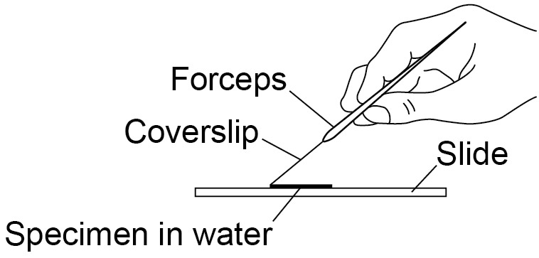
Using the microscope | Students should be given guidance in how to use an optical microscope, with particular reference to the coarse and fine focus controls.

Students should be able to see the following using ×400 magnification.

This diagram may help to identify the different cell parts

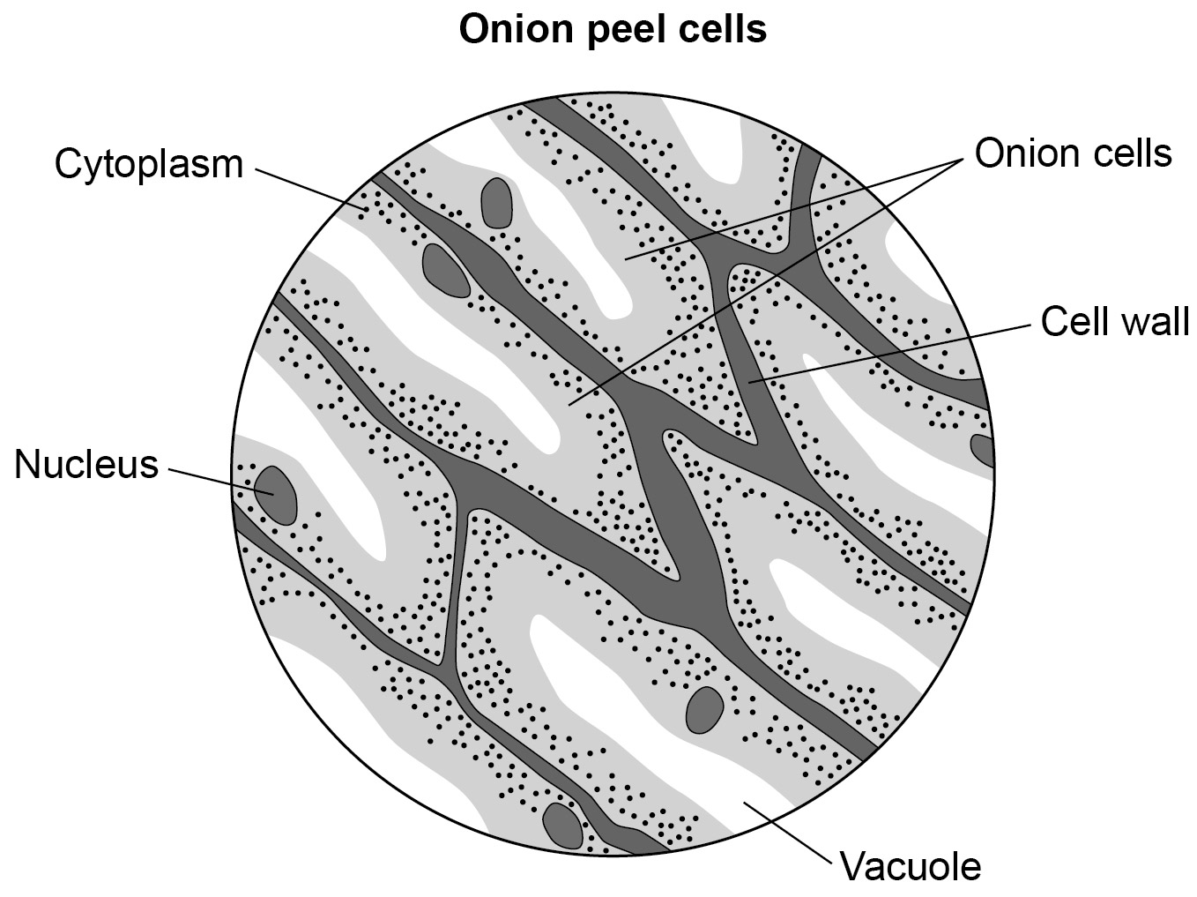
Risk assessment

- Risk assessment and risk management are the responsibility of the school or college.
- Safety goggles should be used when handling iodine solution.
- Wash off any spillages on the skin immediately.

Trialling

The practical should be trialled before use with students.

GCSE Biology required practical activity: Microscopy

Student sheet
Required practical activity | Apparatus and techniques
Use a light microscope to observe, draw and label a selection of plant and animal cells. A magnification scale must be included. | AT 1, AT 7

Using a light microscope to observe, draw and label cells in an onion skin

Prepare a microscope slide to show the contents of cells from onion skin and animal tissue.

Use an optical microscope to observe, draw and measure the cells. You will also need to identify structures within the cells.

Learning outcomes
1

2

3

Teachers to add these with particular reference to working scientifically

Method

You are provided with the following:
- a small piece of onion
- a knife
- a white tile
- forceps
- a microscope slide
- a coverslip
- a microscope
- iodine solution in a dropping bottle
- prepared animal and plant cells.

Read these instructions carefully before you start work.

- Use a dropping pipette to put one drop of water onto a microscope slide.

- Separate one of the thin layers of the onion.

- Peel off a thin layer of epidermal tissue from the inner surface.

- Use forceps to put this thin layer on the drop of water that you have placed on the microscope slide.

- Make sure that the layer of onion cells is flat on the slide.

- Put two drops of iodine solution onto the onion tissue.

- Carefully lower a coverslip onto the slide. Do this by:
- placing one edge of the coverslip on the slide
- use the forceps to lower the other edge onto the slide.

- There may be some liquid around the edge of the coverslip. Use a piece of paper to soak this liquid up.

- Put the slide on the microscope stage.

Using the microscope to look at animal and plant cells

The diagram shows a typical microscope.

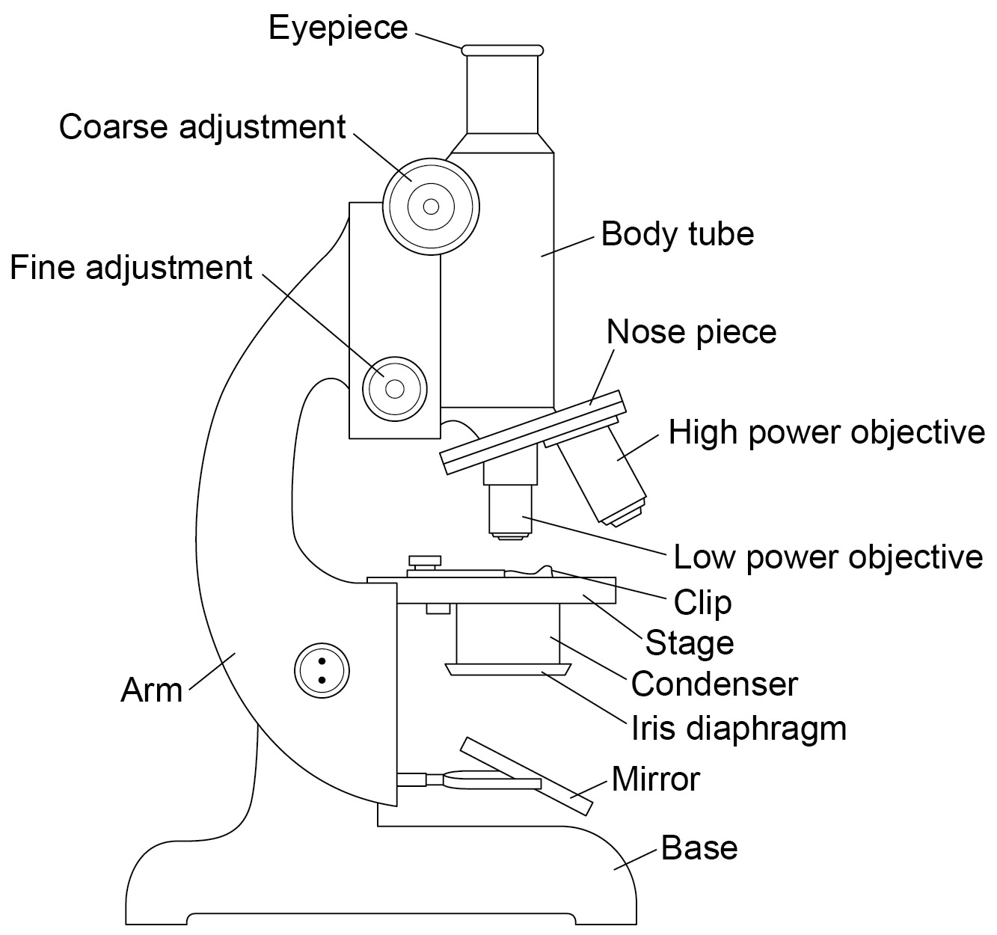

This microscope has a mirror to reflect light up through the slide. Some microscopes have a built-in light instead of a mirror.

- Use the lowest power objective lens. Turn the nosepiece to do this.

- The end of the objective lens needs to almost touch the slide. Do this by turning the coarse adjustment knob. Look from the side (not through the eyepiece) when doing this.

- Now looking through the eyepiece, turn the coarse adjustment knob in the direction to increase the distance between the objective lens and the slide. Do this until the cells come into focus.

- Now rotate the nosepiece to use a higher power objective lens.

- Slightly rotate the fine adjustment knob to bring the cells into a clear focus and use the high-power objective) to look at the cells.

- Make a clear, labelled drawing of some of these cells. Make sure that you draw and label any component parts of the cell.

- Write the magnification underneath your drawing.

- Use this technique to draw a range of animal and plant cells on prepared slides.

GCSE Biology required practical activity: Osmosis

Teachers’ notes

Required practical activity | Apparatus and techniques
Investigate the effect of a range of concentrations of salt or sugar solutions on the mass of plant tissue. | AT 1, AT 3, AT 5

Investigating osmosis in potato tissue

Materials

In addition to access to general laboratory equipment, each group of students needs:

- a potato
- a cork borer or potato chipper/ vegetable stick cutter
- a ruler
- a 10 cm³ measuring cylinder
- labels
- three boiling tubes
- a test tube rack
- paper towels
- a sharp knife
- a white tile
- a range of sugar solutions (1.0M - 0.25 M)
- distilled water
- a top-pan balance (accurate to at least 0.01 g).

Technical information

Make up a solution of 1.0 M sucrose solution by adding distilled water to 342.4 g of sugar (dissolve by heating) and making up to 1 litre in a volumetric flask. Dilute this appropriately to produce a range of solutions from 1.0 M - 0.25 M. This should provide enough for a class as each student or group will need 10 cm³ of each solution, in addition to 10 cm³ of distilled water.

To avoid students having to use sharp implements, the potato cylinders can be prepared for them. They must be freshly prepared.

Ensure that potato cylinders do not have any skin on them as this affects the movement of water molecules.

Additional information

The class will need to collect results from solutions of five different concentrations in order to be able to plot a graph. However, this investigation can be time consuming if students have to wait for access to a balance. Instead students could collect data on only three solutions per group. The class data for all five solutions can then be collated before plotting the graph. Where the line of best fit crosses the x-axis is an approximation of the concentration inside the potato tissue.

The length of time that the potato cylinders are left in the sugar solutions can be adjusted to suit lesson timings. Better results are achieved if they are left for more than 30 minutes.

Note that fungi may grow in the test tubes containing potato in weaker solutions of salt or sugar. Test tube contents should be disposed of after viewing, the day after the potatoes have been placed in the solutions. Any test tubes showing visible growth of fungi should be sterilised by autoclaving.

Risk assessment

- Risk assessment and risk management are the responsibility of the school or college.
- Care should be taken with the use of cork borers and scalpels when students are cutting their own potato cylinders. Small kitchen knives could be used if available.
- Care should be taken with the use of an electrical balance in the presence of water.

Trialling

The practical should be trialled before use with students.

GCSE Biology required practical activity: Osmosis

Student sheet

Required practical activity | Apparatus and techniques
Investigate the effect of a range of concentrations of salt or sugar solutions on the mass of plant tissue. | AT 1, AT 3, AT 5

Investigating osmosis in potato tissue

Osmosis is the movement of water through a selectively permeable membrane. The water moves from an area of high concentration of water to an area of lower concentration of water.

Plant tissues can be used to investigate osmosis. This experiment uses potato, but other tissue such as sweet potato, carrot or beetroot can be used.

Potato tissue is cut into equal sized cylinders. The potato tissue is left overnight in sugar solution and distilled water. The changes in length and mass can then be accurately compared.

Learning outcomes
1

2

3

Teachers to add these with particular reference to working scientifically

Risk assessment

Care should be taken:
- cutting potato cylinders
- with the use of an electrical balance in the presence of water.

Method

You are provided with the following:

- a potato
- a cork borer or potato chipper/vegetable stick cutter
- a ruler
- a 10 cm³ measuring cylinder
- labels
- five boiling tubes
- a test tube rack
- paper towels
- a sharp knife
- a white tile
- a range of sugar solutions
- distilled water
- a top-pan balance.

Read these instructions carefully before you start work.

- Use a cork borer to cut five potato cylinders of the same diameter.

- Trim the cylinders so that they are all the same length (about 3 cm).

- Accurately measure and record the length and mass of each potato cylinder.

- Measure 10 cm³ of the 1.0 M sugar solution and put into the first boiling tube. Label boiling tube as: 1.0. M sugar.

- Repeat step 4 to produce the additional labelled boiling tubes containing solutions of 0.75 M, 0.5 M. and 0.25 M.

- Measure 10 cm³ of the distilled water and put into the fifth boiling tube. Label boiling tube as water.

- Add one potato cylinder to each boiling tube. Make sure you know the length and mass of each potato cylinder in each boiling tube.

- Record the lengths and masses of each potato cylinder in a table such as the one below.
 | 1.0 M sugar solution | 0.75 sugar solution | 0.5 M sugar solution | 0.25 M sugar solution | Distilled water
Initial length (mm)
Final length (mm)
Change in length (mm)
Initial mass (g)
Final mass in (g)
Change in mass in (g)

- Leave the potato cylinders in the boiling tubes overnight in the test tube rack.

- Remove the cylinders from the boiling tubes and carefully blot them dry with the paper towels.

- Re-measure the length and mass of each cylinder (make sure you know which is which).
Record your measurements in the table. Then calculate the changes in length and mass of each potato cylinder.

- Plot a graph with:
- ‘Change in mass in g’ on the y-axis
- ‘Concentration of sugar solution’ on the x-axis.

- Plot another graph with:
- ‘Change in length in mm’ on the y-axis
- ‘Concentration of sugar solution’ on the x-axis.

Compare the two graphs that you have drawn.
GCSE Biology required practical activity: Enzymes

Teachers’ notes

Required practical activity | Apparatus and techniques
Investigate the effect of pH on the rate of reaction of amylase enzyme.  Students should use a continuous sampling technique to determine the time taken to completely digest a starch solution at a range of pH values. Iodine reagent is to be used to test for starch every 30 seconds.  Temperature must be controlled by use of a water bath or immersible electric heater. | AT 1, AT 2, AT 5, AT 8

Investigating the effect of pH on the enzyme amylase

Materials

In addition to access to general laboratory equipment, each student needs:

- test tubes
- a test tube rack
- water baths (electrical or Bunsen burners and beakers)
- spotting tiles
- a 5 cm³ measuring cylinder
- syringes or 10 cm³ measuring cylinders
- a glass rod
- a stop watch
- starch solution
- amylase solution
- buffered solutions
- iodine solution
- thermometers.

Technical information

A 1% solution of amylase and a 1% suspension of starch are appropriate for this experiment.

Amylase will slowly lose activity so it is best to make up a fresh batch, using the powdered enzyme, for each lesson. Otherwise any results collected on different days will not be comparable.

Starch suspension should also be made fresh. This can be done by making a cream of 5 g of soluble starch in cold water and pouring into 500 cm³ of boiling water. Stir well and boil until you have a clear solution.

A 0.01 M solution of iodine is suitable for starch testing.

Buffer solutions should be made using CLEAPSS recipe 18 (The Universal Buffer: Recipe 1). The optimum pH for amylase is pH 6. A range of buffer solutions between pH 5 - 8 would be appropriate.

Additional information

It is best to check that the amylase breaks down the starch at an appropriate rate before students do this experiment. At around the optimum pH of 6, the end point should be reached within 1‒2 minutes.

It might be appropriate for each student to test only one pH, working in a pair or a group, so that results can be pooled. This would ensure that the tests were performed in the same lesson, and therefore are more comparable.

A wider range of pH could be investigated and class results could be collated. This would require more water baths, but students could make their own using beakers and Bunsen burners etc.

Some amylases used in detergents are not denatured even at temperatures close to boiling water. Some amylases are also inhibited by buffers.

Risk assessment

- Risk assessment and risk management are the responsibility of the school or college.
- All solutions, once made up, are low hazard. Refer to Hazcard 33 for amylase.
- Iodine solution may irritate the eyes so safety goggles should be worn. Refer to Hazcards 54A and 54B.
- Universal buffer solution is an irritant. Refer to Hazcards 9, 14, 72, and 91.
- Safety goggles should be worn in the presence of hot water in water baths.
- Care should be taken with the use of naked flames in this experiment if students are using Bunsen burners to make water baths.
- Care should be taken with the presence of water and electrical equipment, if electrical water baths are being used.
- Note that some people are allergic to enzymes.

Trialling

The practical should be trialled before use with students.

GCSE Biology required practical activity: Enzymes

Student sheet

Required practical activity | Apparatus and techniques
Investigate the effect of pH on the rate of reaction of amylase enzyme.  Students should use a continuous sampling technique to determine the time taken to completely digest a starch solution at a range of pH values. Iodine reagent is to be used to test for starch every 30 seconds.  Temperature must be controlled by use of a water bath or electric heater. | AT 1, AT 2, AT 5, AT 8

Investigating the effect of pH on the enzyme amylase

The enzyme amylase controls the breakdown of starch in our digestive system. We are able to simulate digestion using solutions of starch and amylase in test tubes. We can also determine the optimum conditions required.

The presence or absence of starch can be determined using iodine solution. In this experiment, we can measure how long the amylase takes to break down the starch at different pHs.

Learning outcomes
1

2

3

Teachers to add these with particular reference to working scientifically

Risk assessment

- Safety goggles should be worn throughout.
- Take care with boiling water.

Method

You are provided with the following:

- test tubes
- a test tube rack
- water bath (electrical or Bunsen burner and beakers)
- spotting tiles
- 5cm³ measuring cylinder
- syringes
- a stop clock
- starch solution
- amylase solution
- buffered solutions covering a range of pH, each with a labelled syringe/plastic pipette
- iodine solution
- syringes.

Read these instructions carefully before you start work.

- Place one drop of iodine solution into each depression on the spotting tile.

- Place labelled test tubes containing the buffered pH solutions, amylase solution and starch solutions in to the water bath.

- Allow the solutions to reach 25 °C.

- Add 2cm³ of one of the buffered solutions to a test tube.

- Use the syringe to place 2 cm³ of amylase into the buffered pH solution.

- Use another syringe to add 2 cm³ of starch to the amylase/buffer solution.

- Immediately start the stop clock and leave it on throughout the test.

- Mix using a glass rod.

- After 30 seconds, remove one drop of the mixture with a glass rod.
Place this drop on the first depression of the spotting tile with the iodine solution.
The iodine solution should turn blue-black.

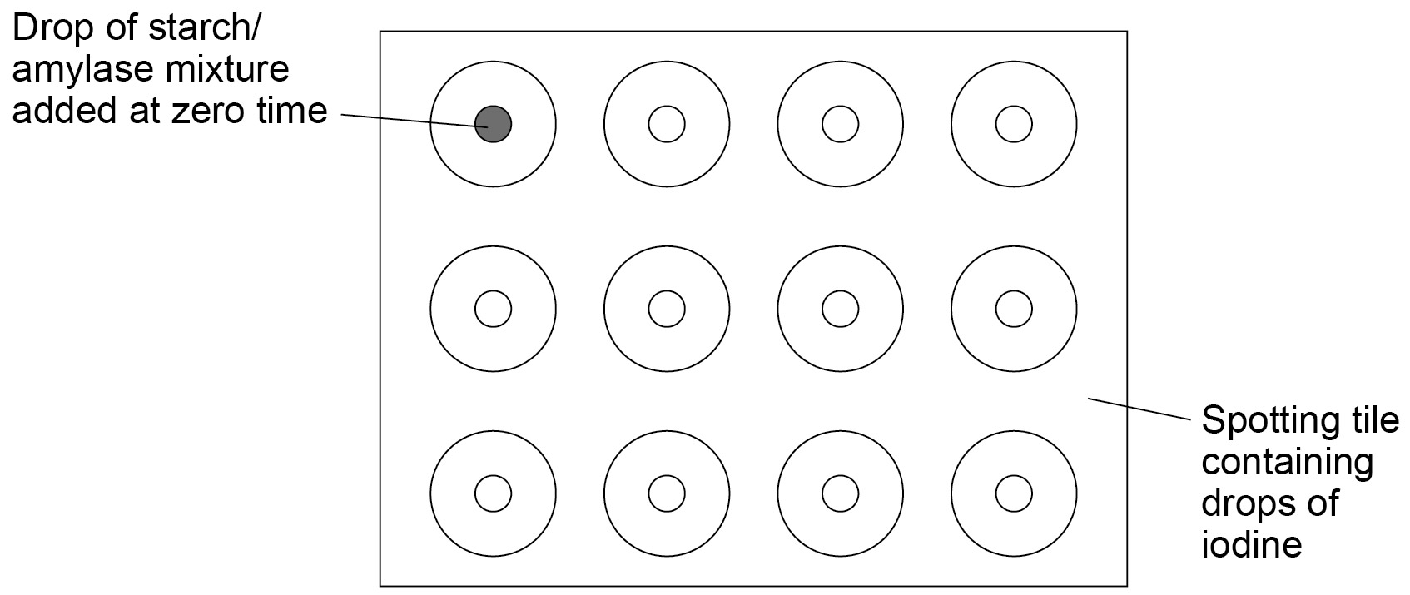

- Use the glass rod to remove one drop of the mixture every 10 seconds. Put each drop onto the iodine solution in the next depression on the spotting tile.
Rinse the glass rod with water after each drop.
Continue until the iodine solution and the amylase/ buffer/ starch mixture remain orange.

- Repeat the procedure with solutions of other pHs
- Record your results in a table such as the one here.

pH of solution | Time taken for amylase to completely break down the starch in seconds (s)

14. Plot a graph with:
- ‘Time taken to break down starch (s)’ on the y-axis
- ‘pH of solution’ on the x-axis

or

15. Calculate the rate of reaction and plot a graph with:
- ‘Rate of reaction’ on the y-axis
- ‘pH of the solution’ on the x-axis

GCSE Biology required practical activity: Food tests

Teachers’ notes

Required practical activity | Apparatus and techniques
Use qualitative reagents to test for a range of carbohydrates, lipids and proteins. To include: Benedict’s test for sugars; iodine test for starch; Biuret reagent for protein. | AT 2, AT 8

Using qualitative reagents to test for a range of carbohydrates, lipids and proteins

Materials

In addition to access to general laboratory equipment, each group of students needs:

- food to be tested
- a pestle and mortar
- a stirring rod
- a filter funnel and filter paper
- 5 × beaker, 250 ml
- a conical flask
- 4 × test tube
- Benedict’s solution
- iodine solution (0.01 M)
- Sudan III stain solution
- Biuret solution
- kettle for boiling water
- a thermometer
- safety goggles.

Technical information

Benedict’s qualitative reagent (CLEAPSS)

Benedict’s solution or DNSA (see Recipe sheet 34) should be used to test for reducing sugars.
Glucose, lactose and maltose are reducing sugars and give a positive test. Sucrose is a non-reducing sugar and does not give a positive result.

No hazard warning symbol is required on the bottle as the concentrations of each of the constituents are low.

Qualitative Biuret Reagent (CLEAPSS)

This does not keep so only prepare what is required.

General hazards:

- Sodium hydroxide (solid) and 2 M solution. See Hazcard 91.
- Copper sulphate, see Hazcard 27C.

Preparing 1 litre of Qualitative Biuret reagent:

- wear safety goggles
- weigh out 0.75 g of copper(II) sulfate(VI)-5 -water
- prepare 1 litre of 2 M potassium or sodium hydroxide solution
- dissolve the copper(II) sulfate(VI) in the alkali and label the solution CORROSIVE.

A purple or pink colouration indicates the presence of protein.

Iodine solution (CLEAPSS)

A 0.01 M solution is suitable as a test reagent for starch and may be purchased ready-made or can be made up following the instructions on CLEAPSS recipe sheet 50.

The concentration of solutions decreases with storage. Check that the solutions work before use in the laboratory.

Sudan III stain solution

Dissolve 0.5 g of dye in 70 ml of ethanol and 30 ml of water, using a warm water bath, and filter.
Ethanol is HIGHLY FLAMMABLE (see Hazcards 32 and 40). Label the solution HIGHLY FLAMMABLE.

Wear safety goggles.

Additional information

The techniques involved should be demonstrated to the students. Students should be allowed time to practise the techniques by testing pure substances first in order to see the expected colour change. The following are suggested for this purpose:
- Biuret test – albumen solution (eg 1% concentration)
- Benedict’s solution – glucose solution (eg 1% concentration)
- iodine solution – starch solution (eg 1% concentration)
- Sudan III – any suitable oil.

In particular, students will need to practice the following:

Techniques requiring practice | Additional information
Use of a pestle and mortar | When crushing the food it may help to add a small amount of sharp sand.
Filtration | Students may need to be taught how to fold the filter paper correctly.
Use of water bath | Students may need to learn how to use a beaker of hot water as a water bath.

Risk assessment

- Risk assessment and risk management are the responsibility of the school or college.
- Biuret solution contains copper sulfate, which is poisonous, and sodium hydroxide, which is caustic.
- Safety goggles should be worn when carrying out the tests.
- Wash off spills on skin immediately.
- Ensure that there is no eating or drinking during testing.

Suggested foods for testing

Proteins: milk, yogurt, cheese, meat, tofu, apple, potato, yeast, cooked beans, eggs.

Lipids: olive oil, sesame seed oil, grape seed oil, margarine, butter, lard, milks (full fat, semi-skimmed, skimmed), egg white solution, egg yolk solution.

Carbohydrates: potato, bread, cooked noodles, biscuits, sugar, apples, flour, corn starch.

Trialling

The practical should be trialled before use with students.

GCSE Biology required practical activity: Food tests

Student sheet

Required practical activity | Apparatus and techniques
Use qualitative reagents to test for a range of carbohydrates, lipids and proteins. To include: Benedict’s test for sugars; iodine test for starch; Biuret reagent for protein. | AT 2, AT 8

1. Testing for sugars

In this experiment you will test one or more foodstuffs for the presence of carbohydrates.

Learning outcomes
1

2

3

Teachers to add these with particular reference to working scientifically

Risk assessment

- Safety goggles should be worn when carrying out the tests.
- Wash off spills on skin immediately.
- Take care with boiling water.

Method

You are provided with the following:

- food to be tested
- a pestle and mortar
- a stirring rod
- filter funnel and filter paper
- 2 × beaker, 250 ml
- a conical flask
- 2 × test tube
- Benedict’s solution
- iodine solution
- kettle for boiling water
- a thermometer
- safety goggles.

Read these instructions carefully before you start work.

- Use a pestle and mortar to grind up a small sample of food.

- Transfer the ground up food into a small beaker. Then add distilled water.

- Stir the mixture so that some of the food dissolves in the water.

- Filter using a funnel with filter paper to obtain as clear a solution as possible.
The solution should be collected in a conical flask.

- Half fill a test tube with some of this solution.

- Add 10 drops of Benedict’s solution to the solution in the test tube.

- Put hot water from a kettle in a beaker. The water should not be boiling.
Put the test tube in the beaker for about five minutes.

- Note any colour change.
If a reducing sugar (such as glucose) is present, the solution will turn green, yellow, or brick-red. The colour depends on the sugar concentration.

- Take 5 ml of the solution from the conical flask and put it into a clean test tube.

- Add a few drops of iodine solution and note any colour change.
If starch is present, you should see a black or blue-black colour appear.

- Record your results in a table such as the one below.

Name of food tested | Colour produced with Benedict’s solution | Colour produced with iodine solution

2. Testing for lipids

In this experiment you will test one or more foodstuffs for the presence of lipids (fats).

Learning outcomes
1

2

3

Teachers to add these with particular reference to working scientifically

Risk assessment

- Safety goggles should be worn when carrying out the tests.
- Sudan III contains ethanol, which is highly flammable. Keep the solution away from naked flames.
- Wash off spills on skin immediately.

Method

You are provided with the following:

- food to be tested
- a pestle and mortar
- a stirring rod
- 2 × beaker, 250 ml
- a test tube
- Sudan III stain solution.
- safety goggles.

Name of food tested | Colour produced with Benedict’s solution | Colour produced with iodine solution

2. Testing for lipids

In this experiment you will test one or more foodstuffs for the presence of lipids (fats).

Learning outcomes
1

2

3

Teachers to add these with particular reference to working scientifically

Risk assessment

- Safety goggles should be worn when carrying out the tests.
- Sudan III contains ethanol, which is highly flammable. Keep the solution away from naked flames.
- Wash off spills on skin immediately.

Method

You are provided with the following:

- food to be tested
- a pestle and mortar
- a stirring rod
- 2 × beaker, 250 ml
- a test tube
- Sudan III stain solution.
- safety goggles.

Read these instructions carefully before you start work.

- Use a pestle and mortar to grind up a small sample of food.

- Transfer the ground up food into a small beaker. Then add distilled water.

- Stir the mixture so that some of the food dissolves in the water. Do not filter.

- Half fill a test tube with some of this solution.

- Add 3 drops of Sudan III stain to the solution in the test tube. Shake gently to mix.

- If fat is present: a red-stained oil layer will separate out and float on the water surface.

3. Testing for proteins

In this experiment you will test one or more foodstuffs for the presence of protein.

Learning outcomes
1

2

3

Teachers to add these with particular reference to working scientifically

Risk assessment

- Safety goggles should be worn when carrying out the tests.
- Biuret solution contains copper sulphate, which is poisonous, and sodium hydroxide, which is caustic.
- Wash off spills on skin immediately.

Method

You are provided with the following:

- food to be tested
- a pestle and mortar
- a stirring rod
- a filter funnel and filter paper
- 2 × beaker, 250 ml
- a test tube
- Biuret solution
- safety goggles.

Read these instructions carefully before you start work.

- Use a pestle and mortar to grind up a small sample of food.

- Transfer the ground up food into a small beaker. Then add distilled water.

- Stir the mixture so that some of the food dissolves in the water.

- Filter using a funnel with filter paper to obtain as clear a solution as possible.
The solution should be collected in a conical flask.

- Put 2 cm³ of this solution into a test tube.

- Add 2 cm³ of Biuret solution to the solution in the test tube. Shake gently to mix.

- Note any colour change. Proteins will turn the solution pink or purple.

GCSE Biology required practical activity: Photosynthesis

Teachers’ notes

Required practical activity | Apparatus and techniques
Investigate the effect of light intensity on the rate of photosynthesis using an aquatic organism such as pondweed. | AT 1, AT 3, AT 4, AT 5

Investigating the effect of light intensity on photosynthesis in pondweed

Materials

In addition to access to general laboratory equipment, each group of students needs:

- a boiling tube
- freshly cut 10 cm piece of pondweed
- a light source
- a ruler
- a test tube rack
- a stop watch
- 0.2% solution of sodium hydrogen carbonate solution
- a glass rod.

Technical information

Native species of Cabomba or Elodea could be used as the pondweed in this investigation. Both can be bought from tropical fish shops and some large garden centres.

Cabomba is recommended as it is the most reliable as it produces the most bubbles. Cabomba should be kept in a well aerated tank prior to its use. If Elodea is used, it is suggested that the plant is placed in a beaker of water in front of a lamp for 2‒3 hours before starting the investigation.

High intensity light sources (at least 1000 lumens) need to be used for the practical.

It is best to use an LED light source as they give off less heat, although care should be taken to ensure that they emit the correct wavelengths required for photosynthesis. If these are not available, use a normal light bulb but place a beaker of water in between the boiling tube and the light source to reduce the chance of temperature affecting the results. Low energy light bulbs should not be used as the light intensity may be too low to promote measurable photosynthesis.
Additional information
Graphs can be drawn of the number of bubbles per minute against distance from light source.

Light intensity is proportional to 1/distance². Higher attaining students may want to draw their graphs of number of bubbles against light intensity instead.

If no bubbles appear from the cut end of the pondweed when placed closest to the light source, cut a few millimetres off the end or, if necessary, use a new freshly-cut piece of pondweed.

Students could work within a group in order to investigate a wider range of distances and with increments of 5 cm instead of 10 cm. Group results could be collated.

Note
Students need to be aware of a method to measure the volume of oxygen produced by photosynthesis. The method described here can be modified by placing the elodea under a filter funnel in a beaker of water. A 10 cm³ measuring cylinder containing water is inverted over the spout of the filter funnel. Any oxygen produced by the elodea passes through the funnel and is collected in the measuring cylinder. The volume of oxygen produced in different light intensities can be measured over a specified time.

Risk assessment
- Risk assessment and risk management are the responsibility of the school or college.
- 0.2% sodium hydrogen carbonate solution is low hazard. Refer to Hazcard 95C.
- Care should be taken when handling glassware.
- Care should be taken with the use of lamps that may get hot.
- Use a large beaker of water in front of hot light sources.
- Care should be taken when using mercury-containing light bulbs (eg compact fluorescent tubes).
- Use light sources that absorb any UV light given off by the bulb/tube.
- Care should be taken with the presence of water and the electrical power supply for the lamp.

Trialling

The practical should be trialled before use with students.
GCSE Biology required practical activity: Photosynthesis

Student sheet

Required practical activity | Apparatus and techniques
Investigate the effect of a factor on the rate of photosynthesis using an aquatic organism such as pondweed. | AT 1, AT 3, AT 4, AT 5

Investigating the effect of light intensity on photosynthesis in pondweed

Plants use carbon dioxide and water to produce glucose and oxygen. This process is called photosynthesis. The rate of photosynthesis is affected by many factors, such as:
- light intensity
- light wavelength.

Aquatic plants produce visible bubbles of oxygen gas into the surrounding water when they photosynthesise. These bubbles can be counted as a measure of the rate of photosynthesis. Pondweed is an example of an aquatic plant.

The effect of light intensity can be investigated by varying the distance between pondweed and a light source. The closer the light source, the greater the light intensity.

Learning outcomes
1

2

3

Teachers to add these with particular reference to working scientifically

Risk assessment
Care should be taken:
- when handling glassware
- with the use of lamps that may get hot
- with the presence of water and the electrical power supply for the lamp.

Method

You are provided with the following:

- a boiling tube
- freshly cut 10 cm piece of pondweed
- a light source
- a ruler
- a test tube rack
- a stop watch
- 0.2% solution of sodium hydrogen carbonate
- a glass rod.

Read these instructions carefully before you start work.

- Set up a test tube rack containing a boiling tube at a distance of 10 cm away from the light source.

- Fill the boiling tube with the sodium hydrogen carbonate solution.

- Put the piece of pondweed into the boiling tube with the cut end at the top. Gently push the pondweed down with the glass rod.

- Leave the boiling tube for 5 minutes.

- Start the stop watch and count the number of bubbles produced in one minute.

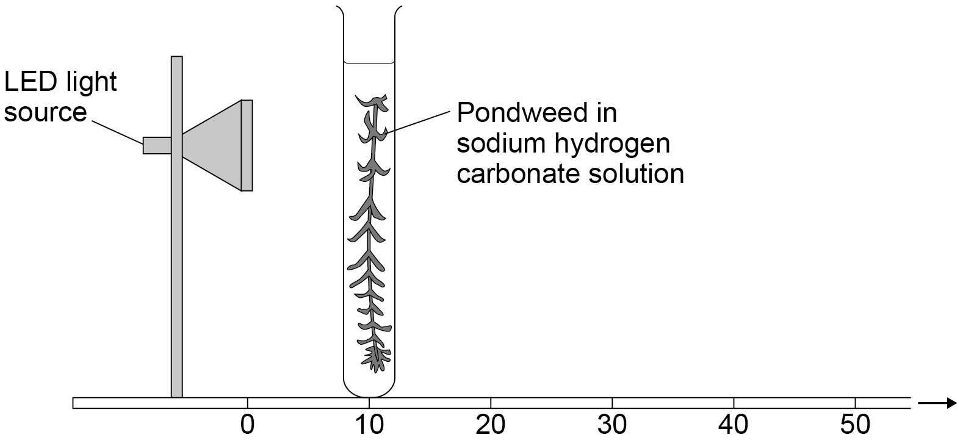

- Record the results in a table such as the one here.

Distance between pondweed and light source in cm | Number of bubbles per minute
 | 1 | 2 | 3 | Mean
10
20
30
40

- Repeat the count twice more. Then use the data to calculate the mean number of bubbles per minute.

- Repeat steps 1‒7 with the test tube rack and boiling tube at distances of 20 cm, 30 cm and 40 cm from the light source.

GCSE Biology required practical activity: Reaction time

Teachers’ notes

Required practical activity | Apparatus and techniques
Plan and carry out an investigation into the effect of a factor on human reaction time. | AT 1, AT 3, AT 4

Investigating whether practice reduces human reaction times

Materials

In addition to access to general laboratory equipment, each group of students needs:

- a metre ruler
- a chair
- a table
- a partner.

Technical information

Students should use their weaker hand for the ruler drop test. They should ensure that they have not done any practicing before the start of the experiment but start taking measurements immediately so that the effects of any practising can be seen.

Ruler measurements can be converted to reaction times using the conversion table below.

Additional information

The following conversion table can be given to students in order to determine reaction times.

Graphs of reaction time against attempt number can be drawn.

Reaction time (s) | 0.41 | 0.41 | 0.41 | 0.41 | 0.42 | 0.42 | 0.42 | 0.42 | 0.43 | 0.43 | 0.43 | 0.43 | 0.44 | 0.44 | 0.44 | 0.44 | 0.45 | 0.45 | 0.45 | 0.45
Reading from ruler (cm) | 81 | 82 | 83 | 84 | 85 | 86 | 87 | 88 | 89 | 90 | 91 | 92 | 93 | 94 | 95 | 96 | 97 | 98 | 99 | 100
Reaction time (s) | 0.35 | 0.36 | 0.36 | 0.36 | 0.36 | 0.37 | 0.37 | 0.37 | 0.38 | 0.38 | 0.38 | 0.38 | 0.39 | 0.39 | 0.39 | 0.39 | 0.40 | 0.40 | 0.40 | 0.40
Reading from ruler (cm) | 61 | 62 | 63 | 64 | 65 | 66 | 67 | 68 | 69 | 70 | 71 | 72 | 73 | 74 | 75 | 76 | 77 | 78 | 79 | 80
Reaction time (s) | 0.29 | 0.29 | 0.30 | 0.30 | 0.30 | 0.31 | 0.31 | 0.31 | 0.32 | 0.32 | 0.32 | 0.33 | 0.33 | 0.33 | 0.34 | 0.34 | 0.34 | 0.34 | 0.35 | 0.35
Reading from ruler (cm) | 41 | 42 | 43 | 44 | 45 | 46 | 47 | 48 | 49 | 50 | 51 | 52 | 53 | 54 | 55 | 56 | 57 | 58 | 59 | 60
Reaction time (s) | 0.21 | 0.22 | 0.22 | 0.22 | 0.23 | 0.23 | 0.23 | 0.24 | 0.24 | 0.25 | 0.25 | 0.26 | 0.26 | 0.26 | 0.27 | 0.27 | 0.28 | 0.28 | 0.28 | 0.29
Reading from ruler (cm) | 21 | 22 | 23 | 24 | 25 | 26 | 27 | 28 | 29 | 30 | 31 | 32 | 33 | 34 | 35 | 36 | 37 | 38 | 39 | 40
Reaction time (s) | 0.05 | 0.06 | 0.08 | 0.09 | 0.10 | 0.11 | 0.12 | 0.13 | 0.14 | 0.14 | 0.15 | 0.16 | 0.16 | 0.17 | 0.18 | 0.18 | 0.19 | 0.19 | 0.20 | 0.21
Reading from ruler (cm) | 1 | 2 | 3 | 4 | 5 | 6 | 7 | 8 | 9 | 10 | 11 | 12 | 13 | 14 | 15 | 16 | 17 | 18 | 19 | 20

Risk assessment

- Risk assessment and risk management are the responsibility of the school or college.
- Care should be taken to avoid injury from the falling ruler.
- Care should be taken to ensure that students do not experience any discomfort when being used as the subjects of investigation.

Trialling

The practical should be trialled before use with students.

GCSE Biology required practical activity: Reaction time

Student sheet

Required practical activity | Apparatus and techniques
Plan and carry out an investigation into the effect of a factor on human reaction time. | AT 1, AT 3, AT 4

Investigating whether practice reduces human reaction times

Messages travel very quickly around your body through the nervous system. This is so that you are able to respond to changes in the environment. The time it takes for you to respond to such a change is called your reaction time.

Athletes spend hours practicing to try and to reduce their reaction time. This is to help them improve their performance in their particular sport. Responding quicker to the starter’s pistol in a race can gain you the advantage over other runners.

You will conduct a simple, measurable experiment called the ruler drop test. From this you can determine whether your reaction time can be reduced with practice.

Learning outcomes
1

2

3

Teachers to add these with particular reference to working scientifically

Risk assessment

- Care should be taken to avoid injury from the falling ruler.

Method

You are provided with the following:

- a metre ruler
- a chair
- a table
- a partner.

Read these instructions carefully before you start work:

- Use your weaker hand for this experiment. If you are right handed then your left hand is your weaker hand.

- Sit down on the chair with good upright posture and eyes looking across the room.

- Place the forearm of your weaker arm across the table with your hand overhanging the edge of the table.

- Your partner will hold a ruler vertically with the bottom end (the end with the 0 cm) in between your thumb and first finger.
Practice holding the ruler with those two fingers.

- Your partner will take hold of the ruler and ask you to remove your fingers.

- Your partner will hold the ruler so the zero mark is level with the top of your thumb. They will tell you to prepare to catch the ruler.

- Your partner will then drop the ruler without telling you.

- You must catch the ruler as quickly as you can when you sense that the ruler is dropping.

- After catching the ruler, look at the number level with the top of your thumb.
Record this in a table such as the one here.

Drop test attempts | Ruler measurements in cm |  | Reaction times in seconds
 | Person 1 | Person 2 | Person 1 | Person 2
1
2
3
4
5
6
7
8
9
10

- Have a short rest and then repeat the test. Record the number on the ruler as attempt 2.

- Continue to repeat the test several times.

- Swap places with your partner. Repeat the experiment to get their results.

- Use a conversion table to convert your ruler measurements into reaction times.

GCSE Biology required practical activity: Field investigations

Teachers’ notes

Required practical activity | Apparatus and techniques
Measure the population size of a common species in a habitat. Use sampling techniques to investigate the effect of a factor on the distribution of this species. | AT 1, AT 3, AT 4, AT 6, AT 8

There are two parts to this investigation:

1. Investigating the population size of a plant species using random sampling
2. Investigating the effect of a factor on plant distribution using a transect line.

Materials

In addition to access to general laboratory equipment, each group of students needs:

- a 25 cm x 25cm quadrat
- a 30 m tape measure
- a clipboard
- a pen
- paper.

Technical information

1. Investigating the population size of a plant species using random sampling

Choose an area of grass with sufficient space to carry out this survey. You will need at least 400 m² to accommodate a class.

Lay out two tape measures (or marked strings) 20m in length so that they form right angles. These two tape measures represent the two sides of a 20m x 20m square. Place two bags containing numbers at the point where the two tape measures meet. Help the students to identify the species being investigated – plantain is very common although dandelion could also be used.

Organise the students into groups of three. One student will select a number from one of the bags and move that distance along the tape. A second student will select a number from the other bag and move that distance along the other tape. The third student with the quadrat uses the other two students as markers in order to place the quadrat on the ground. The group then return their numbers to the bags. The group then return their quadrat to count and record the number of plantain in the quadrat.

Get students to repeat this process in order to count the number of plantain in 10 quadrats. Students can then use this data to estimate the population of the survey area.

For example, in a case where 50 plantain were counted in 10 samples, the total population can be estimated using this equation:

$\text{Estimated population size}\text{ = }\frac{\text{area sampled }}{\text{total area}}$ x number of plantain counted

The area sampled from 10 quadrats is 0.25m x 0.25m = 10 x 0.0625 m² = 0.625 m²

The total area of the survey = 20m x 20m = 400 m²

estimated population $\text{= }\frac{\text{0.625}}{\text{400} }$ x 50 = 32,000

2. Investigating the effect of a factor on plant distribution using a transect line

A transect line from a tree to an open area can be used to record the change in the number of a particular species as light intensity changes. Students can record either % grass cover or the number of plantain in each quadrat. Students need to lay out a tape measure in a straight line so that a quadrat can be placed at regular intervals. A light meter should be used to record the light intensity at each quadrat. This will allow students to plot a graph of distribution against light intensity.

A shorter transect line could be used if space is limited and quadrats could be placed closer together.

Several students can work independently along one transect line if the number of tape measures is limited. Alternatively, string or rope can be used as the transect line by marking intervals along it with a marker pen.

Additional information

Exactly what counts as a plantain should be demonstrated to students to ensure they are counting whole plants (rosettes) and not just counting flowers. Students will need to kneel or crouch down and may need to use their hands to determine how many plants are within the quadrat (especially in the longer grass of the un-trampled area).

Risk assessment

- Risk assessment and risk management are the responsibility of the school or college.
- CLEAPSS members can use safety guidance in “SRA 08, School Grounds”.
- It is advisable not to undertake this experiment if the conditions are very wet as students may slip on wet grass.
- The areas to be used should be checked beforehand to ensure that no hazardous materials, such as broken glass, are present. This is especially necessary where items could be hidden in the longer grass.
- Care should be taken when using tape measures that may recoil back if not carefully locked in place.
- Care should be taken to ensure that students place the quadrats carefully along the transect line and do not throw them around, as this could cause injury to other students.
- Students should wash their hands thoroughly after the activity, before there is any hand to mouth transfer. Protects against plant and fungal allergens etc.

Trialling

The practical should be trialled before use with students.

GCSE Biology required practical activity: Field investigations

Student sheet

Required practical activity | Apparatus and techniques
Measure the population size of a common species in a habitat. Use sampling techniques to investigate the effect of a factor on the distribution of this species. | AT 1, AT 3, AT 4, AT 6, AT 8

This investigation has two parts:

1. Investigating the population size of a plant species using random sampling.
2. Investigating the effect of a factor on plant distribution using a transect line.

Learning outcomes
1

2

3

Teachers to add these with particular reference to working scientifically

Risk assessment

- Wash hands after handling seeds.

Method

You are provided with the following:

- a 25cm x 25cm quadrat
- 2 x 30 m tape measure
- a clipboard
- a pen
- paper.

Read these instructions carefully before you start work.

1. Investigating the population size of a plant species using random sampling.

Your teacher will have prepared a survey area for you and will show you how to identify plantain plants. You will need to work in threes.

- Collect two numbers, one from each bag.

- Use the numbers and the tape measures to locate the first position for your quadrat.

- Lay the 25cm x 25 cm quadrat on the ground.

- Replace the numbers in the bags.

- Count and record the number of plantain inside quadrat 2.

- Collect two more numbers from the bags and use them to locate the next site.

- Replace the numbers in the bags for other students to use.

- Repeat steps 1 – 5 until you have recorded the numbers of plantain in 10 quadrats.

- Your teacher will show you how to estimate the population of plantain using the equation

$\text{estimated population size}\text{ = }\frac{\text{area sampled }}{\text{total area}}$ x number of plantain counted

2. Investigating the effect of a factor on plant distribution using a transect line.

Your teacher will help you identify a species of plant to identify.

- Lay the 30 m tape measure in a line from the base of a tree to an open area of ground.

- Put the 25cm x 25cm quadrat against the transect line. One corner of the quadrat should touch the 0 m mark on the tape measure.

- Count the number of plants within the quadrat and record them in a table.

Distance along the  transect line in m | Number of plants | Light intensity
0
5
10
15
20
25
30

- Move the quadrat 5 m up the transect line and count the number of plants again. Record in the table.

- Continue to place the quadrat at 5 m intervals and count the number of plants in each quadrat.

- Gather data from your class to produce a graph of plant numbers against light intensity.

GCSE Chemistry required practical activity: Making salts

Teachers’ notes

Required practical activity | Apparatus and techniques
Preparation of a pure, dry sample of a soluble salt from an insoluble oxide or carbonate, using a Bunsen burner to heat dilute acid and a water bath or electric heater to evaporate the solution. | AT 2, AT 3, AT 4, AT 6

Preparation of pure dry copper sulfate crystals

Materials

In addition to access to general laboratory equipment, each group of students needs:
- 40 cm³ 1.0M dilute sulfuric acid
- copper (II) oxide powder.

Technical information

If crystallising dishes are not available, petri dishes (without lids) make good substitutes. If small conical flasks are not available, a second small beaker is an acceptable replacement.

To prepare 1.0M dilute sulfuric acid, consult CLEAPSS Recipe Book 98 and Guide L195.

40 cm³ of dilute acid will react with approximately 3.2g copper (II) oxide powder, but more than this will be used due to the excess added.

Additional information

Students should be warned not to boil the acid. If students add copper (II) oxide to hot acid in large portions, the resulting frothing may go over the top of the beaker. Students should be reminded of the importance of good filtering technique (eg correct paper folding, liquid level not above top edge of filter paper). Students will also need to be reminded not to allow the water bath to boil dry.

The procedure may require two 60 minute lessons to complete. If so, it is suggested that the filtrate is retained at the end of the first lesson for evaporation during the second.

Students must not be allowed to take their crystals home. The waste crystals can be recycled to make up new copper (II) sulfate stock solutions.

Risk assessment

- Risk assessment and risk management are the responsibility of the centre.
- Safety goggles should be worn throughout.
- 1.0M dilute sulfuric acid (IRRITANT) is covered by Hazcard 98A
- copper (II) oxide (HARMFUL) is covered by Hazcard 26
- copper (II) sulfate (HARMFUL) is covered by Hazcard 27C.

Trialling

The practical should be trialled before use with students.

GCSE Chemistry required practical activity: Making salts

Student sheet

Required practical activity | Apparatus and techniques
Preparation of a pure, dry sample of a soluble salt from an insoluble oxide or carbonate, using a Bunsen burner to heat dilute acid and a water bath or electric heater to evaporate the solution. | AT 2, AT 3, AT 4, AT 6

Preparation of pure dry copper sulfate crystals.

You will react an acid and an insoluble base to prepare an aqueous solution of a salt. The unreacted base from the reaction will need to be filtered. You will evaporate the filtrate to leave a concentrated solution of the salt, which will crystallise as it cools and evaporates further. When dry, the crystals will have a high purity.

Learning outcomes
1

2

3

Teachers to add these with particular reference to working scientifically

Risk assessment

Safety goggles must be worn throughout.

Method

You are provided with the following:
- 40 cm³ 1.0 M dilute sulfuric acid
- copper (II) oxide powder
- spatula
- glass rod
- 100 cm³ beaker
- Bunsen burner.
- tripod
- gauze
- heatproof mat
- filter funnel and paper
- clamp stand
- conical flask
- 250 cm³ beaker
- evaporating basin
- crystallising dish.

Read these instructions carefully before you start work.

- Measure 40 cm³ sulfuric acid into the 100 cm³ beaker.
The volume does not need to be very accurate, so you can use the graduations on the beaker.

- Set up the tripod, gauze and heatproof mat. Heat the acid gently using the Bunsen burner until it is almost boiling. Turn off the Bunsen burner.

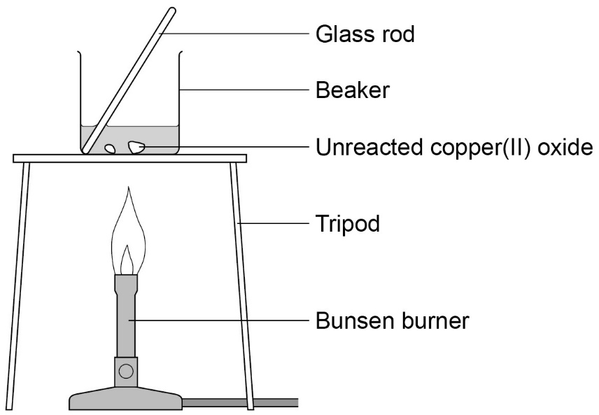

- Use the spatula to add small amounts of copper (II) oxide powder. Stir with the glass rod.
Continue to add copper (II) oxide if it keeps disappearing when stirred. When the
copper (II) oxide disappears the solution is clear blue.

- Stop adding the copper (II) oxide when some of it remains after stirring.
Allow apparatus to cool completely.

- Set up the filter funnel and paper over the conical flask. Use the clamp stand to hold the funnel.
Filter the contents of the beaker from step 3.

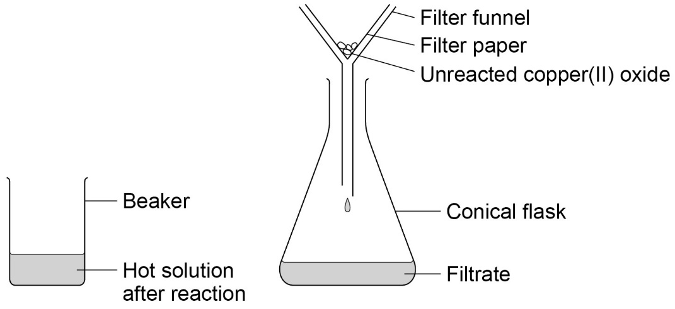

- When filtration is complete, pour the contents of the conical flask into the evaporating basin.
Evaporate this gently using a water bath (250 cm³ beaker with boiling water) on the tripod and gauze (see diagram). Stop heating once crystals start to form.

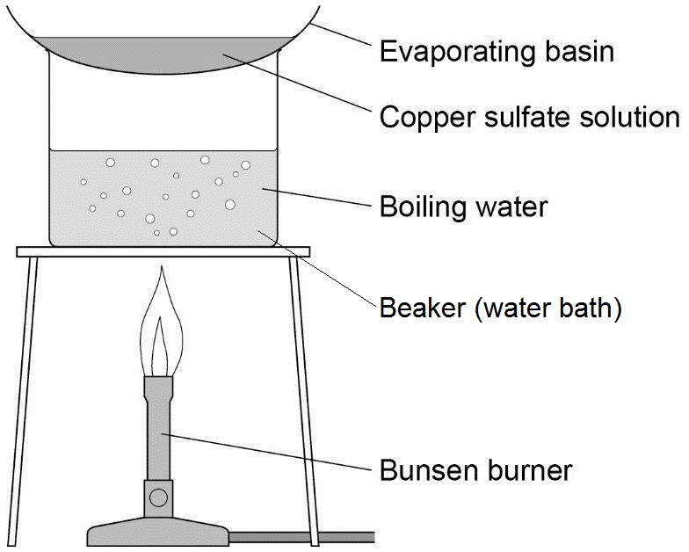

- Transfer the remaining solution to the crystallising dish. Leave this in a cool place for at least 24 hours.

- Remove the crystals from the concentrated solution with a spatula. Gently pat the crystals dry between two pieces of filter paper.
These are pure dry crystals of copper (II) sulfate.

GCSE Chemistry required practical activity: Electrolysis

Teachers’ notes

Required practical activity | Apparatus and techniques
Investigate what happens when aqueous solutions are electrolysed using inert electrodes.  This should be an investigation involving developing a hypothesis. | AT 3, AT 7, AT 8

Investigating the elements formed at each electrode when different salt solutions are electrolysed.

Materials

In addition to access to general laboratory equipment, each group of students needs:

- 0.5M copper (II) chloride solution
- 0.5M sodium chloride solution
- 0.5M copper (II) sulfate solution
- 0.5M sodium sulfate solution
- petri dish lid with bored holes
- two carbon rod electrodes with support bungs
- two crocodile/4mm plug leads
- low voltage power supply
- blue litmus paper
- tweezers.

Technical information

To prepare 0.5M copper (II) chloride solution and 0.5M copper (II) sulfate solution, consult CLEAPSS Recipe Book 31 and Guide L195.

To prepare 0.5M sodium chloride solution, consult CLEAPSS Recipe Book 82 and Guide L195.

Preparation of sodium sulfate solution is not covered by the Recipe Book.

Small petri dish lids fit 100 cm³ beakers well and can be drilled out at 180º spacing to take the two electrodes. If the carbon rods are then fitted with holed bungs that are positioned to rest on the lid above the holes, the rods will be stabilised well and the risk of short circuits will be much reduced.

Proprietary electrolysis cells are available, and can be substituted if available.

Additional information

Chlorine is produced during the first two electrolyses. Students should be warned not to inhale it, and the laboratory should be well ventilated. Limiting the p.d. to 4v and the electrolysis times to 5 minutes will minimize the risk of chlorine exposure.

Much longer times will be needed to collect enough oxygen and hydrogen for testing. If a Hofmann voltameter is available, it could be set up with sodium sulfate (or sulfuric acid) at the beginning of the lesson. This will usually produce enough oxygen and hydrogen for testing by the end of the lesson.

Much frustration can be avoided if the crocodile leads are tested for electrical continuity before this activity.

Risk assessment

- Risk assessment and risk management are the responsibility of the centre.
- Safety goggles must be worn throughout.
- 0.5M copper (II) chloride solution is covered by Hazcard 27A
- 0.5M copper (II) sulfate solution is covered by Hazcard 27C
- 0.5M sodium chloride solution is covered by Hazcard 47B
- 0.5M sodium sulfate solution is covered by Hazcard 98B
- Chlorine is covered by Hazcard 22A.

Trialling

The practical should be trialled before use with students.

GCSE Chemistry required practical activity: Electrolysis

Student sheet

Required practical activity | Apparatus and techniques
Investigate what happens when aqueous solutions are electrolysed using inert electrodes. This should be an investigation involving developing a hypothesis. | AT 3, AT 7, AT 8

Investigating the elements formed at each electrode when different salt solutions are electrolysed.

You will use a low voltage power supply and carbon rod electrodes to pass a current through four different salt solutions. You will identify the element formed at the positive and negative electrode in each case.

Learning outcomes
1

2

3

Teachers to add these with particular reference to working scientifically

Risk assessment

- Safety goggles should be worn throughout.

Method

You are provided with the following:

- copper (II) chloride solution
- copper (II) sulfate solution
- sodium chloride solution
- sodium sulfate solution
- 100 cm³ beaker
- petri dish lid
- two carbon rod electrodes
- two crocodile/4 mm plug leads
- low voltage power supply
- blue litmus paper
- tweezers.

Read these instructions carefully before you start work.

- Pour copper (II) chloride solution into the beaker to about 50 cm³.

- Add the lid and insert carbon rods through the holes. The rods must not touch each other.
Attach crocodile leads to the rods. Connect the rods to the dc (red and black) terminals of a low voltage power supply.

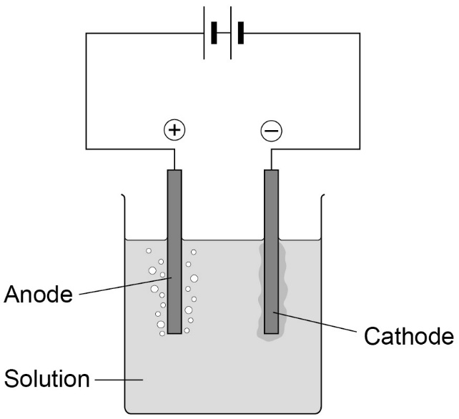

- Select 4 V on the power supply and switch on.

- Look at both electrodes. Is there bubbling at neither, one or both electrodes?

- Use tweezers to hold a piece of blue litmus paper in the solution next to the positive electrode (the one connected to the red terminal). You will need to lift the lid temporarily to do this.
Write your observations in the first blank row of the table below. What is this element?

Solution | Positive electrode (anode) |  | Negative electrode (cathode)
 | Observations | Element formed | Observations | Element formed
Copper (II) chloride
Copper (II) sulfate
Sodium
chloride
Sodium
sulfate

- After no more than five minutes, switch off the power supply.
Examine the negative electrode (the one connected to the black terminal). Is there evidence of a metal coating on it? What could it be?
Record your results in the table.

- Clean the equipment carefully.
Repeat steps 1‒6 using solutions of:
- copper (II) sulfate
- sodium chloride
- sodium sulfate.

Additional information

Gas produced at the positive electrode which does not bleach blue litmus paper, is oxygen. The amounts produced are usually too small to identify by testing.

If a gas is produced at the negative electrode, it is hydrogen. The amounts produced are usually too small to identify by testing.
GCSE Chemistry required practical activity: Temperature changes

Teachers’ notes

Required practical activity | Apparatus and techniques
Investigate the variables that affect temperature changes in reacting solutions such as, eg acid plus metals, acid plus carbonates, neutralisations, displacement of metals. | AT 1, AT 3, AT 5, AT 6

Investigation of the temperature changes which take place when an acid is neutralised by an alkali.

Materials

In addition to access to general laboratory equipment, each group of students needs:

- 2 M dilute hydrochloric acid
- 2 M sodium hydroxide solution
- expanded polystyrene cups and lids with thermometer holes
- 0-110ºC thermometers.

Technical information

To prepare 2 M dilute hydrochloric acid, consult CLEAPSS Recipe Book 43 and Guide L195.

To prepare 2 M sodium hydroxide solution, consult CLEAPSS Recipe Book 85 and Guide L195.

30 cm thermometers are preferable to 15 cm as they are easier to read over the small temperature increases expected and additionally the bulk of the thermometer scale will be above the hole in the lid.

Lids for polystyrene cups can be purchased and perforated, otherwise wooden lids can easily be constructed.

Additional information

Students may need to be reminded to keep thermometer bulbs fully immersed whilst making measurements. Additional guidance may need to be provided to students regarding the drawing of the two lines of best fit so that they intersect.

The solutions used are quite concentrated in order to produce reasonable temperature changes. 2M sodium hydroxide is particularly hazardous to the eyes. The risk assessment should take account of the ability and behaviour of the group and concentrations lowered if necessary. For example, 10 cm³ portions of 1M sodium hydroxide could be substituted.

Alternatively, students could investigate the change in temperature when a metal is added to an acid. They could do this by adding finely divided magnesium, zinc, iron and copper to dilute hydrochloric acid in an expanded polystyrene cup and then measure maximum temperature change for each metal.

Risk assessment

- Risk assessment and risk management are the responsibility of the centre.
- Safety goggles must be worn throughout.
- 2 M dilute hydrochloric acid (IRRITANT) is covered by Hazcard 47A
- 2 M sodium hydroxide solution (CORROSIVE) is covered by Hazcard 91.

Trialling

The practical should be trialled before use with students.

GCSE Chemistry required practical activity: Temperature changes

Student sheet

Required practical activity | Apparatus and techniques
Investigate the variables that affect temperature changes in reacting solutions such as, eg acid plus metals, acid plus carbonates, neutralisations, displacement of metals. | AT 1, AT 3, AT 5, AT 6

Investigation of the temperature changes which take place when an acid is neutralised by an alkali.

You will monitor the temperature rise as small volumes of sodium hydroxide solution are added to dilute hydrochloric acid. The acid will be contained in an insulated cup.

Plot a graph of your results. Determine how much sodium hydroxide was needed to fully react with the acid.

Learning outcomes
1

2

3

Teachers to add these with particular reference to working scientifically

Risk assessment

- Safety goggles should be worn throughout.

Method

You are provided with the following:
- 2 M dilute hydrochloric acid
- 2 M sodium hydroxide solution
- expanded polystyrene cup and lid
- 250 cm³ beaker
- 10 cm³ measuring cylinder
- 50 cm³ measuring cylinder
- thermometer.

Read these instructions carefully before you start work.

- Use the 50 cm³ measuring cylinder to put 30 cm³ dilute hydrochloric acid into the
polystyrene cup.

- Stand the cup inside the beaker. This will make it more stable.

- Use the thermometer to measure the temperature of the acid. Record it in the first blank column of the table such as the one below.

- Put 5 cm³ sodium hydroxide solution into the 10 cm³ measuring cylinder.

- Pour the sodium hydroxide into the cup. Fit the lid and gently stir the solution with the thermometer through the hole.
When the reading on the thermometer stops changing, write the temperature in the next space in the table.

- Repeat steps 4 and 5 to add further 5 cm³ amounts of sodium hydroxide to the cup. A total of 40 cm³ needs to be added.
The last few additions should produce a temperature fall rather than a rise.

- Repeat steps 1–6 and record the results in the second blank column of the table.

- Calculate the mean maximum temperature reached for each of the sodium hydroxide volumes. Record these means in the third blank column.

Total volume of sodium hydroxide  added in cm³ | Maximum temperature in ºC
 | First trial | Second trial | Mean
0
5
10
15
20
25
30
35
40

- Plot a graph with:
- ‘Mean maximum temperature in ºC’ on the y-axis
- ‘Total volume of sodium hydroxide added in cm³’ on the x-axis.

Draw two straight lines of best fit:
- one through the points which are increasing
- one through the points which are decreasing.

Ensure the two lines are extended so they cross each other.

- Use the graph to estimate how much sodium hydroxide solution was needed to neutralise 25 cm³ dilute hydrochloric acid.

GCSE Chemistry required practical activity: Rates of reaction

Teachers’ notes

Required practical activity | Apparatus and techniques
Investigate how changes in concentration affect the rates of reactions by a method involving measuring the volume of a gas produced and a method involving a change in colour or turbidity.  This should be an investigation involving developing a hypothesis. | AT 1, AT 3, AT 5, AT 6

Investigation into how the concentration of a solution affects the rate of a chemical reaction

There are two parts to this practical which investigate how the rate of reaction can be measured using colour change and the volume of gas produced.

Activity 1: Colour change

Materials

In addition to access to general laboratory equipment, each candidate needs:

- 40g/dm³ sodium thiosulfate solution
- 2.0 M dilute hydrochloric acid
- conical flask (100 cm³)
- printed black paper cross
- stopclock.

Technical information

To prepare 40g/dm³ sodium thiosulfate solution, consult CLEAPSS Recipe Book 87 and Guide L195. The concentration is specified in g/dm³ rather than mol/dm³ to simplify graph plotting for students. However, if it is desired that a Higher Tier group work in mole/dm³ then the base thiosulfate solution should be 0.2 M. The diluted solutions prepared by students will then be 0.16, 0.12, 0.08 and 0.04 mol/dm³.

To prepare 2.0 M dilute hydrochloric acid, consult CLEAPSS Recipe Book 43 and Guide L195.

Printed crosses may give a greater likelihood of students obtaining reproducible results between groups.

Additional information

This required practical should form the basis of a complete investigation and will probably require two 60 minute laboratory lessons to complete.
Sulfur dioxide is released during the reaction which can exacerbate breathing difficulties in people with pre-existing conditions such as asthma. The laboratory should be well ventilated. Consult CLEAPPS Guide L195 for additional safety information.

Risk assessment

- Risk assessment and risk management are the responsibility of the centre.
- Safety goggles should be worn throughout.
- 40g/dm3 sodium thiosulfate (LOW RISK) is covered by Hazcard 95C
- 2.0 M dilute hydrochloric acid (IRRITANT) is covered by Hazcard 47A
- Sulfur dioxide (TOXIC) is covered by Hazcard 97.

Trialling

The practical should be trialled before use with students.

Activity 2: Volume of gas

Materials

In addition to access to general laboratory equipment, each candidate needs:
- magnesium ribbon cut into 3 cm lengths
- dilute hydrochloric acid, 1.0 M
- safety goggles
- each group of students will need:
- conical flask (100 cm³)
- single-holed rubber bung and delivery tube to fit conical flask
- trough or plastic washing-up bowl
- measuring cylinders (100 cm³) 2
- clamp stand, boss and clamp
- stopclock
- graph paper.

Technical information

The magnesium ribbon needs to be cleaned by rubbing lengths of the ribbon with fine sandpaper to remove the layer of oxidation. To prepare Hydrochloric acid, HCl (aq) - see CLEAPSS Hazcard 47a and CLEAPSS Recipe Book 43. The bungs in the flasks need to be rubber, since corks are too porous and will leak.

Additional Information

Gas syringes can be used instead of troughs of water and measuring cylinders. But these are expensive and are probably best used by the teacher in a demonstration. Syringes should not be allowed to become wet, or the plungers will stick.

Risk assessment

- Risk assessment and risk management are the responsibility of the centre.
- Safety goggles should be worn throughout.
- 2.0 M dilute hydrochloric acid (IRRITANT) is covered by Hazcard 47A
- Magnesium ribbon, Mg(s) - see CLEAPSS Hazcard 59A.
- 3 Hydrogen gas, H2(g) (EXTREMELY FLAMMABLE) - see CLEAPSS Hazcard 48. Ensure that all naked flames are extinguished.

Trialling

The practical should be trialled before use with students.

GCSE Chemistry required practical activity: Rates of reaction

Student sheet
Required practical activity | Apparatus and techniques
Investigate how changes in concentration affect the rates of reactions by a method involving measuring the volume of a gas produced and a method involving a change in colour or turbidity.  This should be an investigation involving developing a hypothesis. | AT 1, AT 3, AT 5, AT 6

Investigation into how the concentration of a solution affects the rate of a chemical reaction

There are two parts to this practical which investigate how the rate of reaction can be measured.

Activity 1: Observing colour change
You will react sodium thiosulfate with hydrochloric acid. You will then find out how the rate of reaction changes as the thiosulfate solution becomes more dilute.

Activity 2: Measuring the volume of gas produced
You will react magnesium ribbon and hydrochloric acid. You will then find out how the rate of reaction is affected by the concentration of the acid.

Learning outcomes
1

2

3

4

Teachers to add these with particular reference to working scientifically

Risk assessment

Safety goggles should be worn throughout.
Method

Activity 1: Observing colour change

You are provided with the following:
- 40 g/dm³ sodium thiosulfate solution
- 2.0 M dilute hydrochloric acid
- 10 cm³ measuring cylinder
- 100 cm³ measuring cylinder
- 100 cm³ conical flask
- printed black paper cross
- stopclock.

Read these instructions carefully before you start work.

- Use a measuring cylinder to put 10 cm³ sodium thiosulfate solution into the conical flask.
Use the measuring cylinder to then add 40 cm³ water. This dilutes the sodium thiosulfate solution to a concentration of 8 g/dm³.
Put the conical flask on the black cross.

- Put 10 cm³ of dilute hydrochloric acid into the 10 cm³ measuring cylinder.

- Put this acid into the flask. At the same time swirl the flask gently and start the stopclock.

- Look down through the top of the flask. Stop the clock when you can no longer see the cross.
Take care to avoid breathing in any sulfur dioxide fumes.
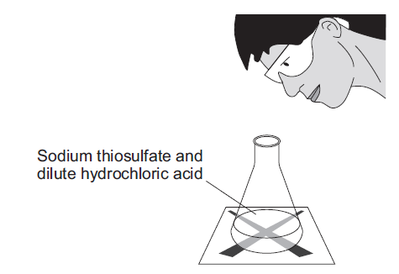

- Write the time it takes for the cross to disappear in the first blank column of the table such as the one below. Record the time in seconds.
You will need to multiply any minutes by 60 and then add the extra seconds.

Concentration of sodium thiosulfate in g/dm³ | Time taken for cross to disappear in seconds
 | First trial | Second trial | Third trial | Mean
8
16
24
32
40

- Repeat steps 1‒5 four times, but in step 1 use:
- 20 cm³ sodium thiosulfate + 30 cm³ water (concentration 16 g/dm³)
- 30 cm³ sodium thiosulfate + 20 cm³ water (concentration 24 g/dm³)
- 40 cm³ sodium thiosulfate + 10 cm³ water (concentration 32 g/dm³)
- 50 cm³ sodium thiosulfate + no water (concentration 40 g/dm³).

- Then repeat the whole investigation (steps 1–5) twice more.
Record the results in the second and third blank columns of the table.

- Calculate the mean time for each of the sodium thiosulfate concentrations. Leave out anomalous values from your calculations.
Record the means in the fourth blank column.

- Plot a graph with:
- ‘mean time taken for cross to disappear in seconds’ on the y-axis
- ‘Sodium thiosulfate concentration in g/dm³’ on the x-axis.

Draw a smooth curved line of best fit.
What can you say about the effect of the independent variable (concentration) on the dependent variable (time taken for the cross to disappear)? What were your control variables? Compare your results with those of others in the class. Is there evidence that this investigation is reproducible?

Activity 2: Measuring the volume of gas produced

You are provided with the following:
- safety goggles
- conical flask (100 cm³)
- single-holed rubber bung and delivery tube to fit conical flask
- trough or plastic washing-up bowl
- two measuring cylinders (100 cm³)
- clamp stand, boss and clamp
- stop clock
- graph paper
- magnesium ribbon cut into 3 cm lengths
- dilute hydrochloric acid, (2.0 M, and 1.0 M).

Read these instructions carefully before you start work.

- Measure 50 cm³ of 2.0 M hydrochloric acid using one of the measuring cylinders. Pour the acid into the 100 cm³ conical flask.

- Set up the apparatus as shown in the diagram.
Half fill the trough or bowl with water.

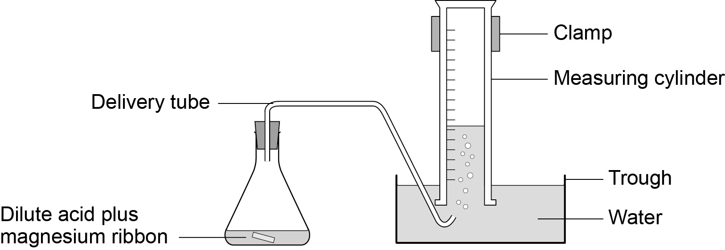

- Fill the other measuring cylinder with water. Make sure it stays filled with water when you turn it upside down.
- When you are ready, add a 3 cm strip of magnesium ribbon to the flask, put the bung back into the flask as quickly as you can, and start the stopclock.

- Record the volume of hydrogen gas given off at suitable intervals (eg 10 seconds) in a table such as the one below.
Continue timing until no more gas appears to be given off.

Time in seconds | Volume of gas produced for 2.0 M hydrochloric acid in cm³
10
20
30
40
50
60
70
80
90
100

- Repeat steps 1-5 using 1.0 M hydrochloric acid.

- Plot a graph with:
- ‘Volume of gas produced in cm³ (for 2.0 M hydrochloric acid)’ on the y-axis
- ‘Time in seconds’ on the x-axis.

- Draw a smooth, curved line of best fit.

- Plot a curve for 1.0 M hydrochloric acid on the same graph.

- Use this graph to compare the rates of reaction of 1.0 M and 2.0 M hydrochloric acid with magnesium.
- Compare your results with the data collected in Activity 1.

- Use kinetic theory to explain your findings.

GCSE Chemistry required practical activity: Chromatography

Teachers’ notes

Required practical activity | Apparatus and techniques
Investigate how paper chromatography can be used to separate and tell the difference between coloured substances. Students should calculate Rf values. | AT 1, AT 4

Investigation in to the use of paper chromatography to separate and identify a mixture of food colourings.

Materials

In addition to access to general laboratory equipment, each group of students needs:

- four known food colourings labelled A–D
- unknown food colouring labelled U
- rectangle of chromatography paper
- capillary melting point tubes.

Technical information

There are several brands of food colouring available. It will be necessary to experiment to obtain a type which gives good results. The unknown mixture should contain two of the known food colourings and a third colour not from A–D. Best results will be obtained if A–D are single dyes and not mixtures themselves.

Additional information

It is suggested that chromatography paper is pre-cut for student use so that it will not touch the beaker walls (if it does, capillary rise at the edges will distort the solvent front).

Melting point tubes take up food dye by capillary attraction and are a convenient way of making small reproducible spots.

Wet chromatography paper is difficult to take measurements from. Because of the drying time involved it may be necessary to make measurements and do calculations during the following lesson.

Students should be told to resist the temptation to move or touch the beaker once the experiment is under way.

A lid is sometimes suggested for good results, especially when the solvent is volatile, but is not essential with water. However, to illustrate good practice, if desired, a petri dish or lid makes a suitable lid. Cut-outs in the wall can be made at 180º to each other to clear the ends of the glass rod.

Risk assessment

- Risk assessment and risk management are the responsibility of the centre.
- Safety goggles must be worn throughout.
- There are no significant safety issues.
- Care should be taken with sharp broken melting point tubes.

Trialling

The practical should be trialled before use with students.

GCSE Chemistry required practical activity: Chromatography

Student sheet

Required practical activity | Apparatus and techniques
Investigate how paper chromatography can be used to separate and tell the difference between coloured substances. Students should calculate Rf values. | AT 1, AT 4

Investigation into the use of paper chromatography to separate and identify a mixture of food colourings.

You will use paper chromatography to separate the different colours present in an unknown mixture of food colourings. You will then measure the distance travelled by each colour and the solvents to calculate R_{f} values.

Learning outcomes
1

2

3

Teachers to add these with particular reference to working scientifically

Risk assessment

- Safety goggles should be worn throughout.

Method

You are provided with the following:

- 250 cm³ beaker
- glass rod
- a rectangle of chromatography paper
- four known food colourings labelled A-D
- an unknown mixture of food colourings labelled U
- glass capillary tubes.

Read these instructions carefully before you start work.

- Use a ruler to draw a horizontal pencil line 2 cm from a short edge of the chromatography paper.
Mark five pencil spots at equal intervals across the line. Keep at least 1 cm away from each end.

- Use a glass capillary tube to put a small spot of each of the known colourings on four of the pencil spots. Then use the glass capillary tube to put a small spot of the unknown mixture on the 5th pencil spot.
Try to make sure each spot is no more than 5 mm in diameter.
Label each spot in pencil.

- Pour water into the beaker to a depth of no more than 1 cm.

- Tape the edge of the chromatography paper to the glass rod. The paper needs to be taped at the end furthest from the spots.
Rest the rod on the top edge of the beaker. The bottom edge of the paper should dip into the water.
Ensure that the:
- pencil line is above the water surface
- sides of the paper do not touch the beaker wall.

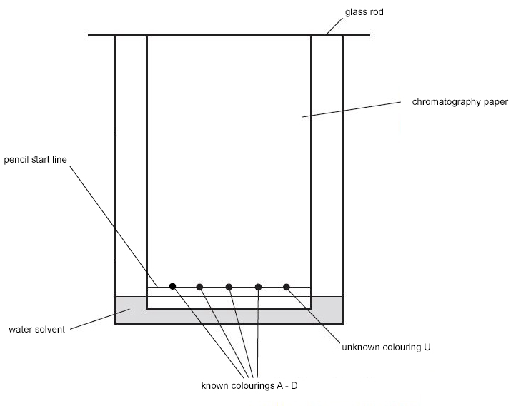
- Wait for the water solvent to travel at least three quarters of the way up the paper. Do not disturb the beaker during this time.
Carefully remove the paper. Draw another pencil line on the dry part of the paper as close to the wet edge as possible.

- Hang the paper up to dry thoroughly.

- Measure the distance in mm between the two pencil lines. This is the distance travelled by the water solvent.
Measure and record the same distance for each food colouring in the table below.

Food colouring | Distance travelled in mm |  | Rf value
 | Solvent | Spot
A
B
C
D

- For each of the four known colours, measure the distance in mm from the bottom line to the centre of each spot. Write each measurement in the table.

- Use the following equation to calculate the R_{f} value for each of the known colours.

$${\text{R}}_{\text{f}}\text{ = }\frac{\text{distance}\text{ moved by substance}}{\text{distance moved by solvent}}$$

Write the calculated values in the table.

- Match the spots in mixture U with those from A–D. Use the colour and distance travelled to help you.
Which of colourings A–D are in mixture U?
Are there any other colourings in mixture U which do not match A–D?

GCSE Chemistry required practical activity: Water purification

Teachers’ notes

Required practical activity | Apparatus and Techniques
Analysis and purification of water samples from different sources, including pH, dissolved solids and distillation. | AT 2, AT 3, AT 4

Analysis and Distillation of water from different sources

Materials
In addition to access to general laboratory equipment, each group needs:

- 50 cm³ sample of ‘sea water’
- 10 cm³ sample of ‘spring water’
- 10 cm³ sample of ‘rain water’
- a few ice cubes
- universal indicator solution or paper.
- access to balance(s) with resolution to 0.01 g.

Technical information
Although only a small quantity of water needs to be distilled, enough needs to be present in the flask to avoid it boiling dry and cracking.

Ersatz sea water can be produced by dissolving 25 g sodium chloride in 1 dm³ water. The pH will need to be adjusted so that it produces a turquoise colour with universal indicator, indicating a pH of 8.0 – 8.5. This can be achieved by adding sodium carbonate solution in small volumes and monitoring with a pH probe until the desired pH is reached.

Ersatz spring water can be simulated using 0.1 M magnesium sulfate solution. This should have a pH of 5.5 – 6.5 and should turn universal indicator yellow-green.

To prepare 0.1 M magnesium sulfate solution, consult CLEAPSS Recipe Book 55.

Ersatz rainwater could be distilled water acidified to produce an orange-yellow effect with universal indicator and a pH of 5.0 – 5.5. This can be done by bubbling carbon dioxide through the water whilst monitoring with a pH probe.

Additional information

Students should be warned about the need to avoid the water bath boiling dry.

Students will need to be cautioned to remove the heat source during distillation if it seems likely the sea water will boil over through the delivery tube. They should also be told to keep the delivery tube at least 2cm from the bottom of the collecting test tube, otherwise the distillate level may rise above it, creating the possibility of suck-back when heating is discontinued.

The complete procedure will probably take two 60 minute lessons to allow for setting up, cooling and clearing away.

If preferred, the weighing of the evaporated residues can be replaced by a qualitative observation of the presence or otherwise of dissolved solids and relative amounts.

Risk assessment

Risk assessment and risk management are the responsibility of the centre. Eye protection should be worn throughout.

0.1 M magnesium sulfate solution (LOW RISK at this concentration) is covered by Hazcard 59B.

Trialling

The practical should be trialled before use with students.

Supplementary demonstration

Outline method | Suggested apparatus | Suggested reagents
Testing pH of water samples using pH probe. Distillation of seawater to obtain water using Liebig condenser. Place solution in clamped side arm distillation flask over tripod, gauze and Bunsen burner or electric heating mantle. Fit thermometer and Liebig condenser and distil into conical flask. | pH probe, Tripod, gauze, clamp stand, heatproof mat, Bunsen burner OR electric heating mantle, side arm distillation flask, thermometer in bung, Liebig condenser, conical flask. | Sea water, spring water, rain water.

GCSE Chemistry required practical activity: Water purification

Student sheet

Required practical activity | Apparatus and Techniques
Analysis and purification of water samples from different sources, including pH, dissolved solids and distillation. | AT 2, AT 3, AT 4

Analysis and Distillation of water from different sources

In this investigation you will test three water samples from different sources for pH and the presence of dissolved solids. After distillation of the sea water, you will test the water again to check that dissolved solids have been removed, making the water fit to drink.

Learning Outcomes
1.

2.

Teachers to add these with particular reference to working scientifically

Method
You are provided with the following:
- water samples
- universal indicator
- test tubes and rack
- Bunsen burner
- 10 cm³ measuring cylinder
- tripod
- gauze
- heatproof mat
- 250 cm³ beaker
- watch glass
- tongs
- clamp stand
- 250 cm³ conical flask
- delivery tube with bung
- ice.
You should read these instructions carefully before you start work.

- Pour around 1 cm depth of the sea water into a test tube in the rack. Add a few drops of universal indicator solution. Using a pH colour chart, match the colour and record the pH of the water in the results table. Repeat this test for spring water and rain water and record the results.

- Weigh a dry watch glass. Record its mass in the table. Pour 4 cm³ sea water (less if your watch glass is small) into it and place it above a beaker acting as a water bath as shown in the diagram.
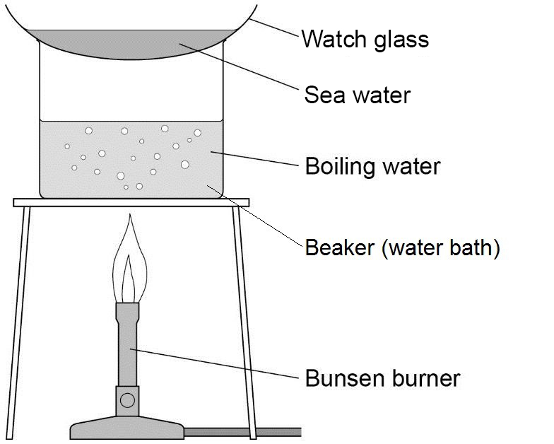

- Allow all the water to evaporate from the watch glass. Do not let the water bath boil dry.

- You should see dissolved solids on the glass. Remove the watch glass with tongs and allow to cool. Dry the bottom of the watch glass with a cloth and reweigh it. Record the new mass in the table. Subtract the mass of the watch glass alone and record the mass of the dissolved solids. Wash the watch glass and dry it.

- Repeat steps 2 – 4 for the other water samples. You do not need to weigh the empty watch glass again as long as you use the same one each time.

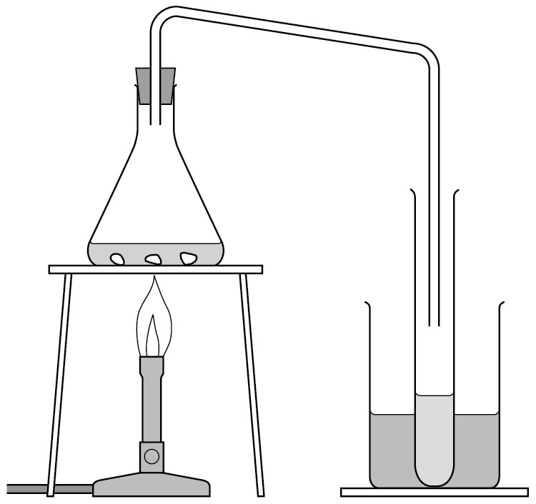
Place the remaining sea water (around 40 cm³) in the conical flask and set up the apparatus for distillation as shown in the diagram.

- Make sure the conical flask is held on the tripod and gauze using the clamp stand. Place a mixture of ice and water in the beaker surrounding the test tube.

- Heat the sea water with the Bunsen burner until it starts to boil. Then reduce the heat so that the water boils gently. Distilled water will collect in the cooled test tube. Collect about 5 cm depth of water in this way, then stop heating.

- Repeat the tests in steps 1 to 4 again using the distilled sea water, again recording your results in the table. How does the distilled water compare with the undistilled sea water?

Water | pH | Mass in grams
 |  | Watch glass | Watch glass and dissolved solids | Dissolved solids
Sea
Spring
Rain
Distilled sea

GCSE Physics required practical activity: Specific heat capacity

Teachers’ notes
Required practical activity | Apparatus and techniques
An investigation to determine the specific heat capacity of one or more materials. The investigation will involve linking the decrease of one energy store (or work done) to the increase in temperature and subsequent increase in thermal energy stored. | AT 1, AT 5

What is the specific heat capacity of copper?

Materials

In addition to access to general laboratory equipment, each group of student’s needs:
V
A
12V

- 1 kg copper block with two holes – one for the heater and one for the thermometer
- 1 kg iron, aluminium or lead blocks for comparison
- thermometer
- pipette to put water in the thermometer hole
- 30 W heater
- 12 V power supply
- insulation to wrap around the blocks
- ammeter and voltmeter
- 4mm leads
- stop watch or stop clock
- balance (capable of measuring more than 1 kg) to determine the mass of the blocks
- heatproof mat.

Technical information

The method involves using the electric heaters to raise the temperature of the blocks. You may have blocks made for this experiment. The blocks usually have a mass of 1 kg and have holes that fit the heater and the thermometer. The heaters fit snugly but there is usually an air gap around the thermometer. A drop of water provides a better thermal contact. The blocks should be insulated to reduce heat loss to the surroundings.

The students will switch on the power supply and measure the current and potential difference. This is to obtain the power of the heater (power = IV) which should remain constant. Typically the heaters are either about 30 W or 50 W. The students can be told the power of the heater rather than measure it if preferred. The students measure and record the temperature of the block every minute for about 10 minutes. They then plot a graph of temperature against electrical work done by the heater. There is some thermal inertia as the block warms up so the beginning of the student’s graphs will not be linear if they start timing from when they switch on.

The student work sheet suggests comparing the specific heat capacities of three metals – aluminium, copper and iron. If you don’t have all three types of block, the experiment can become a simple measurement of one of them.

Additional information

The specific heat capacity of a substance is the amount of energy required to raise the temperature of one kilogram of the substance by one degree Celsius.

The students obtain values for current and potential difference (to work out the power), time and temperature. From the power and time they can work out the energy used, or electrical work done by the heater. A graph of temperature against electrical work done should be a straight line once the block has warmed a bit. Students use the gradient of this line and the mass of the block to work out the specific heat capacity. Having blocks of different materials allows students to see that specific heat capacities vary significantly, even between metals.

Metal | Copper | Aluminium | Iron | Lead
Specific heat capacity (J kg⁻¹ K⁻¹) | 385 | 913 | 500 | 126

Using a 30 W heater for 10 minutes transfers 30 × 60 × 10 = 18 000 J

This would be sufficient to raise the temperature of 1 kg of copper from room temperature to about 70 °C, aluminium to about 40 °C and iron to 55 °C. This supports the idea that 10 minutes is an adequate length of time for the experiment.
An alternative method involves calculating the specific heat capacity of lead shot in a sealed tube. If the tube is turned, the lead shot will fall generating heat when it hits the bottom. If this is repeated 40 times the work done can be calculated and the temperature rise of the shot can be used to calculate the specific heat capacity.

Risk assessment

- Risk assessment and risk management are the responsibility of the centre.
- The mains leads of the power supplies should be checked. The heater connections should also be checked. They will also get hot, particularly if left on without being in contact with the blocks.

Trialling

The practical should be trialled before use with students.

GCSE Physics required practical activity: Specific heat capacity

Student sheet

Required practical activity | Apparatus and techniques
An investigation to determine the specific heat capacity of one or more materials. The investigation will involve linking the decrease of one energy store (or work done) to the increase in temperature and subsequent increase in thermal energy stored. | AT 1, AT 5

What is the specific heat capacity of copper?

In this investigation you will heat up a block of copper using an electric heater.

You will measure:
- mass
- work done by the heater
- temperature.

You will plot a graph of temperature against work done. The gradient of this graph and the mass of the block will be used to determine the specific heat capacity of copper.

Learning outcomes
1

2

3

Teachers to add these with particular reference to working scientifically

Method

You are provided with the following:

- copper block wrapped in insulation, with two holes for a thermometer and heater
- thermometer
- pipette to put water in the thermometer hole
- 30 W heater
- 12 V power supply
- insulation to wrap around the blocks
- ammeter and voltmeter
- five 4 mm leads
- stop watch or stop clock
- balance.

Read these instructions carefully before you start work.

- Measure and record the mass of the copper block in kg.

- Place a heater in the larger hole in the block.

- Connect the ammeter, power pack and heater in series.

- Connect the voltmeter across the power pack.
V
A
12V

- Use the pipette to put a small amount of water in the other hole.

- Put the thermometer in this hole.

- Switch the power pack to 12 V. Switch it on.

- Record the ammeter and voltmeter readings. These shouldn’t change during the experiment.

- Measure the temperature and switch on the stop clock.

- Record the temperature every minute for 10 minutes.
Add your results to a table such as the one below.

Time in seconds | Work done in J | Temperature in °C
0
60
120
180
240
300
360
420
480
540
600

- Calculate the power of the heater in watts.
To do this, multiply the ammeter reading by the voltmeter reading.

- Calculate the work done by the heater. To do this, multiply the time in seconds by the power of the heater.
- Plot a graph of temperature in ºC against work done in J.

Temperature in °C
Work done in J

- Draw a line of best fit. Take care as the beginning of the graph may be curved.

- Mark two points on the line you have drawn and calculate the change in temperature (θ) and the change in work done (E) between these points

- Calculate the specific heat capacity of the copper (c ) by using the equation

$\text{c = }\frac{\text{E}}{\text{m }\text{ θ }}$ where m is the mass of the copper block

- Repeat this experiment for blocks made from other materials such as aluminium and iron.

- Look at the following hypothesis:

Metal blocks with the same mass, yet bigger volume
have a bigger specific heat capacity.

Is this true for the blocks you tested?

GCSE Physics required practical activity: Resistance

Teachers’ notes

Required practical activity | Apparatus and techniques
Use circuit diagrams to set up an appropriate circuit to investigate a factor/the factors that affect the resistance of an electrical component. This should include:  • the length of a wire at constant temperature  • combinations of resistors in series and parallel. | AT 1, AT 6, AT 7

There are two parts to this practical:

- Investigating how the resistance of a wire varies with its length
- Investigating resistance in series and parallel circuits.

Materials

In addition to access to general laboratory equipment, each group of students needs access to:

- a battery or suitable power supply
- ammeter or multimeter
- voltmeter or multimeter
- crocodile clips
- resistance wire eg constantan
- metre ruler
- connecting leads
- wire-wound resistors, eg 10 Ω

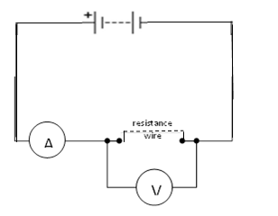
V
A

Technical information

The most straightforward way to investigate resistance is to use an ohmmeter. However, this practical requires the students to make a circuit, measure current and potential difference and calculate the resistance.

There are at least 5 different experiments that could be carried out: the circuit is the same in each case. However, this practical focuses on the variation of resistance with length.

Use a length of resistance wire (just over a metre of 22 swg constantan). Attach it to a metre ruler using tape. Attach a crocodile clip to one end (the zero end of the ruler) of the material. Attach the other crocodile clip to the wire. The students vary the length of wire by moving this crocodile clip and record the length of wire, current and potential difference.

Additional information
The e resistance of the wire is proportional to its length. A graph of resistance against length should be a straight line through the origin. This experiment is a good one to use to discuss zero error as it is hard to attach the crocodile precisely to the zero end of the wire, and there will be some contact resistances. The potential difference will not vary very much during the experiment. Use a low value of potential difference particularly for the short length of wire as the current will increase significantly and the wire can get quite hot. The wire should be fairly thin to give decent values of resistance.

Lock variable power supply unit to low voltages, if possible. Use heatproof mats.
For the second activity, any suitable value of resistors may be used, but if wire wound resistors are used, this should alleviate any potential problems with overheating.

Give students two resistors of the same value and ask them to connect them into the two circuits shown below. By measuring the voltage across the resistors and the current through them (placing the meters in the positions shown in the circuit diagrams) they can calculate the total resistance of the circuit.

As an extension, you could ask them to put three identical resistors in series and then in parallel.

As a further extension you could ask them to measure the current at different points in the circuit.

Risk assessment

- Risk assessment and risk management are the responsibility of the centre.
- Short lengths of wire are likely to get hot. Use low values of potential difference. Switch off between readings.

Trialling

The practical should be trialled before use with students.

GCSE Physics required practical activity: Resistance

Student sheet
Required practical activity | Apparatus and techniques
Use circuit diagrams to set up an appropriate circuit to investigate a factor/the factors that affect the resistance of an electrical circuit. This should include:  • the length of a wire at constant temperature  • combinations of resistors in series and parallel. | AT 1, AT 6, AT 7

Activity 1: Investigating how the resistance of a wire varies with its length

A dimmer switch allows you to control the brightness of a lamp.

You will investigate how the dimmer switch works. You will construct a circuit to measure the potential difference across a wire and the current in the wire. You will do this for different lengths of wire.

Learning outcomes
1

2

3

Teachers to add these with particular reference to working scientifically

Method

You are provided with the following:

- a battery or suitable power supply
- ammeter or multimeter
- voltmeter or multimeter
- crocodile clips
- resistance wire eg constantan
- connecting leads.
Read these instructions carefully before you start work.

- Connect the circuit.
It may be helpful to start at the positive side of the battery or power supply. This may be indicated by a red socket.

- Connect a lead from the red socket to the positive side of the ammeter.

- Connect a lead from the negative side of the ammeter (this may be black) to the crocodile clip at the zero end of the ruler.

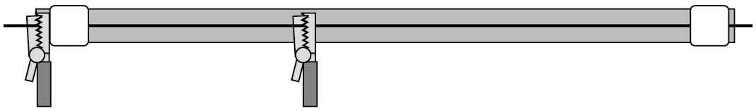

- Connect a lead from the other crocodile clip to the negative side of the battery.
The main loop of the circuit is now complete. Use this lead as a switch to disconnect the battery between readings.

- Connect a lead from the positive side of the voltmeter to the crocodile clip the ammeter is connected to.

- Connect a lead from the negative side of the voltmeter to the other crocodile clip.

- Record on a table the:
- length of the wire between the crocodile clips
- the readings on the ammeter
- the readings on the voltmeter.

You will need four columns in total.

Length of wire in cm | Potential difference in V | Current in A | Resistance in Ω

- Move the crocodile clip and record the new ammeter and voltmeter readings. Note that the voltmeter reading may not change.
Repeat this to obtain several pairs of meter readings for different lengths of wire.

- Calculate and record the resistance for each length of wire using the equation:

resistance in Ω | = | potential difference in V
 |  | current in A
- Plot a graph with:
- ‘Resistance in Ω’ on the y-axis
- ‘Length of wire in cm’ on the x-axis.

- You should be able to draw a straight line of best fit although it may not go through the origin.

Activity 2: Investigating resistors in series and in parallel

You are provided with the following:

- a battery or suitable power supply
- ammeter or multimeter
- voltmeter or multimeter
- crocodile clips
- two 10Ω resistors
- connecting leads.

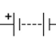
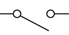
Read these instructions carefully before you start work.
Voltmeter
Switch
V
A
R₁
Ammeter
Power supply
R₂

- Connect the circuit for two resistors in series, as shown in the diagram.

- Switch on and record the readings on the ammeter and the voltmeter.

- Use these readings to calculate the total resistance of the circuit.

- Now set up the circuit for two resistors in parallel.
R₂
Switch
Voltmeter
Ammeter
V
A
R₁
Power supply
- Switch on and record the readings on the ammeter and the voltmeter.

- Use these readings to calculate the total resistance of the circuit.

- With one single resistor in the circuit, the total resistance would be 10 ohms. What is the effect on the total resistance of adding:
  - another identical resistor in series
  - another identical resistor in parallel?

- You could also try setting up a circuit with three resistors in series and one with three resistors in parallel.

- What conclusions can you come to about the effect of adding resistors
- In series
- In parallel.

GCSE-Physics required practical activity: I-V characteristics

Teachers’ notes

Required practical activity | Apparatus and techniques
Use circuit diagrams to construct appropriate circuits to investigate the I-V characteristics of variety of circuit elements including a filament lamp, a diode and a resistor at constant temperature. | AT 6, AT 7

What happens to the current when the p.d across a component changes?

Materials

In addition to access to general laboratory equipment, each group needs access to:

- ammeter and milliammeter, or multimeter
- voltmeter or multimeter
- component holders
- 12 V, 24 W lamp e.g. a ray box lamp
- resistor, for example 100 Ω, 1 W
- diode and protective resistor (eg 10 Ω)
- variable resistor eg 10 Ω, 5 A
- connecting leads.

Technical information

There are many different kits available and the students should use what is familiar to them. If using multimeters, it may be helpful to tape over the connections not in use.

When using the diode, the students will need to use a protective resistor. They should still be able to connect the voltmeter across the diode (ie the resistor and diode should not be soldered together).

If a lab pack is used for the power supply this can remove the need for the variable resistor as the pd can be varied directly.

The pd should not be allowed to get so high as to damage the components.

Additional information

There are three separate experiments.

The students will record the current through each component for different values of pd. The pd. will be varied using a rheostat, although a variable power supply may be used.
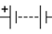
A
V
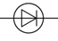
The students will plot a graph of current against pd. This is what is meant by a characteristic.

A

V

mA
V
The circuit with the diode will need to be protected to prevent the current through it getting too big. This circuit also behaves differently depending on the polarity of the supply and due to the low currents through it. A milliammeter will need to be used.

Risk assessment

- Risk assessment and risk management are the responsibility of the centre.
- Care should be taken as components, particularly lamps, are likely to get quite hot. The mains lead should be checked for damage before a lab pack is used by a student.

Trialling

The practical should be trialled before use with students.

GCSE Physics required practical activity: I-V characteristics

Student sheet

Required practical activity | Apparatus and techniques
Use circuit diagrams to construct appropriate circuits to investigate the I-V characteristics of a variety of circuit elements including a filament lamp, a diode and a resistor at constant temperature. | AT 6, AT 7

What happens to the current when the pd across a component changes?

There are three activities. In each one you are going to measure electric current in a component as you change the potential difference (Pd) across the component.

You will then plot a graph of current in against potential difference in V. You will investigate the behaviour of a resistor, a lamp and a diode.

Learning outcomes
1

2

3

Teachers to add these with particular reference to working scientifically

Method

You are provided with the following:

- ammeter and milliammeter, or multimeter
- voltmeter or multimeter
- component holders
- 12 V, 24 W lamp eg a ray box lamp
- resistor
- diode and protective resistor eg 10 Ω
- rheostat eg 10 Ω, 5 A
- connecting leads.

Read these instructions carefully before you start work.

Activity 1: The characteristic of a resistor

- Connect the circuit. It may be helpful to start at the positive side of the battery or power supply. This may be indicated by a red socket.

- Connect a lead from the red socket to the positive side of the ammeter.
A
V
- Connect a lead from the negative side of the ammeter (this may be black) to one side of the resistor.

- Connect a lead from the other side of the resistor to the variable resistor.

- Connect a lead from the other side of the variable resistor to the negative side of the battery.
The main loop of the circuit is now complete. Use this lead as a switch to disconnect the battery between readings.

- Connect a lead from the positive side of the voltmeter to the side of the resistor the ammeter is connected to.

- Connect a lead from the negative side of the voltmeter to the other side of the resistor.

- Record the readings on the ammeter and voltmeter in a suitable table.

- Adjust the variable resistor and record the new ammeter and voltmeter readings. Repeat this to obtain several pairs of readings.

- Swap the connections on the battery. Now the ammeter is connected to the negative terminal and the variable resistor to the positive terminal.
The readings on the ammeter and voltmeter should now be negative.

- Continue to record pairs of readings of current and potential difference with the battery reversed.

- Plot a graph with:
- ‘Current in A’ on the y-axis
- ‘Potential difference in V’ on the x-axis.

As the readings include negative values the origin of your graph will be in the middle of the graph paper.

- You should be able to draw a straight line of best fit through the origin. This is the characteristic of a resistor.

Read these instructions carefully before you start work.

Activity 2: The characteristic of a lamp

- Swap the leads on the battery back to their original positions.

- Replace the resistor with the lamp.
If you are making the circuit from the beginning, follow steps 1-7 in the procedure for the resistor above. For these instructions, use a lamp in place of the resistor.

A

V

- The lamp will get hot. Take care not to touch it.

- Follow steps 8‒11 in the procedure for the resistor above. Remember to swap the leads on the battery to obtain negative readings.
- Plot a graph with:
- ‘Current in A’ on the y-axis
- ‘Potential difference in V’ on the x-axis.

The origin will be in the middle of the paper.
Draw a curved line of best fit for your points.

Read these instructions carefully before you start work.

Activity 3: The characteristic of a diode

- Swap the leads on the battery back to their original positions.

- If you can, reduce the battery potential difference to less than 5 V.

- Remove the lead from the positive side of the battery. Connect it to the extra resistor labelled P.

- Connect the other end of resistor P to the positive side of the battery.

- Replace the ammeter with a milliammeter
or
change the setting on the multimeter.
V
mA

- Replace the lamp with the diode. Connect the positive side of the diode to the milliameter.

- Repeat steps 1–6 above to obtain pairs of readings of potential difference and current for the diode.

- Plot a graph with:
- ‘Current in A’ on the y-axis
- ‘Potential difference in V’ on the x-axis.

The origin will probably be in the middle of the bottom of your graph paper.
There should not be any negative values of current.

GCSE Physics required practical activity: Density

Teachers’ notes

Required practical activity | Apparatus and techniques
Use appropriate apparatus to make and record the measurements needed to determine the densities of regular and irregular solid objects and liquids.  Volume should be determined from the dimensions of regularly shaped objects and by a displacement technique for irregularly shaped objects.  Dimensions to be measured using appropriate apparatus such as a ruler, micrometre or Vernier callipers | AT 1

Using density to identify what something is made from.

Materials

In addition to access to general laboratory equipment, each student needs access to the following apparatus.

For the regular shaped solid objects:
- 30 cm ruler marked off in mm
- digital balance
- materials kits ie various regular shaped objects made of iron, copper, aluminium.

For the irregular shaped solid objects:

- digital balance
- displacement can and something to stand it on (eg a brick)
- measuring cylinders
- 250 ml beaker of water and an extra empty beaker
- paper towels
- cotton or thin string
- various irregular shaped objects.

For the liquids:

- digital balance
- 250 ml beaker
- suitable liquid eg sugar solution.

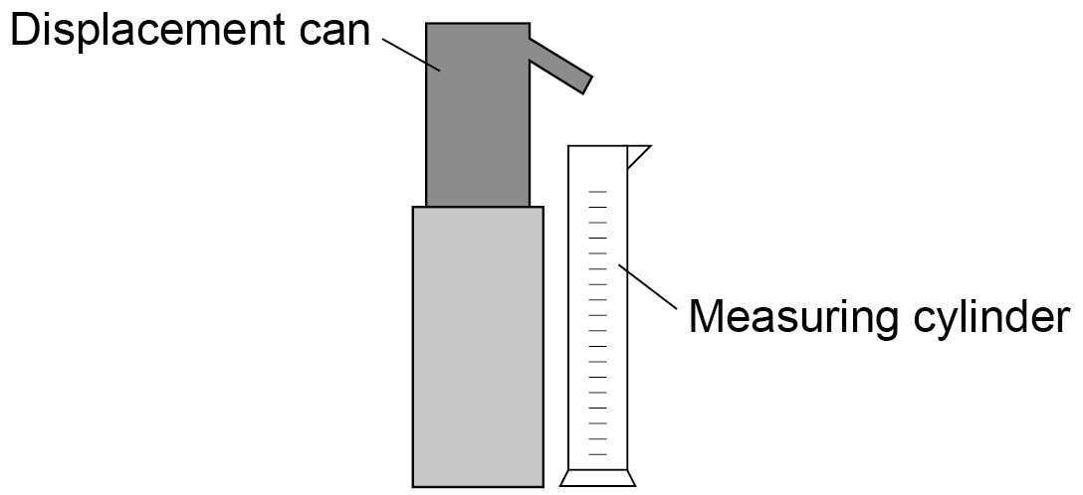

Ideally the digital balance should have a range of 1 kg in 1 g steps.

The experiments are relatively straightforward although the measurement of the densities of the liquids and the irregular objects may create a bit of a mess.

The experiments may be best done as part of a circus – so that everyone uses the different density measuring techniques.

You may want to label the solid objects for easy identification.

The displacement can spout is likely to be too low to fit a measuring cylinder underneath it so use a brick or something similar to stand the displacement can on. Alternatively, they can tip the measuring cylinder so that it goes under the spout, but they may knock the spout when moving it.

Additional information

There are three separate experiments. The density of regular objects focuses on the use of a millimetre scale ruler and the calculations of volume and density. Students use their value of density to identify the material of the object being measured.

In the second experiment students measure the volume by displacement. This can be done by lowering the object into a sufficiently large measuring cylinder and noting the change in volume reading. However, a displacement can allows the use of narrower and therefore more precise measuring cylinders to measure the volume. The students should choose a measuring cylinder and justify their choice.

The density of liquid experiment does not make use of specific gravity bottles. It is a basic technique and students identify a liquid from its density.

Risk assessment

- Risk assessment and risk management are the responsibility of the centre.
- There are no serious issues related to these activities.

Trialling

The practical should be trialled before use with students.

GCSE Physics required practical activity: Density

Student sheet

Required practical activity | Apparatus and techniques
Use appropriate apparatus to make and record the measurements needed to determine the densities of regular and irregular solid objects and liquids.  Volume should be determined from the dimensions of regularly shaped objects and by a displacement technique for irregularly shaped objects.  Dimensions to be measured using appropriate apparatus such as a ruler, micrometre or Vernier callipers. | AT 1

Identifying a substance from its density

There are three activities. In each one you are going to measure the density of an object. You will then use this value to find out what the substance is. You will be expected to work as accurately as possible.

Activity 1: you will determine the density of a regular shaped object using a ruler and balance.

Activity 2: you will measure the mass of an object in the same way as activity 1. You will also measure its volume from the amount of water it displaces.

Activity 3: you will find the density of a liquid.

Learning outcomes
1

2

3

Teachers to add these with particular reference to working scientifically

Method

Activity 1: Regular shaped objects

You are provided with the following:

- 30 cm ruler marked off in mm
- digital balance
- regular shaped objects.

Read these instructions carefully before you start work.

- For each object measure the:
- length
- width
- height.

- Record your results in a table.
Include columns for:
- volume
- mass
- density
- substance.

- Measure the mass of each object using the digital balance. Record the results.

- Calculate and record the volumes (length × width × height).

- Calculate and record the densities (mass ÷ volume).

- Use the table below to identify the substance each object is made from.

Substance | Aluminium | Zinc | Iron | Copper | Gold
Density in g/cm³ | 2.7 | 7.1 | 7.9 | 8.9 | 19.3

Activity 2: Irregular shaped objects.

You are provided with the following:

- digital balance
- displacement can and something to stand it on (eg a brick)
- various measuring cylinders
- beaker of water and an extra empty beaker
- paper towels
- cotton or thin string
- irregularly shaped objects.

Read these instructions carefully before you start work.

- Measure the mass of one of the irregular shaped objects.

- Record your result in a table.
It will need columns for:
- volume
- density
- mass
- substance.

- Place a displacement can on a brick. Put an empty beaker under the spout and fill the can with water. Water should be dripping from the spout.

- Wait until the water stops dripping. Then place a measuring cylinder under the spout instead of the beaker.
Choose the measuring cylinder you think will give the most precise reading.

- Tie the object to a piece of cotton. Very carefully lower it into the displacement can so that it is completely submerged.
Collect all of the water that comes out of the spout in the measuring cylinder.

- Measure and record the volume of the collected water. This volume is equal to the volume of the object.

- Calculate and record the density of the object.
Try to find out what substance it is made from.

- Repeat steps 1‒7 for some other objects.
Remember to refill the can each time.

Activity 3 – liquids

You are provided with the following:

- digital balance
- 250 ml beaker
- 100 ml measuring cylinder
- suitable liquid eg sugar solution.

Read these instructions carefully before you start work.

- Measure the mass of the empty beaker.

- Record your results in a table.
Your table will need columns for the:
- mass of the empty beaker
- mass of the beaker with the liquid in
- mass of the liquid
- volume of the liquid
- density of the liquid.

- Pour about 100 ml of liquid into the measuring cylinder.
Measure and record the volume.

- Pour this liquid into the beaker.
Measure and record the mass of the beaker and liquid.

- Calculate and record the volume of the liquid.

- Calculate the density of the liquid.

- The density of water is 1 g/cm³.

- Determine the mass of sugar per cm³ dissolved in the water. Assume the sugar does not affect the volume of the water.

GCSE Physics required practical activity: Force and Extension

Teachers’ notes

Required practical activity | Apparatus and techniques
Investigate the relationship between force and extension for a spring. | AT 1, AT 2

Making and calibrating a spring-balance (newtonmeter).

Materials

In addition to access to general laboratory equipment, each group of students needs:

- a spring of a suitable stiffness (eg capable of extending more than 1 cm under a load of 1 N) with loops at each end
- metre ruler
- suitable pointer – eg splint and tape
- weight stack appropriate for the spring eg 10 N in steps of 1 N
- clamp stand, 2 clamps and bosses
- g clamp or weight to prevent the apparatus tipping over the edge
- object, eg stone attached to string, to weigh.

Technical information
If you are using new springs, you should extend them under a suitable load for a short while.
The pointer should be attached so that it doesn’t slip or change angle. It is probably best attached to the bottom of the spring. The students will measure the extension ie the increase in length. Many are likely to think that this is the incremental increase – in fact it is the total increase (ie from the original length). The students align the top of the ruler with the top of the spring – this isn’t essential but it may help emphasise this point about the extension.

Students may need to be told how to convert the mass (in grams) written on the weight stack into a weight in newtons. (Using the equation W = mg, 100 g has a weight of 1 N). This practical can be used to emphasise the difference between mass and weight.

The weight of the stone should be within the range of weights used. The length of the spring shouldn’t exceed one metre when fully stretched.
Additional information

The relationship between force and extension is given by Hooke’s Law. This is an opportunity to investigate the life and work of Robert Hooke who was a contemporary of Isaac Newton.
The students will record the reading on the metre ruler (which will be the length of the spring if set up that way) as the weights are added. They will then calculate the extension (ie the increase from the original reading). The extension should increase in proportion to the weight. A graph of extension against weight will be a straight line through the origin. The gradient of the line is 1/stiffness or 1/spring constant. (ie the graph for a stiffer spring will have a lower gradient). To determine the weight of the stone, students measure the extension and either use their graphs (read off the weight directly) or use 1/gradient multiplied by the extension to give the weight.

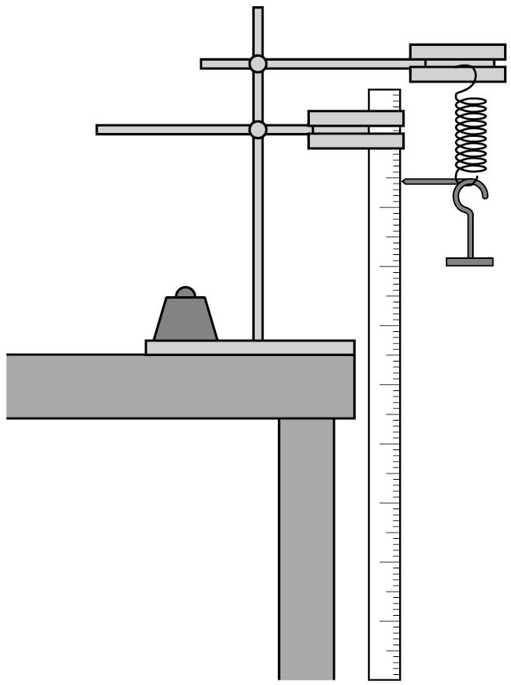
Risk assessment

- Risk assessment and risk management are the responsibility of the centre.
- The springs should be checked so that the loops at the ends don’t unravel when the greatest weight is used.
- It is likely that the spring will extend below the edge of the bench. The clamp stand should be secure so as not to tip over. Put something under the spring and weight to protect the floor in case things slip.

Trialling

The practical should be trialled before use with students.
GCSE Physics required practical activity: Force and extension

Student sheet

Required practical activity | Apparatus and techniques
Investigate the relationship between force and extension for a spring. | AT 1, AT 2

Making and calibrating a spring balance (newtonmeter)

You will investigate the relationship between the weight hung from a spring and how much longer the spring gets (the extension).

You will use your results to plot a graph of extension against weight. Then you will use your graph to find the weight of a mystery object.

Learning outcomes
1

2

3

Teachers to add these with particular reference to working scientifically

Method

You are provided with the following:
- a spring
- a metre ruler
- a splint and tape to act as a pointer
- a 10 N weight stack
- a clamp stand, with two clamps and bosses
- a heavy weight to prevent the apparatus tipping over
- a mystery object to weigh.

Read these instructions carefully before you start work.

- Attach the two clamps to the clamp stand using the bosses. The top clamp should be further out than the lower one.

- Place the clamp stand near the edge of a bench. The ends of the clamps need to stick out beyond the bench.

- Place a heavy weight on the base of the clamp stand to stop the clamp stand tipping over.

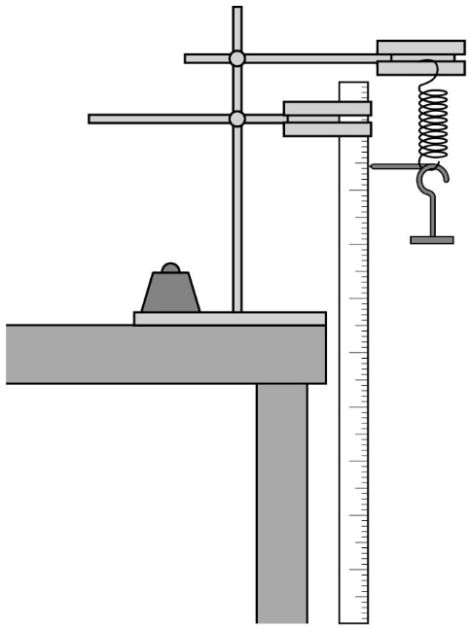

- Hang the spring from the top clamp.

- Attach the ruler to the bottom clamp with the zero on the scale at the top of the ruler.
If there are two scales going in opposite directions you will have to remember to read the one that increases going down.

- Adjust the ruler so that it is vertical. The zero on the scale needs to be at the same height as the top of the spring.

- Attach the splint securely to the bottom of the spring. Make sure that the splint is horizontal and that it rests against the scale of the ruler.

- Take a reading on the ruler – this is the length of the unstretched spring.

- Carefully hook the base of the weight stack onto the bottom of the spring. This weighs 1.0 newton (1.0 N).

- Take a reading on the ruler – this is the length of the spring when a force of 1.0 N is applied to it.

- Add further weights. Measure the length of the spring each time.

- Record your results in a table such as the one below.
You will need a third column for the extension. This is the amount the string has stretched. To calculate this you subtract the length of the unstretched spring from each of your length readings.

Weight in N | Length of spring in cm | Extension of spring in cm

- Do not put the apparatus away yet.

- Plot a graph with:
- ‘Extension of spring in cm’ on the y-axis
- ‘Weight in N’ on the x-axis.

- Hang the unknown object on the spring. Measure the extension and use your graph to determine the object’s weight. Check it with a newtonmeter.

GCSE Physics required practical activity: Acceleration

Teachers’ notes

Required practical activity | Apparatus and techniques
Investigate the effect of varying the force on the acceleration of an object of constant mass and the effect of varying the mass of an object on the acceleration produced by a constant force. | AT 1, AT 2, AT 3

Investigating acceleration using an air track and light gates.

Materials

In addition to access to general laboratory equipment, each group of students needs access to:

- linear air track and gliders
- bench pulley, string and small weight stack e.g. 1 N in steps of 0.2 N
- card 10 cm x 5 cm
- two clamp stands, clamps and bosses
- two light gates, interface and computer software
- Blu-Tack or similar to attach the weights to the glider.

Technical information

The air track provides a cushion of air for the gliders to ‘float’ on, thus reducing friction to almost zero. Air is often provided by a vacuum cleaner in ‘blow’ mode. The air track should be level. This can be achieved by adjusting the legs. There are two adjustments: one to make sure that the air track isn’t leaning to one side. The other to make sure it is horizontal. Place a glider in the middle of the air track and switch on the vacuum cleaner. Adjust the legs so that the glider rests on the cushion of air without moving or touching the sides of the air track.

The card is attached to the glider. Using the clamp stands, the light gates are positioned so that the card interrupts the light beam as the glider moves along the air track. The time is measured automatically. The software usually requires you to input the length of the card (10 cm in this case).
The force is provided by the weight stack, string and pulley. Attach the pulley to the bench at the far end of the air track. Hang the weight stack on the string, pass it over the pulley and attach it to the glider. Check that, when the vacuum cleaner is switched on, the weight starts to fall and the glider to accelerate. It is important that the card passes through the second light gate before the weight stack hits the ground.
When varying the force, the total mass of the system should stay constant. The mass of the system is the mass of the glider plus the mass of the weight stack. The ‘unused’ weights should therefore be attached to the sides of the glider (with the Blu-Tack).
The experiment is best controlled with the vacuum cleaner mains switch. When everything is ready simply switch it on and the glider will go. When the weight stack hits the ground, switch it off and the glider stops.

Additional information

The relationship between force, mass and acceleration is given by Newton’s Second Law of Motion. The acceleration of the glider is usually worked out automatically by the software that comes with the light gates, provided the length of the card is input into the system. Students should understand how the calculation is done:

$$acceleration= \frac{\left(\frac{length ofcard}{interrupt time 2}-\frac{length of card}{interrupt time 1}\right)}{time between interruptions}$$

The students will record the values of acceleration for constant mass as the force is varied. They can plot a graph of acceleration against force and get a straight line through the origin.

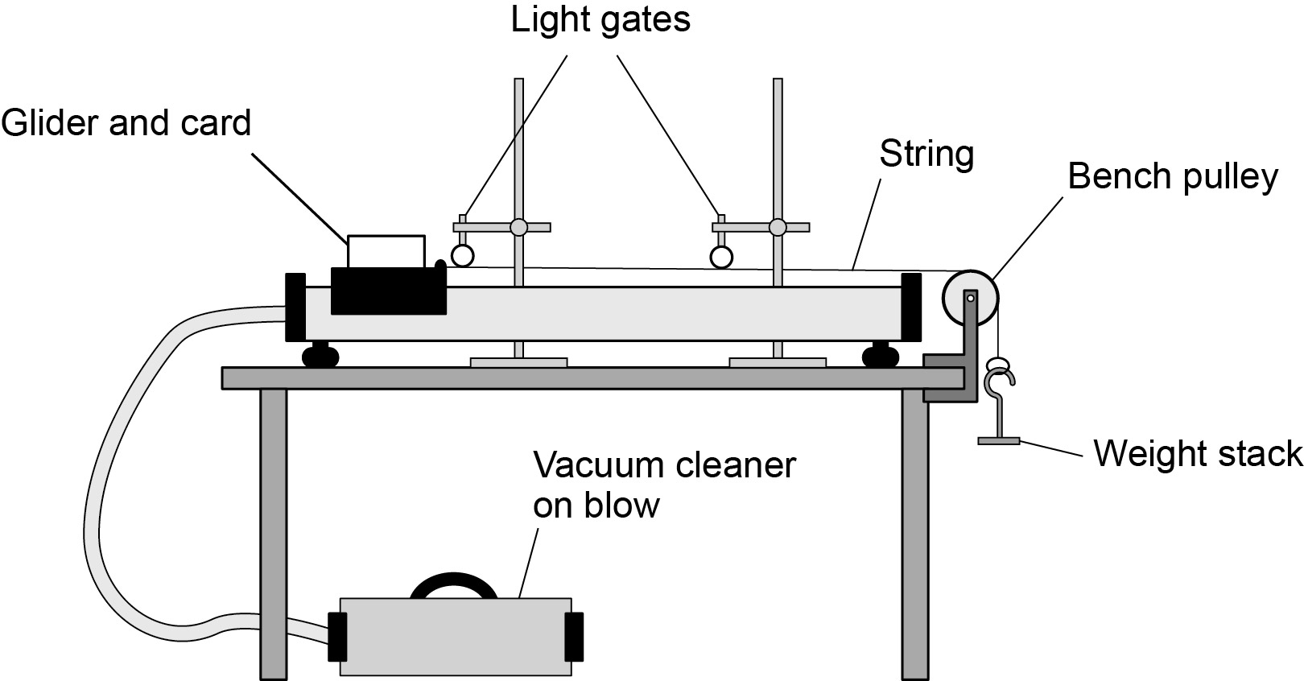

Alternatively, this investigation can be carried out using a trolley, ramp and ticker timers. Students would use the ticker tape to make a velocity-time graph and measure the acceleration from the slope.

Risk assessment

- Risk assessment and risk management are the responsibility of the centre.
- Check the mains cable to the vacuum cleaner.
- Do not use large weights on the weight stack. The glider can cause the air track to fall off the bench if it hits the end moving quickly.

Trialling

The practical should be trialled before use with students.

GCSE Physics required practical activity: Acceleration

Student sheet

Required practical activity | Apparatus and techniques
Investigate the effect of varying the force on the acceleration of an object of constant mass and the effect of varying the mass of an object on the acceleration produced by a constant force. | AT 1, AT 2, AT 3

Investigating acceleration using an air track and light gates

You will investigate the relationship between the acceleration of an object and the size of the force acting upon it.

You will use an air track. This produces a cushion of air which allows gliders to move almost friction free.

Learning outcomes
1

2

3

Teachers to add these with particular reference to working scientifically

Method

You are provided with the following:
- linear air track and gliders
- vacuum cleaner
- bench pulley, string and small weight stack eg 1 N in steps of 0.2 N
- card
- two clamp stands, with clamps and bosses
- two light gates, interface and computer
- Adhesive putty to attach the weights to the glider.
Read these instructions carefully before you start work.

- Place the air track on a bench and attach it to the vacuum cleaner, set on ‘blow’.

- Place a glider on the air track and switch on the vacuum cleaner. The glider should lift up off the air track and be free to move.

- Adjust the legs of the air track so that the glider moves without touching and the air track is horizontal.
There are two separate adjustments to make. With the vacuum cleaner on:
- place the glider above the adjuster that tilts the air track from side to side. Adjust the length of the leg until the glider does not touch the sides
- place the glider in the middle of the air track. Adjust the other leg until the glider does not move when released.

- Cut out a piece of card measuring 5 cm × 10 cm. Put it in the groove on the glider. The long side should be horizontal.

- Clamp the two light gates horizontally. Position them above the air track so that the card passes through them as the glider moves.

- Connect the light gates to the interface and computer. Start the software for timing.
You should have the opportunity to choose acceleration using two light gates.
Type in the length of the card (10 cm) when asked by the computer.

- Check the movement of the glider by gently pushing it along the track. The software needs to be on.
The acceleration should be close to zero. Switch off the vacuum cleaner.

- Attach the bench pulley to the end of the air track away from the vacuum cleaner.

- Tie a length of string to the glider. Pass the string over the pulley and attach the weight stack to the other end of the string.
Make sure the string is horizontal and is in line with the air track.

- Switch on the vacuum cleaner. The glider should accelerate through the light gates as the weight falls to the ground.

- If necessary, move the second light gate so that the glider passes through it before the weight hits the ground. If the weight hits the ground too early the glider will stop accelerating too early.

- The first experiment will investigate how the acceleration depends upon the force. The force is provided by the weight stack.
- Attach the full weight stack (1 N) to the end of the string.
- Switch on the software.
- Make sure the glider is in position and switch on the vacuum cleaner.
- The glider should accelerate through the light gates towards the bench pulley.
- Record the acceleration. Repeat.
- If the two values are not similar, repeat again.
- Record your readings in a table such as the one below. Calculate the mean.

Force in N | Acceleration in cm/s²
 | First reading | Second reading | Third reading  (if necessary) | Mean

- Remove one weight (0.2 N) and attach that to the glider. This will keep the total mass constant. (The weight stack is being accelerated too.)

- Repeat the experiment for a force of:
- 0.8 N
- 0.6 N
- 0.4 N
- 0.2 N

Remember to attach each weight to the glider as it is removed from the weight stack.

- Plot a graph with:
- ‘Acceleration in m/s²’ on the y-axis
- ‘Force in N’ on the x-axis.

GCSE Physics required practical activity: Waves

Teachers’ notes

Required practical activity | Apparatus and techniques
Make observations to identify the suitability of apparatus to measure the frequency, wavelength and speed of waves in a ripple tank and waves in a solid and take appropriate measurements. | AT 4

This activity is likely to be a teacher demonstration or form part of a ‘circus’ of experiments for students to perform.

The activity is split into two parts
- observing water waves in a ripple tank
- observing waves on a stretched string or elastic cord.

Activity 1: Observing waves in a ripple tank

Materials:

- ripple tank plus accessories
- suitable low voltage power supply
- metre ruler.

Technical information

The design of ripple tanks varies slightly from one manufacturer to another. The following is given for general guidance.

The depth of water in the ripple tank should be about 5 mm.

To produce plain (straight) waves, a wooden rod should be used (usually one of the accessories supplied with the ripple tank). When stationary the wooden rod should just touch the water surface. A single low voltage power supply may be used for both the motor attached to the wooden rod and the lamp (usually a power supply designed specifically for use with a ripple tank). Alternatively, a fixed power supply can be used for the lamp and a single 1.5 V cell with a variable resistor (in series) as a variable supply to the motor.

The ripple pattern can be viewed either on a large sheet of white card placed on the floor directly below the ripple tank or on the ceiling. To view the pattern on the floor, put the lamp above the ripple tank. To view the pattern on the ceiling, have the lamp below the ripple tank. If viewing the pattern on the floor students should look from the side directly at the card and not look from above through the water in the ripple tank. The position of the lamp should be adjusted to give a clear image. Some ripple tanks are designed to sit on top of an overhead projector. If one of these is used, the students will be able to view a large image projected onto a wall.

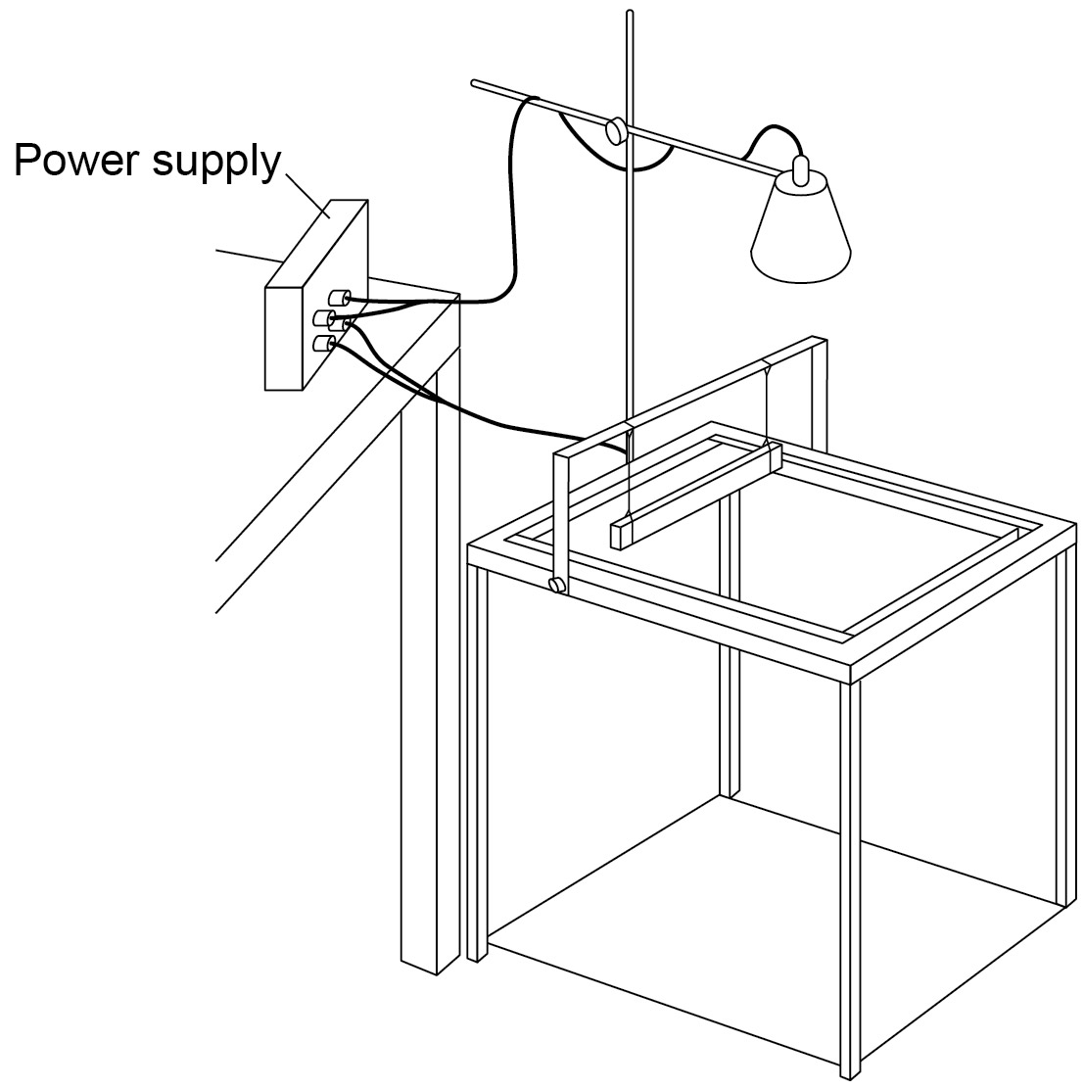
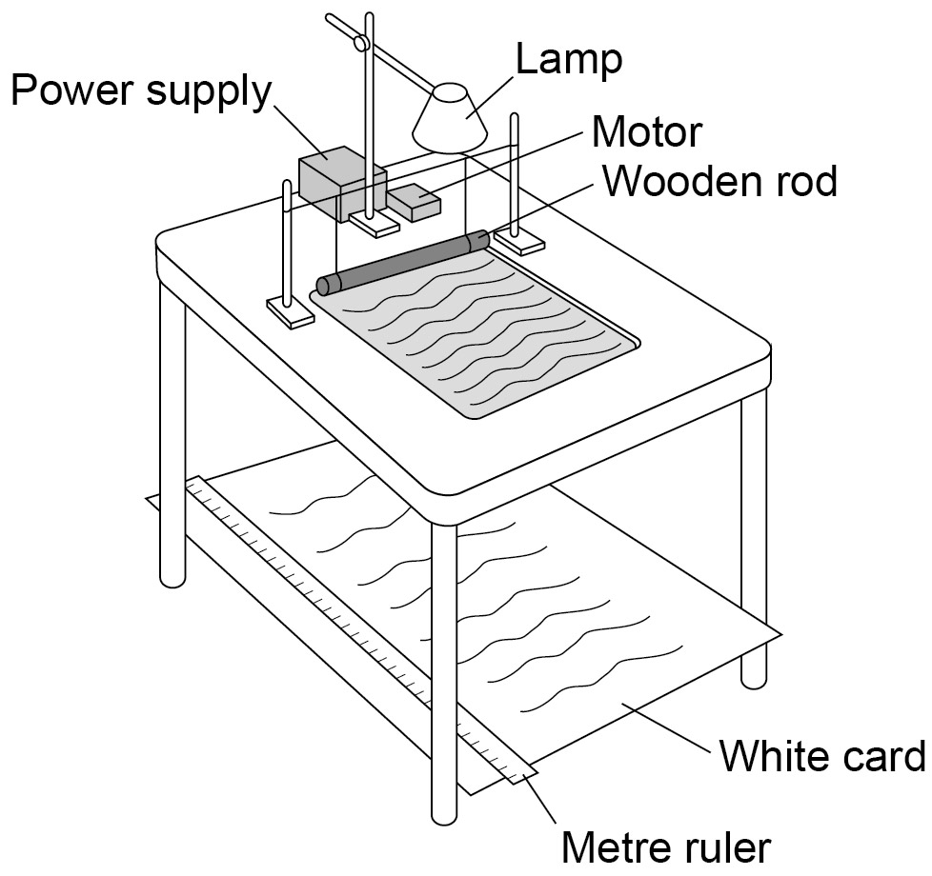
Additional information
A darkened laboratory may make it easier to observe the wave pattern.

Students should observe the wave pattern and then decide how the wavelength, frequency and speed should be measured.

Wavelength – it is likely that a metre ruler positioned at right angles to the projected wave fronts will be used. Measure across as many waves as possible, then divide the total length by the number of waves.

Frequency – it is likely that no apparatus will be used. If the motor is rotating slowly so the frequency is low, it should be possible to count the number of waves passing a point in the pattern over a given time (say 10 seconds). Then divide the number of waves counted by 10. If this is a demonstration experiment ask several students to count the waves and then calculate the mean value.

Speed – this will be calculated using the equation:

wave speed = frequency x wavelength

Risk assessment

- Water is easily spilt onto the floor. Mop up all spills straight away.
- Place any power supply used on a laboratory bench and not on the floor.
- The frequency of a stroboscope can trigger an epileptic fit (7-15 Hz). Although this method may be suggested by students, it is NOT advisable to use a stroboscope with the class.

Trialling

Obtaining a clear pattern from a ripple tank is not easy. It is advisable to trial the experiment and if possible have the ripple tank set up and ready for use before the class starts.

Activity 2: Observing waves on a stretched string or elastic cord

This method uses resonance to set up a standing wave on a vibrating string. The theory of resonance and standing waves does not need to be covered.

Materials
- vibration generator
- suitable power supply (variable frequency)
- suitable string or elasticated cord
- set of 100g masses and hanger
- set of 10g masses and hanger
- wooden bridge
- pulley on a clamp

Technical information
To achieve the conditions necessary for resonance, the following can be adjusted:
- the frequency at which the generator vibrates (adjust the frequency of the power supply)
- the length of string allowed to vibrate (move the wooden bridge)
- the tension in the string (add or remove masses).

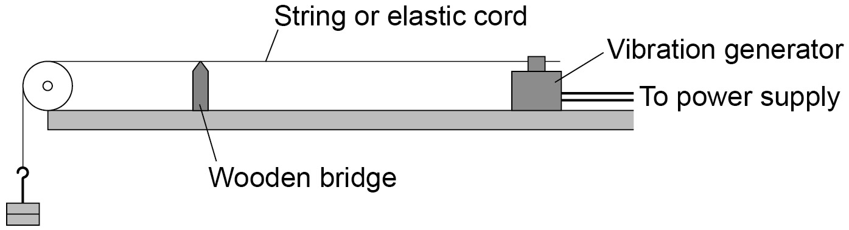

For a quick demonstration use an elasticated cord attached to the vibration generator. Then simply stretch the cord until it resonates and a standing wave pattern is seen.

Students should observe the wave pattern and then decide how the wavelength, frequency and speed should be measured.

- Wavelength – it is likely that a metre ruler will be used to measure across as many half wavelengths as possible. Then divide the total length by the number of half waves. Multiplying this number by two will give the wavelength.
- Frequency – it is likely that no apparatus will be used. The frequency will be the frequency of the power supply. It may be suggested that a stroboscope is used. This will ‘freeze’ the pattern to show a transverse wave. The frequency of the stroboscope is then the frequency of the waves.
- Speed – this will be calculated using the equation:

wave speed = frequency x wavelength

Risk assessment

- Students sitting close to the vibrating string should wear safety goggles or sit behind a safety screen.
- The frequency of a stroboscope can trigger an epileptic fit. Although this method may be suggested by students it is therefore NOT advisable to use a stroboscope with the class.

Trialling

The practical should be trialled before use with students to ensure a standing wave can be set up and seen.

Extension
Using the same apparatus, the relationship between the tension in the string and speed of the wave could be investigated.

GCSE Physics required practical activity: Waves

Student sheet

Required practical activity | Apparatus and techniques
Make observations to identify the suitability of apparatus to measure the frequency, wavelength and speed of waves in a ripple tank and waves in a solid and take appropriate measurements. | AT 4

The activity is split into two parts:

- observing water waves in a ripple tank
- observing waves on a stretched string or elastic cord.

Your teacher may complete both parts of this activity as a class demonstration.

Activity 1: Observing waves in a ripple tank

Learning outcomes
1

2

3

Teachers to add these with particular reference to working scientifically

Method

You are provided with the following:

- ripple tank plus accessories
- suitable low voltage power supply
- metre ruler.

Read these instructions carefully before you start work.

- Set up the ripple tank.
A large sheet of white card or paper needs to be on the floor under the tank.

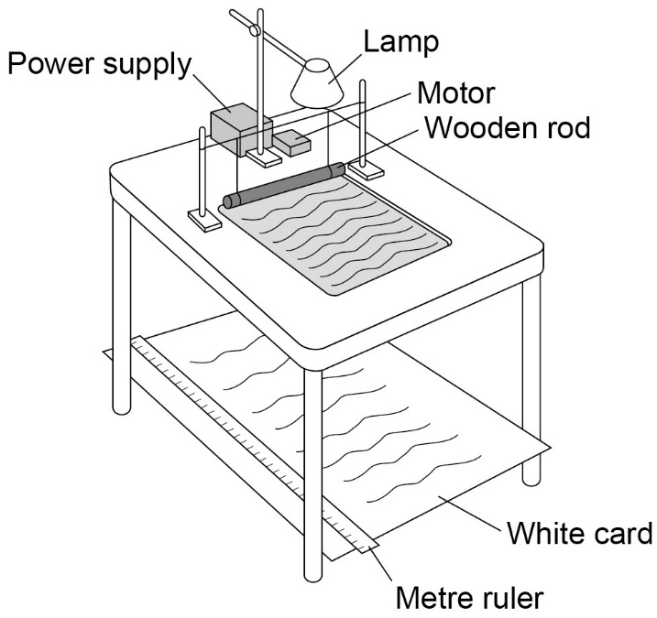

- Pour water to a depth of about 5 mm into the tank.

- Adjust the height of the wooden rod so that it just touches the surface of the water.

- Switch on both the overhead lamp and the electric motor.

- Adjust the speed of the motor. Low frequency water waves need to be produced.

- Adjust the height of the lamp. The pattern needs to be clearly seen on the card on the floor.

- Place a metre ruler at right angles to the waves shown in the pattern on the card.
Measure across as many waves as possible. Then divide that length by the number of waves. This gives the wavelength of the waves.

- Count the number of waves passing a point in the pattern over a given time (say 10 seconds).
Then divide the number of waves counted by 10. This gives the frequency of the waves.

- Calculate the speed of the waves using the equation:

wave speed = frequency × wavelength

Activity 2: Observing waves on a stretched string or elastic cord

Learning outcomes
1

2

3

Teachers to add these with particular reference to working scientifically

Method

You are provided with the following:

- vibration generator
- suitable power supply (variable frequency)
- suitable string or elasticated cord
- set of 100 g masses and hanger
- set of 10 g masses and hanger
- wooden bridge
- pulley on a clamp.

Read these instructions carefully before you start work.

- Set up the apparatus as shown.

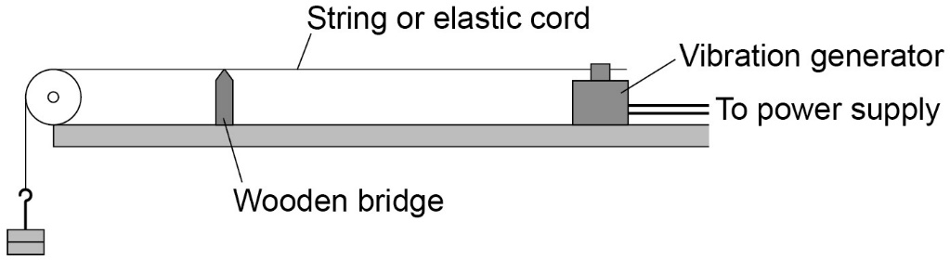

- Switch on the vibration generator. The string (or elasticated cord) should start to vibrate.

- A clear wave pattern needs to be seen. To do this, adjust the tension in the string or move the wooden bridge to adjust the length of the string.
The waves should look like they are stationary.

- Use a metre ruler to measure across as many half wavelengths as possible (a half wavelength is one loop).
Then divide the total length by the number of half waves. Multiplying this number by two will give the wavelength.

- The frequency is the frequency of the power supply.

- Calculate the speed of the wave using the equation:

wave speed = frequency × wavelength

GCSE Physics required practical activity: Radiation and absorption

Teachers’ notes

Required practical activity | Apparatus and techniques
Investigate how the amount of infrared radiation absorbed or radiated by a surface depends on the nature of that surface. | AT 1, AT 4

Investigate the amount of infrared radiation emitted by different surfaces

Materials

- Leslie cube
- kettle
- infrared detector
- heatproof mat

Technical information

If a Leslie cube is not available or a class set is required then a simple ‘home-made’ version could be used. Take a large empty metal can and lid, for example a coffee tin. Remove any outside paper labels so that only the bare metal is seen. Paint one section with a matt white paint and another with a matt black paint. Leave one section as a shiny ‘silver’ surface.

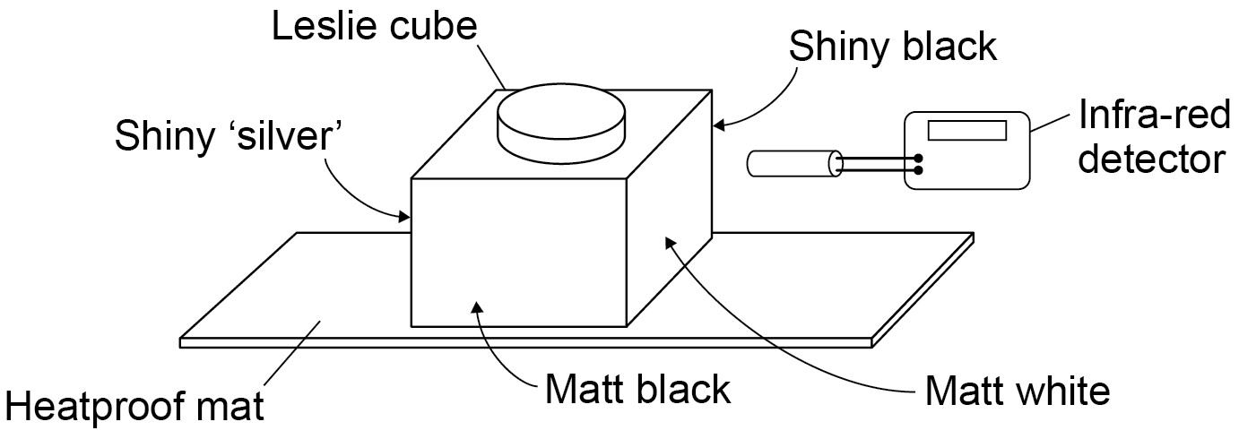
Infrared
detector

The detector may be an infrared detector with a suitable meter, an infrared thermometer or a liquid-in-glass thermometer with the bulb painted matt black. The last option is likely to have the least resolution.
Additional information

Before filling with boiling (or very hot) water, the Leslie cube should be placed on a heatproof mat.

A simple investigation showing how the type of surface affects the amount of infrared radiation involves placing two metal sheets an equal distance from an infrared source. One side of one sheet is painted black, the other side is left shiny. The other sheet is left shiny on both sides. The two sheets are placed near the infrared source, the black side facing inwards. Use candle wax to attach a small coin to the side of the sheets that face away from the infrared source. When the infrared radiation source is turned on the coin that drops off first will have been attached to the sheet that was the better absorber of radiation.

Risk assessment

- Risk assessment and risk management are the responsibility of the centre.
- Care must be taken when boiling (or very hot) water is used. Students should not carry containers of hot water across the laboratory.
- Take care with black surfaces as these can reach high temperatures (~80 °C).

Trialling

The practical should be trialled before use with students.

GCSE Physics required practical activity: Radiation and absorption

Student sheet

Required practical activity | Apparatus and techniques
Investigate how the amount of infrared radiation absorbed or radiated by a surface depends on the nature of that surface. | AT 1, AT 4

Investigating the amount of infra-red radiation emitted by different surfaces

Your teacher may complete this investigation as a class demonstration or include it in a ‘circus’ of experiments.

Learning outcomes
1

2

3

Teachers to add these with particular reference to working scientifically

Method

You are provided with the following:

- Leslie cube kettle
- infrared detector
- heat proof mat.

Read these instructions carefully before you start work.

- Place the Leslie cube on to a heatproof mat.

- Fill the cube with very hot water and replace the lid of the cube.

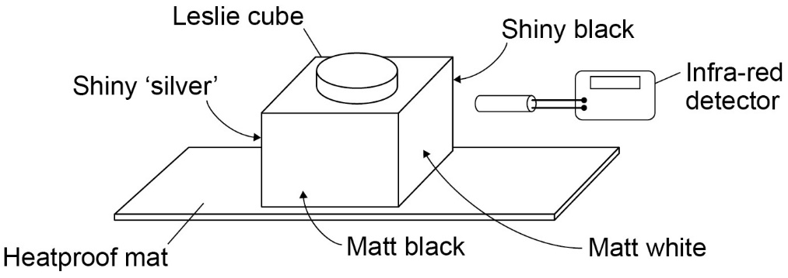

- Use the detector to measure the amount of infrared radiated from each surface.
Make sure that before a reading is taken the detector is the same distance from each surface.
Draw a bar chart to show the amount of infrared radiated against the type of surface.

