Scheme of work

Combined Science: Trilogy

Physics – Electricity
This resource provides guidance for teaching the Electricity topic from our new GCSE in Combined Science: Trilogy/Physics (8464). It has been updated from the draft version to reflect the changes made in the accredited specification. There are many changes throughout the document.

The scheme of work is designed to be a flexible medium term plan for teaching content and development of the skills that will be assessed.
It is provided in Word format to help you create your own teaching plan – you can edit and customise it according to your needs. This scheme of work is not exhaustive; it only suggests activities and resources you could find useful in your teaching.

6.2 Electricity

6.2.1 Current, potential difference and resistance
Spec ref. | Summary of the specification content | Learning outcomes  What most candidates should be able to do | Suggested timing (hours) | Opportunities to develop Scientific Communication skills | Opportunities to develop and apply practical and enquiry skills | Self/peer assessment opportunities and resources  Reference to past questions that indicate success
6.2.1.1 | How to draw circuit symbols. | 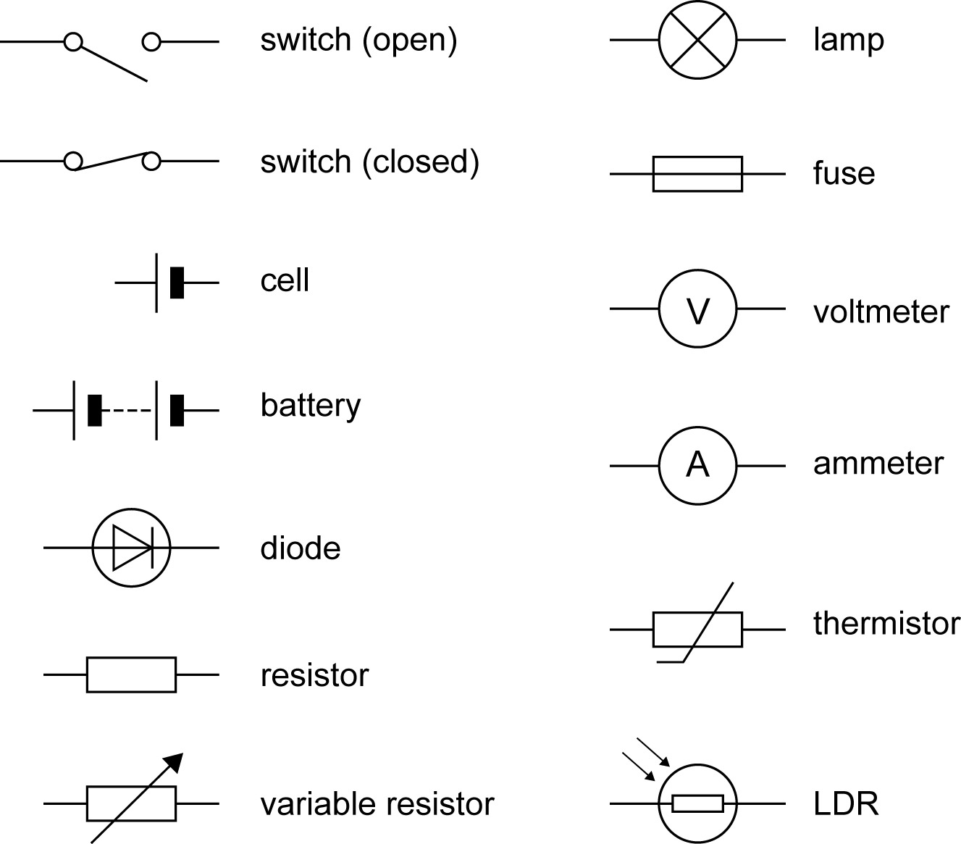  Circuit diagrams use standard symbols:  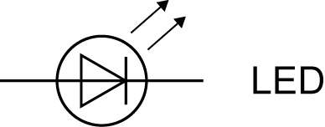 | 0.5 | Recall circuit symbols.  Identify circuit symbols used in a circuit.  Construct circuit diagrams using standard symbols.  Ask questions such as:  - Why are circuit symbols used?  - How are the electrical components connected together to form a circuit?  - What happens to the energy store of a cell/battery when it is connected into a circuit?  Play generation game with the circuit symbols shown on a PowerPoint. Give pupils 2 minutes to draw and label all of them – allow less time for more able pupils. | Set up simple circuits from circuit diagrams. Circuits need to include voltmeters and ammeters so that students are aware of how these devices are connected. | BBC Bitesize – Circuit symbols  Exampro user guide PowerPoint
6.2.1.2 | Electric currents are the flow of charge.  Equation for electric current as the rate of flow of charge should be known. | For electrical charge to flow through a closed circuit the circuit must include a source of potential difference.  Electric current is a flow of electrical charge. The size of the electric current is the rate of flow of electrical charge. Charge flow, current and time are linked by the equation:  $$charge flow=$$  $$current x time$$  $$[ Q = I t ]$$  charge flow, Q, in coulombs, C  current, I, in ampere, A  time, t, in seconds, s | 1 | Define potential difference.  State the name of the particle that carries the electrical charge round a circuit.  Ask questions such as:  - What is an electric current?  - Which particle moves to cause an electric current?  - What makes the particle move?  Define an electric current.  Describe and explain why an electric current will flow in a circuit.  Describe different models of electricity including:  - marbles moving down a ramp with masses placed on the ramp to represent atoms  - rope models of electricity with knots or marks on the rope to represent electrons  - students modelling the electrons taking energy (sweets) from the battery (teacher) to a component (cup held by a pupil).  Evaluate the benefits and drawbacks of each model.  Calculate the charge flow, current or time when given the other two values. State the units used for each quantity. | Demonstrate models of electricity and discuss what each part of the model represents and what makes the particles move. Examples could include the rope model, sweets model, water flow model, etc.  Model the flow of an electric current using various models and also video clips available on YouTube, eg Modelling electric current.  Describe how the model represents an electric current and the limitations of the model. | BBC Bitesize – Current, voltage and resistance  Pass My Exams – Electric Current  Cyberphysics – Electric Current  Nuffield Foundation | Models of electric circuits  Pass My Exams – Electric Current  Cyberphysics – Electric Current
6.2.1.3 | The current in a series circuit. | The current at any point in a series circuit has the same value as the current at any other point in the same circuit.. | 1 | Draw a circuit that can be used to measure the current in a component.  Describe how the current varies in a series circuit.  Explain why the current at each point in a series circuit must be the same in terms of electrons not being lost from the wire. | Investigate the current at various points within a series circuit. Does the current vary if the ammeter is placed either side of a component?  Link this idea about the current in a series circuit being the same throughout the circuit to the models of electricity looked at previously. | YouTube: Current in series circuits  Pass my Exams – Conventional Current & Electron Flow  Cyberphysics – Basic electricity – Simple circuits
6.2.1.3 | How the resistance of a component affects the current through it. | The current through a component depends on both the resistance of the component and the potential difference across the component. The greater the resistance of the component the smaller the current for a given potential difference (p.d.) across the component. | 1 | Define resistance.  Describe and explain how increasing the resistance in a circuit will affect the current through the circuit. | What is resistance?  Why are materials with low resistance chosen for power cables?  What are superconductors?  Model the effect of resistance on a circuit. You can do this with clear tubing and coloured water to act as the current. Pinch the tubing to show higher resistance.  Investigate how increasing the resistance of a circuit affects the current.  *. | BBC Bitesize - Resistance  BBC Bitesize – Current, voltage and resistance  Cyberphysics – Resistances in series and in parallel  Pass My Exams – Electrical Circuits, Resistance
6.2.1.3 | How potential difference, current and resistance are linked.  Equation linking potential difference, current and resistance should be known.  How to find the resistance of electrical components by experiment. | Current, potential difference or resistance can be calculated using the equation:  $$potential difference=$$  $$current x resistance$$  $$[ V = I R ]$$  potential difference, V, in volts, V  current, I, in amperes, A  resistance, R, in ohms, Ω  Explain the design and use of a circuit to measure the resistance of a component by measuring the current through, and potential difference across, the component.  Students should set up and use a circuit to investigate a factor/ the factors that affect the resistance of an electrical component(s). | 1 | Use the equation $V = I R$ to calculate the potential difference (voltage), current or resistance when given the other two values.  State the correct SI units for each quantity (potential difference, current and resistance).  How does the type of metal used for a wire affect its resistance?  Why do expensive scart leads have gold plating on them?  What factors affect the resistance of a given length of wire?  Draw a circuit that can be used to find the resistance of an electrical component using a voltmeter and an ammeter. | How can the resistance of a component be calculated using the current and potential difference?  Why does increasing the potential difference in a circuit also increase the current?  What is meant by resistance?  Find the resistance of some electrical components using current and potential difference readings.  Required practical:  Use circuit diagrams to set up and check appropriate circuits to investigate the factors affecting the resistance of electrical circuits. This should include:  • the length of a wire at constant temperature  • combinations of resistors in series and parallel (10.2.15).  Explain how the circuit for determining the resistance will give you the value of resistance from a simple calculation or graphical methods.  Analyse the results of the investigation to describe and explain how the resistance is affected. | BBC Bitesize - Measuring resistance  Nuffield Foundation | Measuring resistance with a voltmeter and an ammeter  Cyberphysics – Basic electricity – Simple circuits  Pass My Exams – Ohm’s Law
6.2.1.4 | Ohm’s law and the conditions needed for it to apply.  Current-potential difference graphs for electrical components. | The current through an ohmic conductor (at a constant temperature) is directly proportional to the potential difference across the resistor. This means that the resistance remains constant as the current changes. | 1 | Define what is meant by an ohmic conductor.  What components are ohmic conductors?  Describe the conditions for which Ohm’s law is valid.  Explain why Ohm’s law is not valid when the temperature of the conductor increases in terms of collisions.  Draw the I-V graph for an ohmic conductor.  Explain the shape of the I-V graph of the ohmic conductor. | Find the resistance of a resistor by experiment. Plot an I-V graph for the resistor, disconnecting the power supply unit between readings to let the resistor cool down. Calculate the resistance from the graph and compare with the known value from the colour coding on the resistor.  Required practical *:  Use circuit diagrams to construct appropriate circuits to investigate the I–V characteristics of a variety of circuit elements including a filament lamp, a diode and a resistor at constant temperature. (10.2.16)  *This activity is spread over two sessions. | Thy Physics Classroom – Ohm’s Law  Pass My Exams – Ohm’s Law
6.2.1.4 | How the resistance of electrical components change with external conditions.  Current-potential difference graphs for electrical components. | The resistance of components such as filament lamps, diodes, thermistors and LDRs is not constant; it changes with the current through the component.  The resistance of a filament lamp increases as the temperature of the filament increases.  The current through a diode flows in one direction only. The diode has a very high resistance in the reverse direction.  The resistance of a thermistor decreases as the temperature increases.  The resistance of an LDR decreases as light intensity increases. | 1.5 | Draw the I-V graphs for a filament lamp and a diode.  Explain the shape of the resulting graph in terms of resistance and current.  Draw graphs to show how the resistance of an LDR will vary with light intensity and of a thermistor with temperature.  Why do the current-potential difference graphs for diodes and filament lamps look different to that of an ohmic conductor?  Calculate the resistance of an LDR or a thermistor given the range of resistances for that component and the conditions that it is placed in.  Describe and explain real world applications of thermistors and LDRs including thermostats and switching on lights. | Required practical *:  Use circuit diagrams to construct appropriate circuits to investigate the I–V characteristics of a variety of circuit elements including a filament lamp, a diode and a resistor at constant temperature. (10.2.16)  Plot the graphs for these components and explain the resulting shape in terms or resistance.  Plan and carry out an investigation into how the resistance of an LDR varies with light intensity and how the resistance of a thermistor varies with temperature.  *continued from the previous session. | BBC Bitesize – Resistance graphs  Cyberphysics – Characteristic Curves  Pass My Exams – Ohm’s Law  BBC Bitesize - Thermistors and LDRs  Pass My Exams - Diodes, LDRs and Thermistors  Cyberphysics - Thermistor

6.2.2 Series and parallel circuits
Spec ref. | Summary of the specification content | Learning outcomes  What most candidates should be able to do | Suggested timing (hours) | Opportunities to develop Scientific Communication skills | Opportunities to develop and apply practical and enquiry skills | Self/peer assessment opportunities and resources  Reference to past questions that indicate success
6.2.2 | Series and parallel circuits. | There are two ways of joining electrical components, in series and in parallel. Some circuits include both series and parallel parts. | 1 | Describe the differences between series and parallel circuits.  Draw circuit diagrams for components connected in series and in parallel.  Describe how ammeters and voltmeters are connected into a circuit  Why are decorative lights for Christmas trees connected in parallel and not series?  Why does adding additional lamps in series, make them all dimmer? | Investigate series and parallel circuits:  - make a simple circuit containing a switch, power supply and a lamp  - add more lamps – both in series and then in parallel  - note the effect on the brightness of the lamps.  Current through, and potential difference across, each lamp can be measured to get numerical values and see the effect of adding more lamps. | BBC Bitesize – Series and parallel circuits  Pass My Exams - Conventional Current & Electron Flow  Cyberphysics – Basic electricity – Simple circuits
6.2.2 | Properties of series circuits and adding resistors in series. | For components connected in series:  - there is the same current through each component  - the total potential difference of the power supply is shared between the components.  - the total resistance of two components is the sum of the resistance of each component.  $$R_{total} = R_{1} + R_{2}$$  resistance, R, in ohms, Ω | 1 | Explain why the current through each component in a series circuit is the same.  Why does adding more lamps in series cause the current to decrease?  What is resistance?  Describe how the potential difference of the power supply is shared between the components and that the share of the potential difference a component receives depends on the resistance of that component.  Calculate the resistance or two components in a circuit using  $R_{total} = R_{1} + R_{2}$  Use the concept of equivalent resistance.  Apply knowledge of series circuits to real world applications.  Students should be able to explain the design and use of d.c. series circuits for measurement and testing purposes. | Investigate series circuits to find out how adding resistance, in the form of a variable resistor, changes the current and the potential difference. | Properties of series and parallel circuits – Studyphysics! PDF  Cyberphysics - Resistances in Series and in Parallel
6.2.2 | Properties of parallel circuits including giving the upper limit of resistance when resistors are added in parallel. | For components connected in parallel:  - the potential difference across each component is the same  - the total current through the whole circuit is the sum of the currents through the separate components  - the total resistance of two resistors is less than the resistance of the smallest individual resistor. | 1 | State that the potential difference across each component in a parallel circuit is the same.  Describe how the currents in different parts of a parallel circuit change and give the reasons for this change.  Describe the effect on the resistance of adding resistors in parallel.  State that adding resistors in parallel will make the total resistance less than the lowest value resistor.  Describe the differences between series and parallel circuits in terms of current and potential difference.  Students are not required to calculate the total resistance of resistors placed in parallel. | Investigate how the current in each loop of a parallel circuit compares to the current in the main branch of the circuit.  Investigate the effect of adding two resistors in series in a simple circuit, then adding the same resistors in parallel in the same circuit.  Find the resistance of three resistors in parallel by experimental methods. | Properties of series and parallel circuits – Studyphysics! PDF  Cyberphysics - Resistances in Series and in Parallel
6.2.2 | Resistance in series and in parallel circuits. | Students should be able to explain qualitatively why adding resistors in series increases the total resistance, while adding resistors in parallel decreases the total resistance. | 0.5 | What causes resistance?  Research what resistance is and why some materials have no resistance (superconductors).  Explain why adding resistors in series to a circuit, increases the resistance of that circuit in terms of number of collisions.  Explain why adding resistors in parallel decreases the resistance of a circuit in terms of increased number of pathways. | Find out some factors that affect the resistance of a wire. | BBC Bitesize – Current, voltage and resistance  Properties of series and parallel circuits – Studyphysics! PDF  Cyberphysics - Resistances in Series and in Parallel

6.2.3 Domestic uses and safety
Spec ref. | Summary of the specification content | Learning outcomes  What most candidates should be able to do | Suggested timing (hours) | Opportunities to develop Scientific Communication skills | Opportunities to develop and apply practical and enquiry skills | Self/peer assessment opportunities and resources  Reference to past questions that indicate success
6.2.3.1 | Alternating and direct potential difference.  Mains electricity supply. | The potential difference across cells and batteries is always in the same direction. The potential difference does not change polarity.  The potential difference of mains electricity changes direction. The potential difference changes polarity.  Mains electricity is an a.c. supply. In the UK it has a frequency of 50 Hz and is about 230 V. | 0.5 | Describe the potential difference across a cell in a circuit as being in one direction only.  State some common sources of a direct potential difference including cells, batteries and solar cells.  Describe the potential difference of an alternating supply as changing direction.  Describe mains electricity in the home in terms of potential difference, frequency and type of current. | What is the difference between direct and alternating potential difference?  What are common sources of direct and alternating potential difference?  Research the use of direct and alternating potential difference. Find out why the USA used direct potential difference, then changed to an alternating potential difference..  Use an oscilloscope to display direct and alternating potential difference signals, or the animation on Boardworks. | BBC Bitesize – Direct current and alternating current  Cyberphysics – AC/DC  Pass My Exams – Direct Current (dc) and Alternating Current (ac)
6.2.3.2 | The name, colour and function of each wire in a three core electrical cable. | Most electrical appliances are connected to the mains using three-core cable.  The insulation covering each wire is colour coded for easy identification:  live wire – brown  neutral wire – blue  earth wire – green and yellow stripes.  The live wire carries the alternating potential difference from the supply. The neutral wire completes the circuit. The earth wire is a safety wire to stop the appliance becoming live.  The potential difference between the live wire and earth (0 V) is about 230 V. The neutral wire is at or close to earth potential (0 V). The earth wire is at 0 V, it only carries a current if there is a fault. | 1 | Describe the construction of a three core electric cable.  State the name, the colour of the wire and the function of each wire in a three-core cable.  Match the name, colour and function of each wire.  Describe the potential difference in the live wire with respect to earth.  Describe how the earth wire acts as a safety wire and only carries a current if there is a fault. State that the resistance of the earth wire is low and that it will allow a large current to flow through it.  How does the earth wire help prevent electrocution? |  | Colours and functions of each wire in a three core cable – BBC Bitesize Wiring a plug  Pass My Exams – The Three Pin Plug  Cyberphysics – 3-Pin Plug

6.2.4 Energy transfers
Spec ref. | Summary of the specification content | Learning outcomes  What most candidates should be able to do | Suggested timing (hours) | Opportunities to develop Scientific Communication skills | Opportunities to develop and apply practical and enquiry skills | Self/peer assessment opportunities and resources  Reference to past questions that indicate success
6.2.4.1 | Electrical power and how it is calculated.  Equations for electrical power should be known | The power of a device is related to the potential difference across it and the current through it by the equation:  $$power=$$  $$potential difference x current$$  $$[P = V I ]$$  $$power =$$  $$current squared x resistance$$  $$\left[P = I^{2} R \right]$$  power, P, in watts, W  potential difference, V, in volts, V  current, I, in amperes, A  resistance, R, in ohms, Ω | 1 | Define power.  State the equation that links power, potential difference and current.  Calculate the power of an electrical appliance given the potential difference and the current.  Use the equation $P=I^{2} R$ to find any missing value given the other two. | . | BBC Bitesize – Calculating electrical power  Pass My Exams – Electrical Power and Electricty Bill
6.2.4.2 | Energy transfers in everyday appliances | Everyday electrical appliances are designed to bring about energy transfers.  Describe how different domestic appliances transfer energy from batteries or a.c. mains to the kinetic energy of electric motors or the energy of heating devices.  The amount of energy an appliance transfers depends on how long the appliance is switched on for and the power of the appliance. | 0.5 | What energy transfers take place in electrical appliances?  Describe in terms of energy stores the energy transfers that are taking place in a given electrical appliance – stating which energy transfers are useful and which are wasted. Electrical appliances may be either battery or mains operated and may involve motors or heating elements.  Describe how the amount of electrical energy transferred depends on the time the appliance is on for and the power of the appliance. | Investigate a number of electrical appliances, either around the lab or well-known devices, eg a TV, to look at the energy transfers that occur  Investigate how the amount of energy transferred to an electrical appliance depends on the amount of time that it is on for by connecting the appliance to a joulemeter. | BBC Bitesize – Energy transfer
6.2.4.2 | Work done when charge flows.  Calculating the amount of energy transferred.  Equations for energy transfer should be known. | Work is done when charge flows in a circuit.  The amount of energy transferred by electrical work can be calculated using the equation:  $$energy transferred=$$  $$power x time$$  $$[ E = P t ]$$  $$energy transferred =$$  $$charge flow x$$  $$potential difference$$  $$[ E = Q V ]$$  energy transferred, E, in joules, J  power, P, in watts, W  time, t, in seconds, s  charge flow, Q, in coulombs, C  potential difference, V, in volts, V | 1 | Describe how work is done when a charge flows in a circuit.  What are the charge carriers in an electric current?  How does a moving charge do work?  What can moving charge do?  Describe, with examples, the relationship between the power ratings for domestic electrical appliances and the changes in stored energy when they are in use.  Calculate the energy transferred by an electrical appliance and rearrange the equation $E = P t$ to find the other two values.  Use the equation $E = Q V$ including rearranging the equation to find any quantity given the other two.  Convert units into SI units where required. Use of standard form may also be required as well as understanding the meaning of the different prefixes used in a scientific context. |  | BBC Bitesize – Electrical energy calculations  Pass My Exams – Electrical Power and Electricty Bill
6.2.4.3 | The National Grid. | The National Grid is a system of cables and transformers linking power stations to consumers.  Electrical power is transferred from power stations to consumers using the National Grid.  Step-up transformers are used to increase the potential difference from the power station to the transmission cables then step-down transformers are used to decrease, to a much lower value, the potential difference for domestic use.  This is done because, for a given power, increasing the potential difference reduces the current, and hence reduces the energy losses due to heating in the transmission cables. | 1 | Describe how electrical power is transferred from the power stations to the consumers via the National Grid. Students will need to be able to give the types of transformer used and describe how the potential difference in the wires changes at each stage of the process.  How does electricity get from the power station to our homes?  A large potential difference is dangerous. Why is the electricity sent at a high potential difference rather than a low p.d.?  How do transformers work?  What do substations do?  Explain how the National Grid system is an efficient way to transfer energy.  Apply the equation $P=I^{2} R$ to explain why step-up transformers are used to transfer electrical power at high voltage (but low current) through the National Grid.  Why is it more economical to transfer power through the National Grid at high potential differences rather than using lower and potentially safer potential differences? | Model the National Grid to show how electricity is sent from power stations to consumers.  Demonstrate how transformers work and where they are placed in the National Grid.  Demonstrate a model of the national grid to show the effect of transferring energy at high and low potential differences. | Video clip  YouTube:  AQA GCSE Science and P1 – The National Grid  Cyberphysics – National Grid – Electricity Distribution  Pass My Exams – Electricity Generation, The National Grid  BBC Bitesize Dynamos and transformers  BBC Bitesize – Transformers – Higher

