Scheme of work
Combined Science: Synergy

Interactions over small and large distances

This resource provides guidance for teaching the Interactions over small and large distances topic from our new GCSE in Combined Science: Synergy (8465). It has been updated from the draft version to reflect the changes made in the accredited specification. There have been no changes to the required practical. However there have been minor changes in the specification content in sections 4.6.1.5 Gravitational potential energy, 4.6.2.4 Covalent bonding, 4.6.2.7 Properties of metals and 4.6.3.1 Magnets.

The scheme of work is designed to be a flexible medium term plan for teaching content and development of the skills that will be assessed.

It is provided in Word format to help you create your own teaching plan – you can edit and customise it according to your needs. This scheme of work is not exhaustive; it only suggests activities and resources you could find useful in your teaching.

4.6 Interactions over small and large distances
4.6.1 Forces and energy changes
Spec ref. | Summary of the specification content | Learning outcomes  What most candidates should be able to do | Suggested timing (hours) | Opportunities to develop Scientific Communication skills | Opportunities to apply practical and enquiry skills | Self/peer assessment Opportunities and resources  Reference to past questions that indicate success
4.6.1.1 | Scalar quantities have magnitude only. Vector quantities have magnitude and an associated direction.  Force is a vector quantity.  A vector quantity may be represented by an arrow. The length of the arrow represents the magnitude, and the direction of the arrow the direction of the vector quantity.  A force is a push or pull that acts on an object due to the interaction with another object. All forces between objects are either:  - contact forces – the objects are physically touching  - non-contact forces – the objects are physically separated. | Describe the difference between scalar and vector quantities and give examples.  Draw vector diagrams for vectors where the size and direction of the arrow represents the size and direction of the vector.  Give examples of contact and non-contact forces.  Describe the effects of forces in terms of changing the shape and/or motion of objects.  Describe examples of contact forces, explaining how the force is produced.  Describe examples of non-contact forces and state how the force is produced, eg gravitational force caused by two objects with mass exerting an attractive force on each other. | 1 | Questions for students to consider (think-pair-share):  - Why are crashes on motorways usually less serious than crashes on country roads?  - Why is direction important when looking at forces?  - What do forces do to objects?  - How do objects move other objects that are not in contact? | Research why country lanes have more casualties and fatalities than motorways even though the speed is lower.  Students could model displacement vectors by sketching a scale drawing for displacement vectors, eg 3 m East followed by 5 m North in the playground. Then back in the classroom get them to draw a scale diagram (eg 1 m = 1 cm) of this using the arrow notation.  Investigate contact and non-contact forces. This can include magnets, friction along a surface, eg when a shoe is pulled along it. You can change the surface to explore how this changes the amount of force required to move the show. You could also add a lubricant (eg water/oil) to the surface.  Make parachutes of different sizes (eg 10 × 10 cm and one 50 × 50 cm) and then drop from a height if available. Time how long it takes to fall and then discuss the change in forces.  Measuring the size of a force using a newtonmeter eg from the show experiment above.  To illustrate static electricity as a non-contact force students could rub a polythene rod with a duster and then use the charged rod to attract small pieces of paper (eg from a hole punch) or bend water. | More able class: Mechanics Tutorial 1 – Vectors and Scalars  Scalars and Vectors  Exampro user guide PowerPoint  AQA-8465-SOW-EXCH  Key word Bingo – students make a grid 3 × 3 and in each of the 9 squares they write a key word from this topic (More able classes can come up with their own words). The teacher or other student asks a question where the answer is one of the keywords. If it is one of their words they can cross it off – you can do first to get a row of three etc.  Types of Forces  BBC Bitesize – Forces
4.6.1.2 | (HT only)  A number of forces acting on an object may be replaced by a single force that has the same effect as all the original forces acting together. This single force is called the resultant force.  A free body diagram shows the magnitude and direction of the forces acting on an object.  A single force can be resolved into two components acting at right angles to each other. The two component forces together have the same effect as the single force. | Use a free body diagram to show the magnitude and direction of the forces acting on an object. | 1 | Draw force diagrams to represent the magnitude and direction of a number of forces acting on an object.  Discuss the reasons for the use of free body diagrams to model a situation and the limitations of these diagrams in complex situations.  WS 1.2, MS 4a, 5a, 5b  Use vector diagrams to illustrate resolution of forces, equilibrium situations and determine the resultant of two forces, to include both magnitude and direction (scale drawings only). |  | Drawing Free-Body Diagrams  Forces and Motion  What are forces? Examples of forces
4.6.1.3 | A force does work on an object when the force causes a displacement of the object.  work done = force × distance  (moved along the line of action of the force)  [W = F s ]  work done, W, in joules, J  force, F, in newtons, N  distance, s, in metres  One joule of work is done when a force of one newton causes a displacement of one metre.  1 joule = 1 newton-metre | Give the standard Physics definition of work.  Equate joules with newton-metres.  Describe and calculate the changes in energy involved when a system is changed by the work done by forces acting upon it.  Recall and apply the equation:  work done = force × distance  [W = F s ] | 1 | When work is done on an object how are the energy stores changed?  For various situations where work is done on an object analyse where the work done has gone, eg an increase in GPE or an increase in thermal energy stores.  WS 1.2, MS 3b, 3c  Recall and apply this equation.  MS 1c, 3c  Translate between newton-metres and joules. | Energy circus, eg kettle, microwave, hairdryer, etc – students list the energy transfers. | BBC Bitesize –Movement means energy  Work & Energy
4.6.1.4 | Weight is the force acting on an object due to gravity. The force of gravity close to the Earth is due to the gravitational field around the Earth.  The weight of an object depends on the gravitational field strength at the point where the object is:  weight = mass × gravitational field strength  [W = m g ]  weight, W, in newtons, N  mass, m, in kilograms, kg  gravitational field strength, g, in newtons per kilogram, N/kg  The weight of an object and the mass of an object are directly proportional.  Weight is measured using a calibrated spring balance (a newtonmeter). | Describe and explain what weight is and why objects on Earth have weight.  State the units used to measure weight.  Define weight and mass and explain the difference between them.  Calculate the weight of an object on Earth using W = mg. Rearrange this equation to find any unknown quantity.  Give the correct units of weight and mass.  Convert quantities into SI units (eg grams into kilograms).  Compare the weight of an object on different planets when given the gravitational field strength of the planets.  Describe the relationship between weight and mass and what would happen to weight if mass was doubled. | 2 | Questions for students to consider (think-pair-share).  - Why are astronauts said to be weightless even though they are pulled down by gravity  - How do we measure weight?  - Would aliens living on a massive planet be smaller than animals on Earth?  - How can a spring be used to find the weight of an object on Earth?  WS 1.2, MS 3b, 3c  Recall and apply this equation.  In any calculation the value of the gravitational field strength (g) will be given. | Find the weight of objects within the laboratory using Newton meters and then their mass using laboratory balances or (for heavier objects) bathroom scales.  Research how the pull of gravity varies around the Earth and how this would affect the weight of a 1 kg mass. To achieve this, students can make a model of what a 1 kg mass would weigh on different planets using tin cans filled with sand to represent the planets in our Solar System.  Investigate how a spring stretches with weight. Plot a graph of the results and then using this and the extension of the spring find the weight of small objects in the lab or lumps of wood with hooks attached. | BBC Bitesize  Weight and mass  Questions on weight and mass  Video clip: BBC Bitesize  Relationship between planet size and gravitational field strength  Jodrell Bank gravity teaching resources
4.6.1.5 | An object raised above ground level gains gravitational potential energy  g.p. e . = mass × gravitational field strength × height  E_{p} = m g h  gravitational potential energy, E_{p}, in joules, J  mass, m, in kilograms, kg  gravitational field strength, g, in newtons per kilogram, N/kg  height, h, in metres, m | Calculate the amounts of energy associated with an object raised above ground level. | 1 | WS 1.2, MS 3c  Recall and apply this equation to calculate changes in stored energy.  In any calculation the value of the gravitational field strength (g) will be given. | Set up a range of objects at different heights above ground level. Ask students to work out the gravitational potential energy. What will they need to measure? | BBC Bitesize - GPE
4.6.1.6 | An object that has been stretched has been elastically deformed if the object returns to its original length after the forces are removed. An object that does not return to its original length after the forces have been removed has been inelastically deformed. The extension of an elastic object, such as a spring, is directly proportional to the force applied, provided that the limit of proportionality is not exceeded.  force = spring constant × extension  [ F = k e ]  force, F, in newtons, N  spring constant, k, in newtons per metre, N/m  extension, e, in metres, m  A force that stretches (or compresses) a spring does work, and elastic potential energy is stored in the spring. Provided the spring does not go past the limit of proportionality the work done on the spring and the elastic potential energy stored are equal. | Define elastic deformation.  Sketch and describe the force and extension curve of an elastic material (eg elastic band or spring) when not stretched beyond its elastic limit.  Sketch and describe the force and extension curve of an elastic material when stretched beyond its elastic limit.  Calculate the force acting on a spring when given the spring constant and the extension of the spring. Rearrange the equation to find any missing quantity.  Calculate the work done in stretching or compressing a spring when given the mass or weight applied to the spring.  Explain what is meant by the limit of proportionality.  Identify the limit of proportionality on a graph showing the force applied against extension. | 2 | Why shouldn’t I stretch springs too much?  Sketch on an existing graph the force – extension curve for a spring with a spring constant of greater or lesser value than the spring given.  Calculate the force acting on a spring when given the spring constant and the extension of the spring. Rearrange the equation to find any missing quantity.  Evaluate the best spring to use for a given situation when given the spring constants of the springs.  Interpret data from an investigation of the relationship between force and extension.  WS 1.2, MS 3c, 4a, 4b, 4c  Recall and apply this equation. | Investigate the effect of loading and unloading springs stretched too and beyond their elastic limits. Add a force of 1N (100 g mass) at a time and measure the extension of the spring. Continue until the spring is clearly stretched beyond its elastic limit and then remove 1N at a time, recording the extension each time.  Find the spring constant of a spring by experiment.  Required practical 13: investigate the relationship between force and extension for a spring.  Physics AT 1, 2 | Elasticity  BBC Bitesize  Hooke’s Law  Practical: Hooke’s Law – Stretching Springs  Teachit Science resource (23771) ‘Hooke’s Law’
4.6.1.7 | Elastic potential energy is stored in a stretched spring.  elastic potential energy = 0.5 × spring constant × (extension)²  [ E_{e} = ½ k e²]  (assuming the limit of proportionality has not been exceeded)  elastic potential energy, E_{e}, in joules, J  spring constant, k, in newtons per metre, N/m  extension, e, in metres, m | Calculate the amounts of energy associated with a stretched spring. | 1 | WS 1.2, MS 1c, 3c  Calculate the work done in stretching.  MS 3b, 3c  Apply this equation which is given on the equations sheet.

4.6.2 Structure and bonding
Spec ref. | Summary of the specification content | Learning outcomes  What most candidates should be able to do | Suggested timing (hours) | Opportunities to develop Scientific Communication skills | Opportunities to apply practical and enquiry skills | Self/peer assessment Opportunities and resources  Reference to past questions that indicate success
4.6.2.1 | There are three types of strong chemical bonds: ionic, covalent and metallic.  For ionic bonding the particles are oppositely charged ions.  For covalent bonding the particles are atoms that share pairs of electrons.  For metallic bonding the particles are atoms that share delocalised electrons.  Ionic bonding occurs in compounds formed from metals combined with non-metals.  Covalent bonding occurs in non-metallic elements and in compounds of non-metals.  Metallic bonding occurs in metallic elements and alloys. | Describe the nature and arrangement of the three types of chemical bonds: ionic, covalent and metallic.  Describe the compounds each type of chemical bond occurs in.  Explain chemical bonding in terms of electrostatic forces and the transfer or sharing of electrons. | 1 | Introduction to bonding – circus of activities. Include:  - display of elements, compounds, metals, alloys, solids  - liquids and gases; students list properties  - range of magnets; students explore 'feel' of attraction and repulsion  - diagrams of common atoms to show electron arrangements, students suggest how they might bond to form simple compounds eg H atoms and H₂  - 3D models and 2D diagrams representing types of (not named) bonding; students suggest what these have in common  - examples of continuums (eg image of rainbow, musical scale, three words, eg: noisy, quiet, silent) – students suggest other things that lie on a continuum/scale. | Demo the formation of sodium chloride in a fume cupboard.  Discussion of bonding circus:  - observing substances, their properties and states, their chemical reactions – like watching a game to which you do not know the rules. Chemical bonding provides the rules  - models – discuss what the parts represent. Atoms – not solid spheres. Bonds – not physical attachments but akin to push and pull of magnetic forces  - types of bond lie along a scale. Like picking out colours red, yellow, blue, violet from spectrum to study we choose certain types of chemical bond but they are all related.  Give students a simple summary of Coulomb's Law in relation to bonding. Students could research work of Henry Cavendish and/or Charles Augustin de Coulomb.  Students find out for themselves the types of chemical bonding they might be studying in subsequent lessons.

Spec ref. | Summary of the specification content | Learning outcomes  What most candidates should be able to do | Suggested timing (hours) | Opportunities to develop Scientific Communication skills | Opportunities to apply practical and enquiry skills | Self/peer assessment Opportunities and resources  Reference to past questions that indicate success
4.6.2.2 | When a metal atom reacts with a non-metal atom electrons in the outer shell of the metal atom are transferred. Metal atoms lose electrons to become positively charged ions. Non-metal atoms gain electrons to become negatively charged ions. The ions produced by metals in groups 1 and 2 and by non-metals in groups 6 and 7 have the electronic structure of a noble gas (Group 0).  The electron transfer during the formation of an ionic compound can be represented by a dot and cross diagram, eg for sodium chloride:  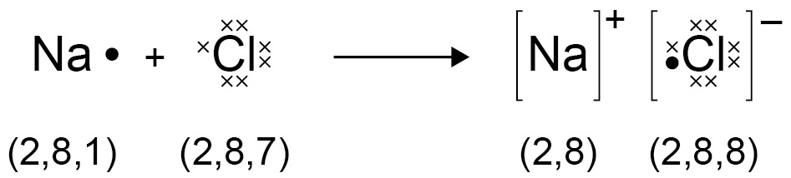  The charge on the ions produced by metals in groups 1 and 2 and by non-metals in groups 6 and 7 relates to the group number of the element in the periodic table.  An ionic compound is a giant structure of ions. Ionic compounds are held together by strong electrostatic forces of attraction between oppositely charged ions. These forces act in all directions in the lattice and this is called ionic bonding. The structure of sodium chloride can be represented in the following forms:  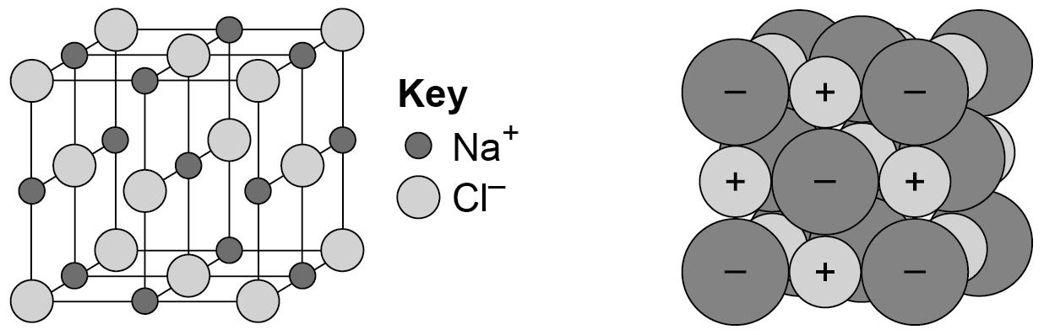  Knowledge of the structures of specific ionic compounds other than sodium chloride is not required. | Draw dot and cross diagrams for ionic compounds formed by metals in groups 1 and 2 with non-metals in groups 6 and 7  Work out the charge on the ions of metals and non-metals from the group number of the element, limited to the metals in groups 1 and 2, and non-metals in groups 6 and 7.  Deduce that a compound is ionic from a diagram of its structure in one of the specified forms.  Describe the limitations of using dot and cross, ball and stick, two- and three-dimensional diagrams to represent a giant ionic structure.  Work out the empirical formula of an ionic compound from a given model or diagram that shows the ions in the structure. | 1 | Discussion questions:  - Name an electrically charged particle.  - What characteristic do poles of a magnet and positive/negative charges share?  - What is the role of this characteristic in chemical bonding? What does 'stability' mean and how can it be applied here?  Tabulate common atoms and state the charges of the ions formed.  Extended writing: describe the bonding in the sodium chloride lattice using the correct terms, eg electrostatic forces of attraction.  WS 1.2  Draw dot and cross diagrams for ionic compounds formed by metals in groups 1 and 2 with non-metals in groups 6 and 7.  Work out the charge on the ions of metals and non-metals from the group number of the element, limited to the metals in groups 1 and 2, and non-metals in groups 6 and 7.  WS 1.2  Describe the limitations of particular representations and models to include dot and cross diagrams, ball and stick models and two- and three-dimensional representations.  MS 4a  Translate data between diagrammatic and numeric forms.  MS 5b  Visualise and represent 2D and 3D forms including two dimensional representations of 3D objects. | What SI unit is charge measured in?  Use magnesium ribbon to produce magnesium oxide. Discussion question: Why do we use dots and crosses? Draw the dot and cross diagram for this reaction.  Model the sodium chloride lattice using molecular model kits.  Students use periodic table to give quick-fire response to questions about charge on ions. | Video clips:  BBC Bitesize Ionic compounds and the periodic table  YouTube: What are ions?  YouTube: What are ionic bonds?  Teachit Science resource (23315) ‘Ionic bonding’  RSC (HT) bonding models handout  RSC (HT) ionic bonding extension
4.6.2.3 | Ionic compounds have regular structures (giant ionic lattices) in which there are strong electrostatic forces of attraction in all directions between oppositely charged ions.  These compounds have high melting points and high boiling points because of the large amounts of energy needed to break the many strong bonds.  When melted or dissolved in water, ionic compounds conduct electricity because the ions are free to move and so charge can flow. | Describe the structure of giant ionic lattices.  Explain why these compounds have high melting points and boiling points.  Explain why ionic compounds when melted or dissolved conduct electricity. | 1 | WS 1.2  Use ideas about energy transfers and the relative strength of chemical bonds and intermolecular forces to explain the different temperatures at which changes of state occur.  Represent melting and boiling points of ionic compounds to scale, on a giant thermometer.  WS 1.2  Use data to predict states of substances under given conditions. | Electrolysis demo or class practical to show movement of ions in electrolysis.  Students investigate electrolysis and explain the process qualitatively and quantitatively. | RSC experiment ‘The migration of ions: evidence for the ionic model’  You Tube video – ions in an electric field
4.6.2.4 | When atoms share pairs of electrons they form covalent bonds. These bonds between atoms are strong.  Covalently bonded substances may consist of small molecules.  Some covalently bonded substances have very large molecules, such as polymers.  Some covalently bonded substances have giant covalent structures, such as diamond and silicon dioxide.  The covalent bonds in molecules and giant structures can be represented in the following forms:  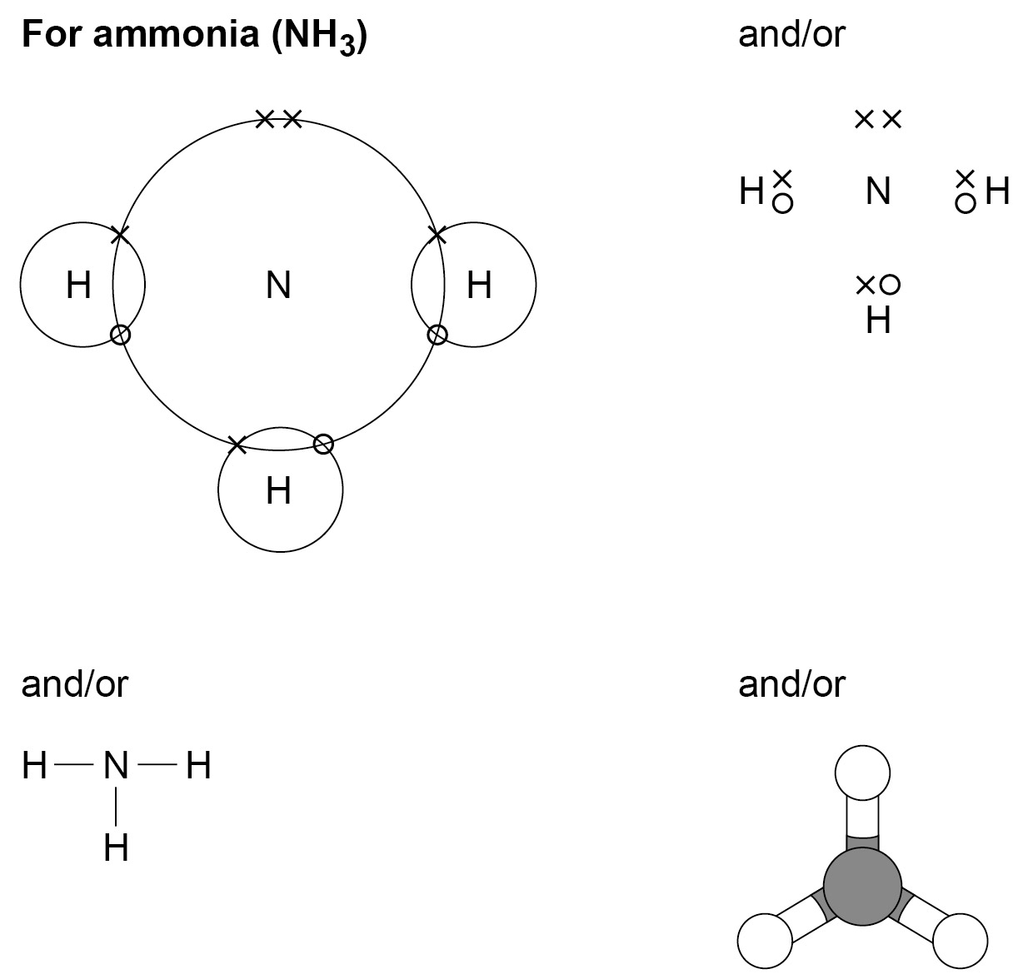  Polymers can be represented in the form:  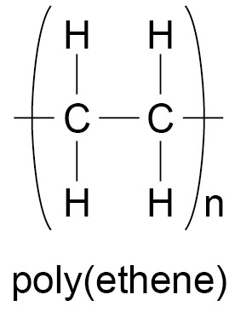  where n is a large number. | Recognise substances as small molecules, polymers or giant structures from diagrams showing their bonding.  Draw dot and cross diagrams for the molecules H₂, Cl₂, O₂, N₂, HCl, H₂O, NH₃ and CH_{4.}  Represent the covalent bonds in small molecules, in the repeating units of polymers and in part of giant covalent structures, using a line to represent a single bond.  Describe the limitations of using dot and cross, ball and stick, two- and three-dimensional diagrams to represent molecules or giant structures.  Deduce the molecular formula of a substance from a given model or diagram in these forms showing the atoms and bonds in the molecule. | 1 | Write a vignette for both simple and giant covalent substances, which illustrates the differences between them.  WS 1.2  Describe the limitations of particular representations and models to include dot and cross diagrams, ball and stick models and two- and three-dimensional representations.  MS 5b  Visualise and represent 2D and 3D forms including two dimensional representations of 3D objects. | Demo the formation of hydrogen chloride. Draw the dot and cross diagram for this reaction.  Model simple covalent substance using molecular model kits.  Demo giant covalent structures using molecular model kits.  Discussion questions:  - Why are covalently bonded substances so different?  - Can oxygen form a polymer?  - Is water a polymer?  Students research new polymers and their properties. They present a 'pitch' to promote the new polymer of their choice. | Video clip:  BBC Bitesize Covalent bonding and the periodic table
4.6.2.5 | Substances that consist of small molecules are usually gases or liquids that have relatively low melting points and boiling points.  These substances have only weak forces between the molecules (intermolecular forces). It is these intermolecular forces that are overcome, not the covalent bonds, when the substance melts or boils.  The intermolecular forces increase with the size of the molecules, so larger molecules have higher melting and boiling points.  These substances do not conduct electricity because the molecules do not have an overall electric charge.  Polymers have very large molecules. The atoms in the polymer molecules are linked to other atoms by strong covalent bonds. The intermolecular forces between polymer molecules are relatively strong and so these substances are solids at room temperature.  Substances that consist of giant covalent structures are solids with very high melting points. All of the atoms in these structures are linked to other atoms by strong covalent bonds. These bonds must be overcome to melt or boil these substances. Diamond and graphite (forms of carbon) and silicon dioxide (silica) are examples of giant covalent structures. | Use the idea that intermolecular forces are weak compared with covalent bonds to explain the bulk properties of molecular substances.  Recognise polymers from diagrams showing their bonding.  Recognise giant covalent structures from diagrams showing their bonding. | 1 | Represent melting and boiling points of covalent substances to scale, on a giant thermometer.  Extended writing: describe melting points and boiling points of covalent substances.  Describe the difference between an intermolecular force and a covalent bond.  Students demonstrate and communicate the relationship between melting points and boiling points, size of molecule and size of intermolecular forces, by designing an animation.  Extended writing: explain why the melting point and boiling point increases as the size of the molecule does in terms of intermolecular forces.  Write a dialogue between two cartoon characters who reveal why covalent substances do not conduct electricity.  Extended writing: explain how ethene polymerises.  Ask students how they would model the structure of diamond, silicon dioxide and graphite, to reveal their properties.  Extended writing: describe the structure of diamond, silicon dioxide and graphite.  How does 'dry ice' work?  Extended writing: explain how covalent substances boil.  WS 1.2  Use the idea that intermolecular forces are weak compared with covalent bonds to explain the bulk properties of molecular substances.  Use ideas about energy transfers and the relative strength of chemical bonds and intermolecular forces to explain the different temperatures at which changes of state occur.  Recognise polymers from diagrams showing their bonding.  Recognise giant covalent structures from diagrams showing their bonding.  WS 1.2  Use data to predict states of substances under given conditions. | Research some uses of covalent substances.  Extension: make links between the uses of covalent substances, their properties and structure.  RSC experiment - test and compare the conductivity of simple covalent and ionic substances .  Model polymers.  Make a polymer from cornstarch.  Investigate the properties of plastic bags.  Research some uses of covalent substances.  Extension: make links between the uses of covalent substances, their properties and structure  Research the uses of liquid nitrogen and suggest measures for using it safely.  Find out why is silicon dioxide an electrical insulator? | Video clips:  YouTube: Properties of covalent compounds  BBC Bitesize The plastic revolution  BBC Bitesize The uses of polymers  YouTube: Polymerisation of propene & chloroethene  RSC experiment ‘Which substances conduct electricity’
4.6.2.6 | Metals consist of giant structures of atoms arranged in a regular pattern.  The electrons in the outer shell of metal atoms are delocalised and so are free to move through the whole structure. The sharing of delocalised electrons gives rise to strong metallic bonds. The bonding in metals may be represented in the following form:  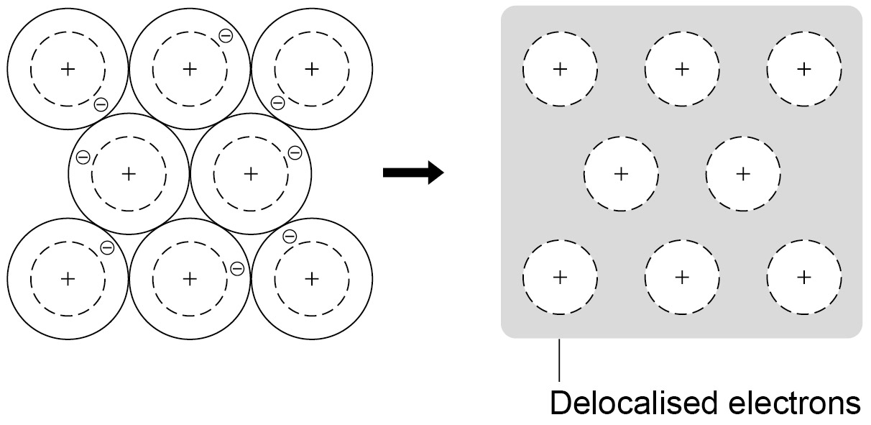 | Recognise substances as giant metallic structures from diagrams showing their bonding  Visualise and represent 2D and 3D forms including two dimensional representations of 3D objects.  Define delocalised electrons | 0.5 | Make a video animation to show how metals conduct electricity | Use copper wire and silver nitrate solution to grow silver crystals. | Video clips:  BBC Bitesize The properties and uses of metals  BBC Bitesize Bronze – the first alloy  Video clips:  BBC Bitesize The atomic structure of metals  YouTube: What are metallic bonds?
4.6.2.7 | Metals have giant structures of atoms with strong metallic bonding. This means that most metals have high melting and boiling points.  The layers of atoms in metal crystal can slide over each other. This means metals can be bent and shaped.  Pure metals are too soft for many uses and so are mixed with other metals to make alloys.  The different sizes of atoms in an alloy distort the crystal structure, making alloys harder than pure metals.  Metals are good conductors of electricity because the delocalised electrons in the metal carry electrical charge through the metal. | Describe the structure of a metal and an alloy.  Compare the structure of a metal with the structure of an alloy.  Explain why an alloy of a metal is harder than the pure metal.  Explain why metals have high melting and boiling points.  Explain why metals are good conductors of electricity. | 1 | Students put metallic substances in a melting point 'league table'  Using finger puppets, students explain why metallic substances and dissolved ionic compounds conduct electricity and covalent substances do not.  Extended writing: explain why metallic substances conduct electricity.  Discussion questions:  - Why are alloys harder than pure metals?  - Are alloys 'designer metals'?  Extended writing: describe melting points and boiling points of metallic substances.  Students write a script for a dinner table conversation explaining why a metal fork does not melt in the scalding soup.  Extended writing: explain why the melting point and boiling point of metallic substances are high.  Extended writing: describe the structure of metal alloys.  WS 1.2  Use ideas about energy transfers and the relative strength of chemical bonds and intermolecular forces to explain the different temperatures at which changes of state occur.  WS 1.2  Use data to predict states of substances under given conditions. | Research some uses of metal alloys.  Extension: make links between the uses of metal alloys, their properties and structure.  Students agree criteria before researching new metal alloys, presenting their example to the class and voting for the 'best'.  Research some metal alloys and present the information in a table suitable for a GCSE educational web page.  Research some uses of metallic substances.  Research and discuss:  - Should silicon be a metal?  - Why is gold relatively unreactive?  - Does gold form alloys?  Extension: make links between the uses of metal substances, their properties and structure.  Students deduce chemical formula of compounds from a variety of diagrams. | Teachit Science resource (19994) ‘Alloys and their uses’  RSC – spot the bonding handout

4.6.3 Magnetism and electromagnetism
Spec ref. | Summary of the specification content | Learning outcomes  What most candidates should be able to do | Suggested timing (hours) | Opportunities to develop Scientific Communication skills | Opportunities to apply practical and enquiry skills | Self/peer assessment Opportunities and resources  Reference to past questions that indicate success
4.6.3.1 | The poles of a magnet are the places where the magnetic forces are strongest. When two  magnets are brought close together they exert a force on each other. Attraction and repulsion between two magnetic poles are examples of non-contact force.  A permanent magnet produces its own magnetic field. An induced magnet is a material that becomes a magnet when it is placed in  a magnetic field. Induced magnetism always causes a force of attraction. When removed from the magnetic field an induced magnet  loses most/all of its magnetism quickly. | Describe the attraction and repulsion between like and unlike poles.  Identify magnetism as a non-contact force.  Describe how an induced magnet is produced.  Describe the difference between permanent and induced magnets. | 1 | Describe two experiments that can be used to identify the magnetic field pattern of a permanent magnet.  Describe what would happen if two North seeking Magnetic Poles were placed near each other, two South seeking Poles or one of each.  Which part of a permanent magnet is the strongest? | Investigate and draw the shape of the magnetic field pattern around a permanent magnet.  Investigate the effect that two magnets have on each other in different orientations.  How can we make an electromagnet?  Investigate how to make an induced magnet by stroking an iron nail with a permanent magnet.  Investigate electromagnets and why they are referred to as temporary magnets. Find out why soft iron is used as the core in an electromagnet rather than steel. Investigate what affects the strength of a temporary magnet. | Video clip:  BBC Bitesize – Laws of magnetism  BBC Bitesize – Magnets  Cyberphysics – Magnetism  BBC Bitesize – Magnets  BBC Bitesize – Electromagnets and motors  Cyberphysics – Electromagnetism experiment
4.6.3.2 | The region around a magnet where a force acts on another magnet or on a magnetic material (iron, steel, cobalt and nickel) is called the magnetic field.  The force between a magnet and a magnetic material is always one of attraction.  The strength of the magnetic field depends on the distance from the magnet. The field is strongest at the poles of the magnet.  The direction of the magnetic field at any point is given by the direction of the force that would act on another north pole placed at that point. The direction of a magnetic field line is from the north (seeking) pole of a magnet to the south (seeking) pole of the magnet. | Name three magnetic elements.  Describe why steel is magnetic.  Explain what is meant by the magnetic field of a magnet.  Describe how to distinguish between a magnetic material and a magnet by experiment.  Describe where the strongest point of a magnet is and how this is shown by the magnetic field pattern.  Describe how the strength of the magnetic field varies with distance from the magnet. | 1 | What is the shape of the magnetic field of a permanent magnet? How is the field pattern found?  WS 2.2  Draw the magnetic field pattern of a bar magnet and describe how to plot the magnetic field pattern using a compass. | Investigate the magnetic field of a permanent magnet using plotting compasses or iron filings if this wasn’t done in the earlier section.  Floating paper clip challenge. Can students make a paper clip float in mid-air?  Investigate the difference between magnetic materials and permanent magnets.  Investigate the strength of a permanent magnet at various points along its length to show that the magnet is strongest at the poles. This can be demonstrated with the iron filings investigation.  Plan and carry out an experiment to find out how the strength of a magnet changes with the distance from the magnet. | S-cool, the revision website – Magnetism  Cyberphysics – Magnetism  BBC Bitesize – Magnets  Cyberphysics – Magnetism
4.6.3.3 | A magnetic compass contains a small bar magnet. The Earth has a magnetic field. The compass needle points in the direction of the Earth’s magnetic field.  The Earth’s magnetic field is probably caused by movements in the liquid, iron-rich part of the outer core of the Earth. The slow changes to the positions of the magnetic north and south poles and the way that field reverses its direction from time to time show that the magnetism of the core is dynamic and not static. The intervals between reversals are not uniform. The last reversal happened about 800,000 years ago. | Explain how the behaviour of a magnetic compass is related to evidence that the core of the Earth must be magnetic. | 1 | Draw the magnetic field pattern of a bar magnet and describe how to plot the magnetic field pattern using a compass.  Describe how a compass can be made using a needle floating on a leaf once it has been magnetised by a permanent magnet.  Explain how the behaviour of a magnetic compass is related to evidence that the core of the Earth must be magnetic.  Investigate the magnetic field pattern of the Earth.  Question for students to consider (think-pair-share): What is the shape of the Earth’s magnetic field?  WS 1.3  Explain why the data needed to answer a scientific question, in a given context, may not be available because of matters of scale and complexity. | How does a compass work?  Why would a compass sometimes point in the wrong direction (eg not to the North Pole in the UK)?  Try making a compass using a needle and a permanent magnet.  Suspend a permanent magnet so it is free to rotate. Check the direction it points with an actual compass. | BBC – Earth – Earth’s magnetic field now flips more often than ever  BBC Bitesize – Magnetic fields  Cyberphysics – The Earth's Magnetic Field
4.6.3.4 | When a current flows through a conducting wire a magnetic field is produced around the wire. The shape of the magnetic field can be seen as a series of concentric circles in a plane, perpendicular to the wire. The direction of these field lines depends on the direction of the current.  The strength of the magnetic field depends on the current through the wire and the distance from the wire.  Shaping a wire to form a solenoid increases the strength of the magnetic field created by a current through the wire. The magnetic field inside a solenoid is strong and uniform.  The magnetic field around a solenoid has a similar shape to that of a bar magnet. Adding an iron core increases the magnetic field strength of a solenoid. An electromagnet is a solenoid with an iron core. | Describe how the magnetic effect of a current can be demonstrated.  Use the ‘right hand grip rule’ to draw the magnetic field pattern of a wire carrying an electric current. | 1 | Use the ‘right hand grip rule’ to draw the magnetic field pattern of a wire carrying an electric current.  WS 1.2, 3.1  Draw the magnetic field pattern for a straight wire carrying a current (showing the direction of the field).  WS 1.2  Use the 'right hand grip rule' to predict the direction of the field.  WS 3.1  Draw the magnetic field pattern for a solenoid carrying a current (showing the direction of the field).  WS 1.4  Compare the advantages and disadvantages of permanent and electromagnets for particular uses. | Demonstrate what happens when a foil strip with a current flowing through it is placed in a strong magnetic field. What happens if the direction of the current is reversed?  Try to demonstrate the shape by placing a wire through a piece of card with iron filings sprinkled near it. Apply a current through the wire. | YouTube: The Motor Effect  BBC Bitesize – Electromagnets and motors  Cyberphysics – Electromagnetism
4.6.3.5 | (HT only)  When a conductor carrying a current is placed in a magnetic field the magnet producing the field and the conductor exert a force on each other. This is called the motor effect.  The direction of the force on the conductor is reversed if either the direction of the current or the direction of the magnetic field is reversed.  The size of the force on the conductor depends on:  - the magnetic flux density  - the current in the conductor  - the length of conductor in the magnetic field.  For a conductor at right angles to a magnetic field and carrying a current:  force = magnetic f lux density × current × length  [ F = B Ι l ]  force, F, in newtons, N  magnetic flux density, B, in tesla, T  current, Ι, in amperes, A (amp is acceptable for ampere)  length, l, in metres, m | Explain what is meant by the motor effect.  Explain why a motor spins with respect to the magnetic field produced by a wire carrying an electric current and the magnetic field of the permanent magnets in the motor interacting.  Recall and use Fleming’s left-hand rule.  Describe how the size and direction of the force on a conductor in a magnetic field can be changed.  Use and apply the equation to calculate any missing value when given other values.  State the units of force, magnetic flux density, current and length.  Convert units into SI units as required and use standard form as required. | 1 | WS 1.2  Use Fleming’s left-hand rule to predict the direction of the force on a conductor.  MS 3c  Apply this equation, which is given on the equations sheet.  - Questions for students to consider (think-pair-share).  - What is magnetic flux density?  - What determines magnetic flux density? | Fleming’s left-hand rule demonstration  Make an electric motor (eg available from Winchester Kits) and investigate how the speed and direction of rotation can be changed.  Predict the direction of rotation of an electric motor when given the direction of the magnetic field and the direction of the current in the coil. Use animations or models students have built themselves.  Investigate both the size and direction of the force on a conductor in a magnetic field. This can be done when making simple motors by wrapping more wire around, increasing the potential difference or using stronger magnets. | IOP – Fleming’s left hand rule demo  BBC Bitesize – Electric motors  Cyberphysics – The Motor Effect  Pass My Exams – Electric Motors & Generators  BBC Bitesize – Electromagnets and motors  Cyberphysics – The Motor Effect  Pass My Exams – Electric Motors & Generators  Schoolphysics – Force on a current in a magnetic field
4.6.3.6 | (HT only)  A simple electric motor consists of a rectangular coil of wire that is free to turn in the magnetic field of a permanent magnet. A commutator reverses the direction of the current every half turn, to allow the rotation to continue. | Describe a simple motor.  Apply Fleming’s left-hand rule to a simple electric motor.  Explain how rotation is caused in electric motors. | 1 | WS 1.2  Apply Fleming’s left-hand rule to a simple electric motor.  WS 1.4  Explain everyday and technological applications of science. | Class practical – the electric motor.  Research applications of electric motors and commutators. | Nuffield Foundation / IOP practical – the electric motor  BBC Bitesize – the motor effect  BBC Bitesize – Electromagnets and motors

