Name: _____________________________
Date: ______________________________
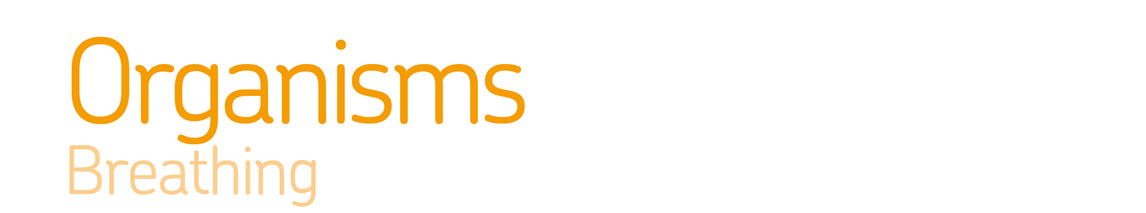

Investigate a claim linking height to lung volume.
Know |  |  | Apply  2  1
Ideas
K1 | In gas exchange, oxygen and carbon dioxide move between alveoli and the blood. Oxygen is transported to cells for aerobic respiration and carbon dioxide, a waste product of respiration, is removed from the body. |  | A1 | Explain how exercise, smoking and asthma affect the gas exchange system.
 |  |  | A2 | Explain how the parts of the gas exchange system are adapted to their function.
K2 | Breathing occurs through the action of muscles in the ribcage and diaphragm. The amount of oxygen required by body cells determines the rate of breathing. |  | A3 | Explain observations about changes to breathing rate and volume.
 |  |  | A4 | Explain how changes in volume and pressure inside the chest move gases in and out of the lungs.
Key words
K3 | Breathing: The movement of air in and out of the lungs. |  | A5
K6  K4 | Trachea (windpipe): Carries air from the mouth and nose to the lungs.
K5 | Bronchi: Two tubes which carry air to the lungs.
K6 | Bronchioles: Small tubes in the lung.
K7 | Alveoli: Small air sacs found at the end of each bronchiole. |  | A6
K8 | Ribs: Bones which surround the lungs to form the ribcage.
K9 | Diaphragm: A sheet of muscle found underneath the lungs.
K10 | Lung volume: Measure of the amount of air breathed in or out.
3 | Extend
E1 | Evaluate a possible treatment for a lung disease.
E2 | Predict how a change in the gas exchange system could affect other processes in the body.
E3 | Evaluate a model for showing the mechanism of breathing.
E4 | Find out how recreation drugs might affect different body systems.
E5
E6

