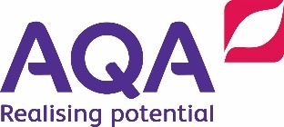
Name: _______________________
Date: _________________________

Investigate a phenomenon that relies on an exothermic or endothermic reaction.

Know |  |  | Apply  2  1
Ideas
K1 | During a chemical reaction bonds are broken (requiring energy) and new bonds formed (releasing energy). If the energy released is greater than the energy required, the reaction is exothermic. If the reverse, it is endothermic. |  | A1 | Use experimental observations to distinguish exothermic and endothermic reactions.
 |  |  | A2 | Use a diagram of relative energy levels of particles to explain energy changes observed during a change of state.
Key words
K2 | Catalysts: Substances that speed up chemical reactions but are unchanged at the end. |  | A3
K3 | Exothermic reaction: One in which energy is given out, usually as heat or light.
K4 | Endothermic reaction: One in which energy is taken in, usually as heat.
K5 | Chemical bond: Force that holds atoms together in molecules.
3 | Extend
E1 | Predict whether a chemical reaction will be exothermic or endothermic given data on bond strengths.
E2 | Use energy data to select a reaction for a chemical hand warmer or cool pack.
E3
E4

