Social media templates
These post templates have been created for you to use on your school or college’s social media channels – just edit them to suit your needs.
Twitter

Completing an #EPQ can benefit [your/your child’s] A-level performance by developing independent research and study skills.

Find out more at our open evening on [enter date].

The #EPQ allows young people to follow their passions and stand out from the crowd by choosing to research a topic they’re passionate about.

Find out more at our open evening on [enter date].

The skills developed by taking #EPQ can enhance students’ performance in their other subjects and beyond into higher education and the workplace.

Find out more at our open evening on [enter date].

The #EPQ is worth half an A-level at UCAS and is look upon favorably by universities.

Find out more at our open evening on [enter date].

Use these Twitter cards to bring your posts to life.

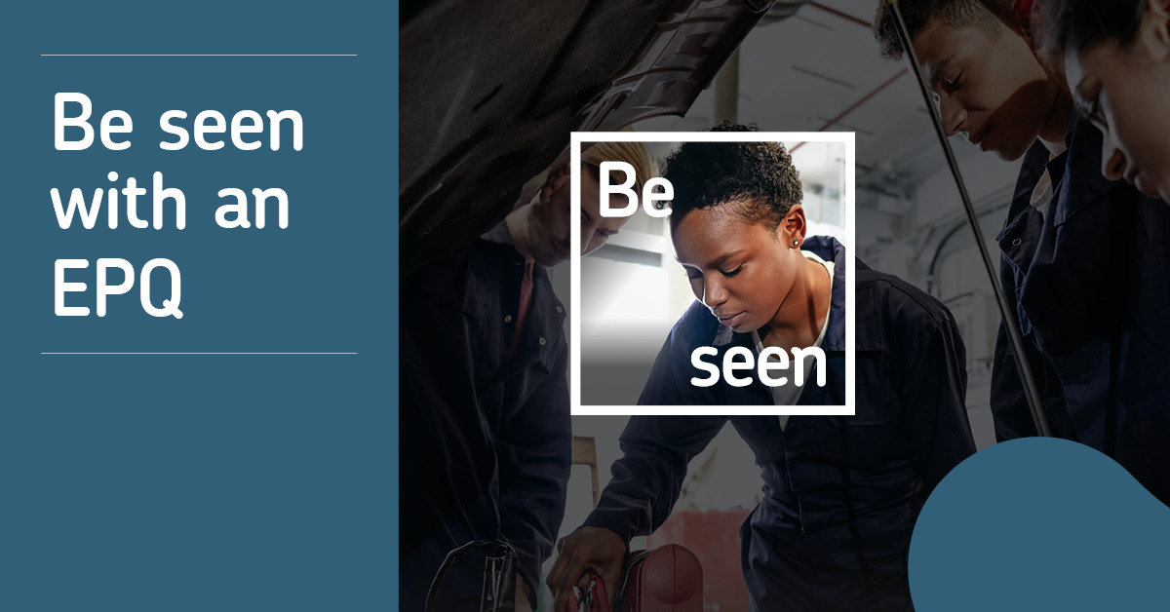
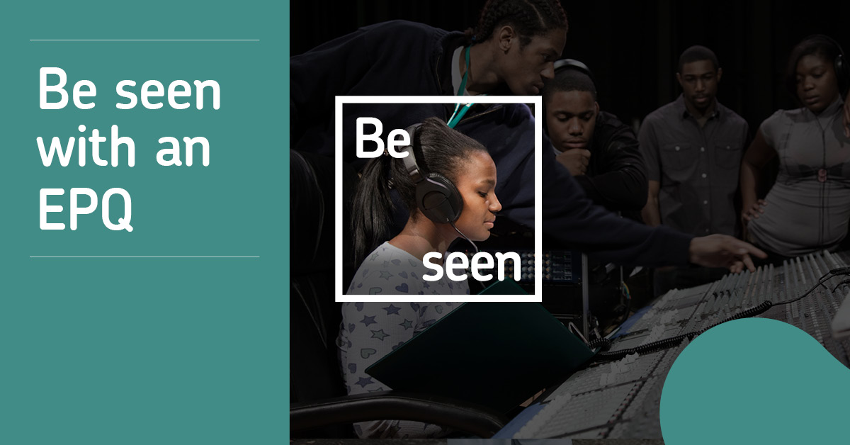
Facebook

The EPQ allows young people to follow their passions and stand out from the crowd by choosing to research a topic they’re passionate about.

The independent research and study skills developed throughout the EPQ course can enhance students’ performance in their other subjects and beyond into higher education and the workplace.

Find out more at our open evening on [enter date].

Instagram
The #EPQ is an opportunity for you to take the lead on developing your skills while researching a topic that you’re passionate about that will help you to stand out from the crowd in university and job applications.
Find out more at our open evening on [enter date].

